# SFMEM handover

目录

SFMEM handover 1

**Project background** 2

**Function introduction** 3

Concept explanation: 3

Registration function: 6

Adjust product inventory: 20

Batch creation of events: 22

Function of bringing friends when users register or make reservations: 23

**Code explanation** 28

**Release process** 45

**To deploy list** 56

# **Project background**

This is a project that can be used by users in the company's marking department in the form of a form to create various marketing activities for clients to participate in various forms (registration, reservation, purchase).

Demo：

[“HKT x WESTK POPFEST: Popnorama” Ticket Lucky Draw (site.com)](https://here2serve--dev1a360v5.sandbox.my.site.com/ld2023registration/s/)

Env：

Dev360: https://here2serve--dev1a360v5.sandbox.lightning.force.com/lightning/setup/ObjectManager/01I2w0000027gZV/Details/view

Uat: <https://here2serve--uatd.sandbox.lightning.force.com/lightning/r/Event__c/a6zBU00000008qPYAQ/view>

Sfmem：https://here2serve--sfmem.sandbox.my.salesforce.com/?ec=301&startURL=%2Fvisualforce%2Fsession%3Furl%3Dhttps%253A%252F%252Fhere2serve--sfmem.sandbox.lightning.force.com%252Flightning%252Fsetup%252FSetupNetworks%252Fhome

# **Function introduction**

Miro link：[SFMEM Architeture - Miro](https://miro.com/app/board/uXjVN77bNzE=/)

### Concept explanation:

Event：

Parent Event：

Child Event：

Last Child Event：correspond timeslot（Event Start Date

, Event End Date

）

Currently only supports three-layer event structure，first parent event -->muliti second child Event-->multi third child Event（timeslot）

Note: This three-layer function is not yet available in the prod environment. Currently, the prod environment only has a two-layer structure, and the last layer is still Timeslot.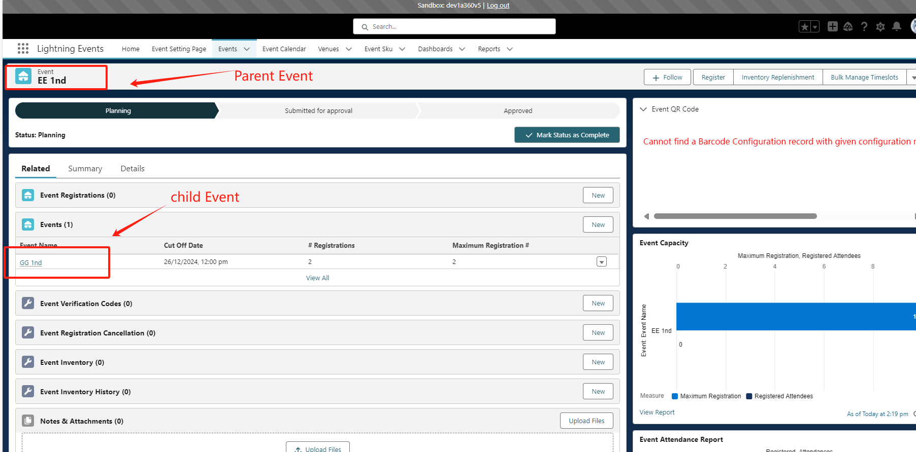

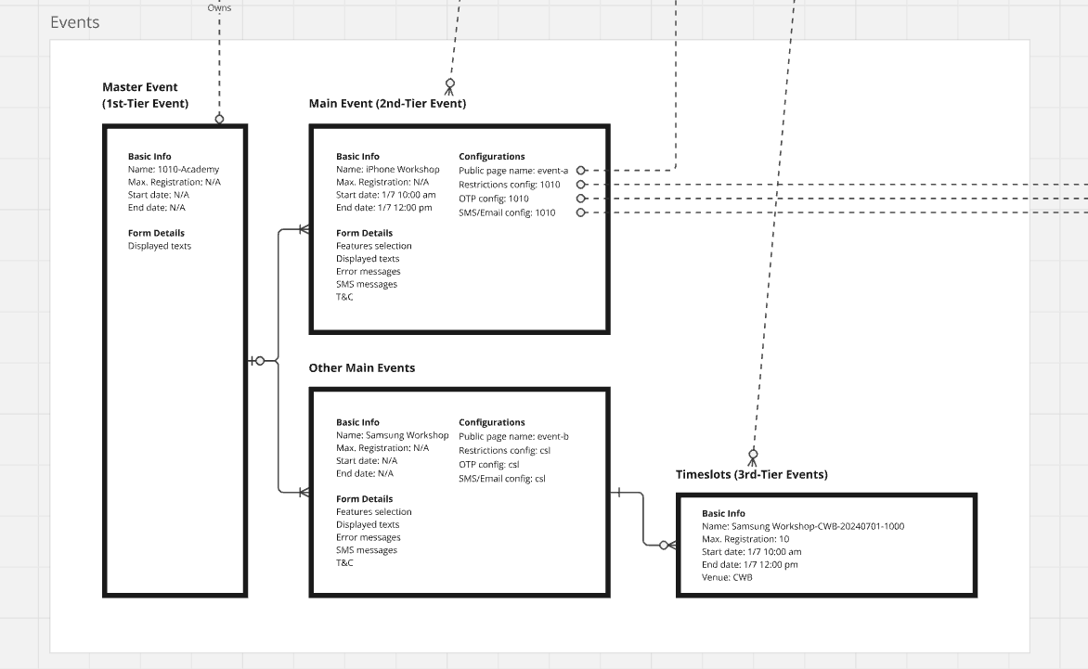

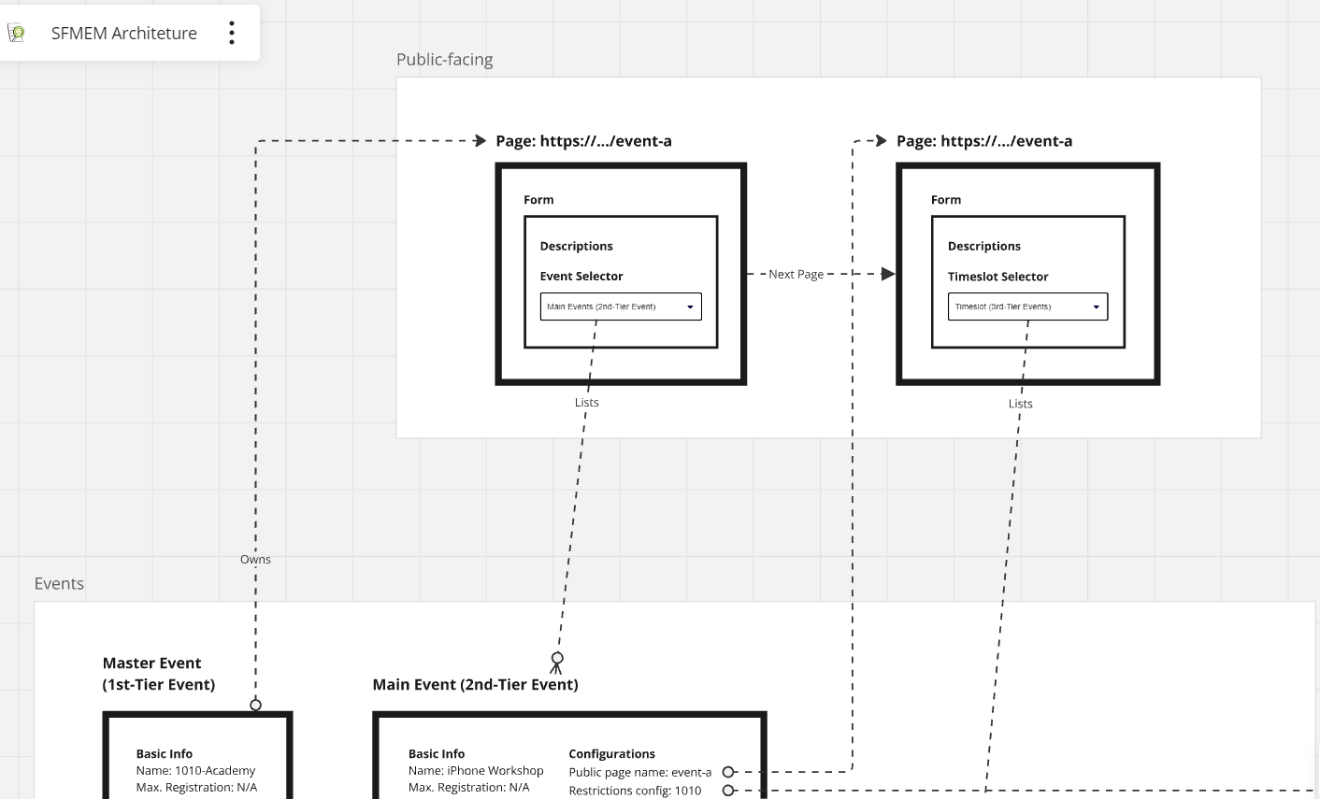

Venue：

Timeslot：Event Start Date

, Event End Date

Cut Off Date: Each Event must satisfy that the current time is within the Start Date and End Date before it will be displayed.

Venue and Timeslot are related to the last child event and are placed on the detail page of the last child event.

Each Venue corresponds to a bunch of Timeslot, and Venue and Timeslot are displayed in conjunction.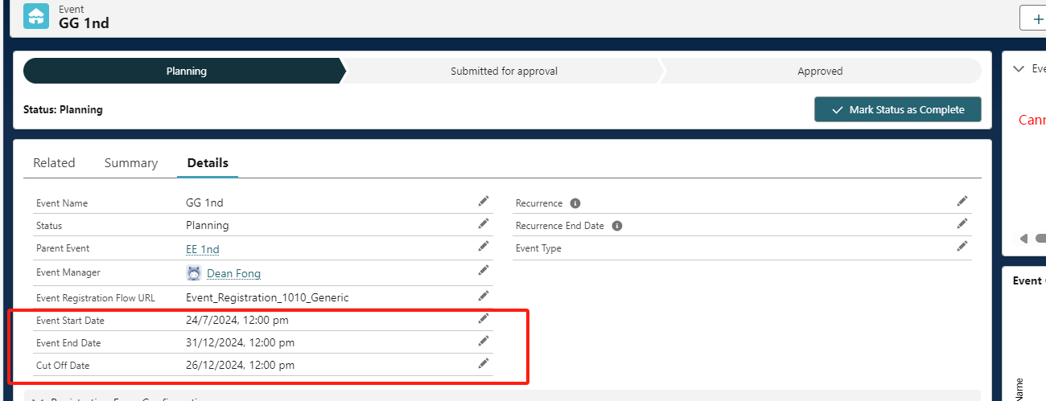

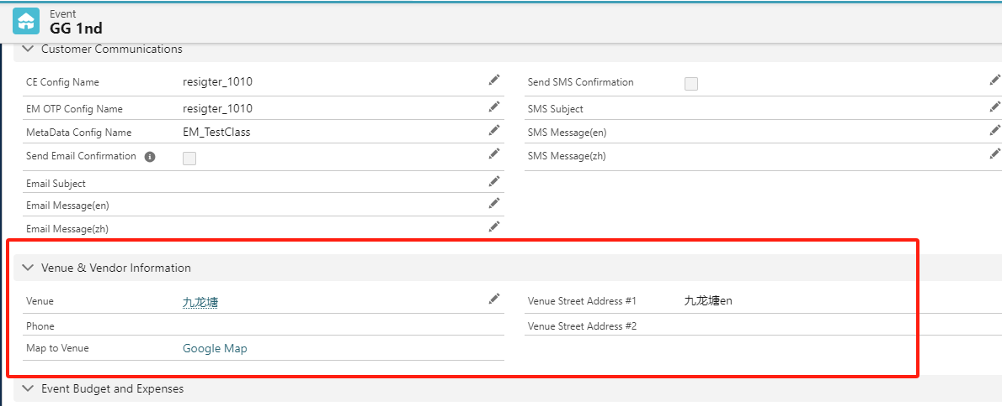

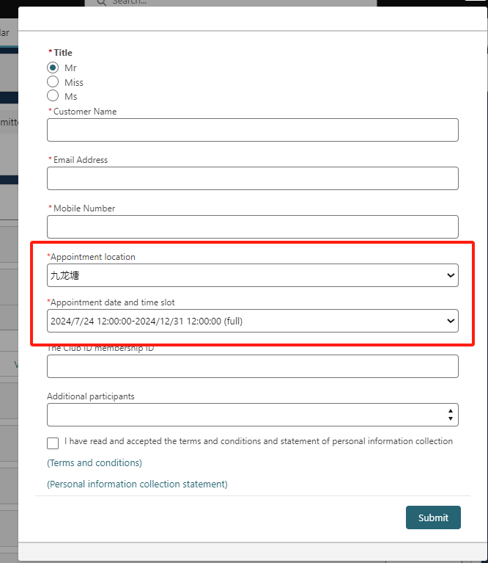

Registration function: Create various activities (EVENT) for users to participate in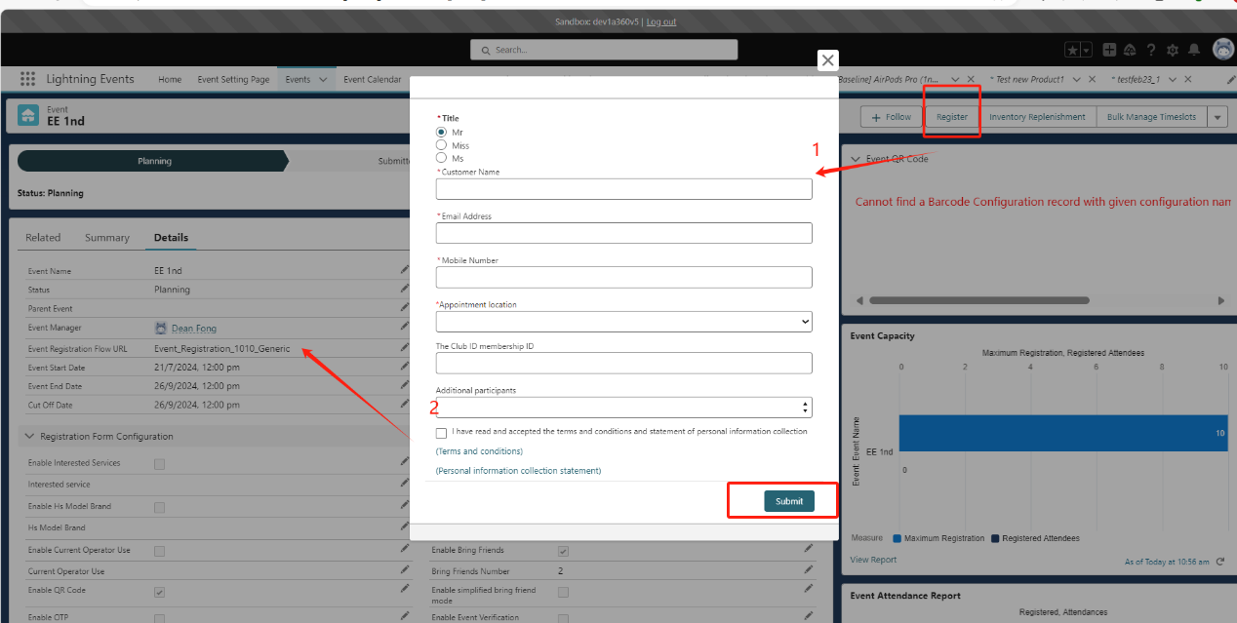

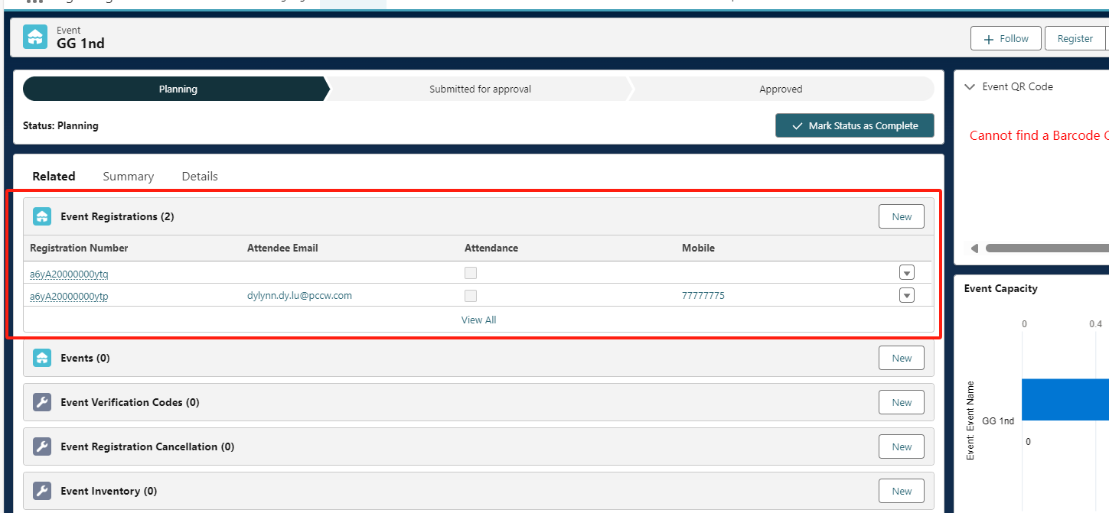

Corresponding code logic: flow: Event_Registration_1010_Generic

Processing logic configuration switches corresponding to each Event: all contents of the Detail page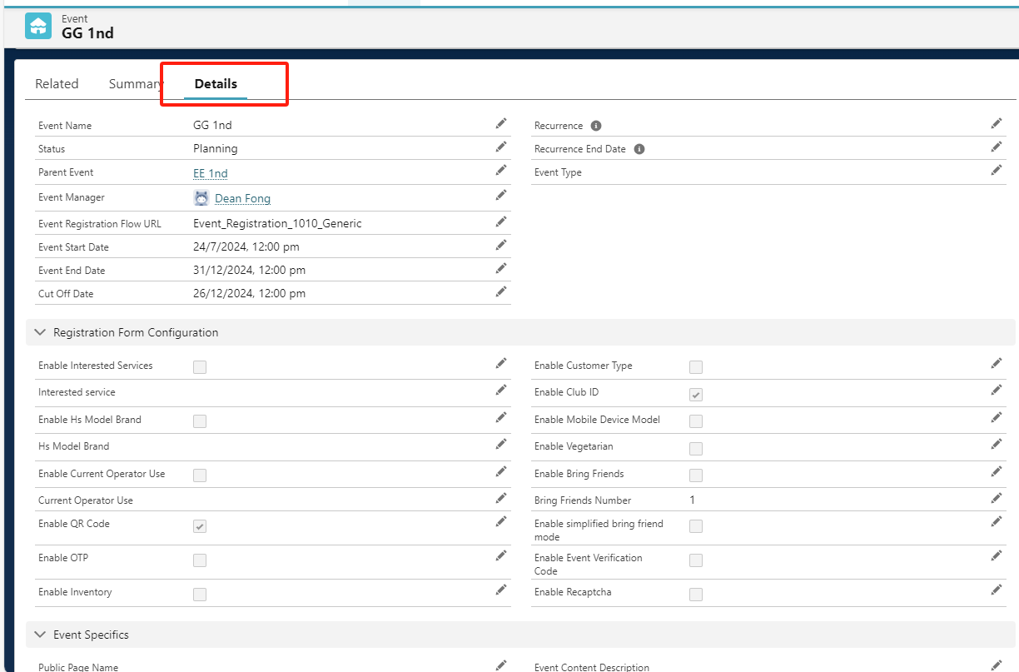

**Configuration of registration restrictions for Parent Event and child Event:**

1. Registration uses user mobile as the only registration primary key. According to the configuration information, a mobile can be registered once or multiple times in a last child event.

2. Registration restriction configuration information, some are only configured with the detail page of the last child event, and some are configured with the detail page of the parent event of the last child event or global configuration of the metadata setting page

2.1 Only the detail page configuration of the last child event: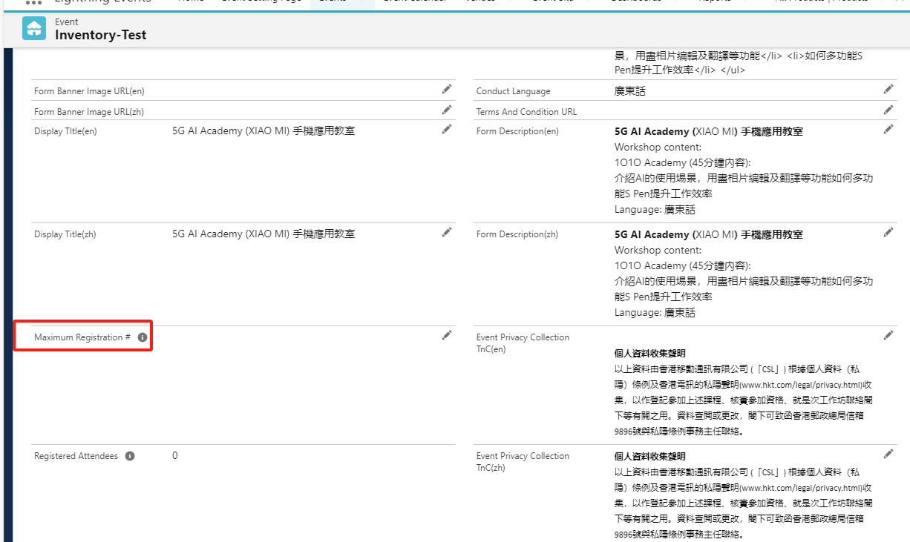

Maximum_Registration__c: Limit the maximum number of registrations for this event

If the maximum limit is triggered, an error will be reported:

[Error: There are only 0 positions left! You and your friends exceed the remaining positions!]

2.2 Only follow the detail page configuration of the parent event of the last child event or the global configuration of the metadata setting page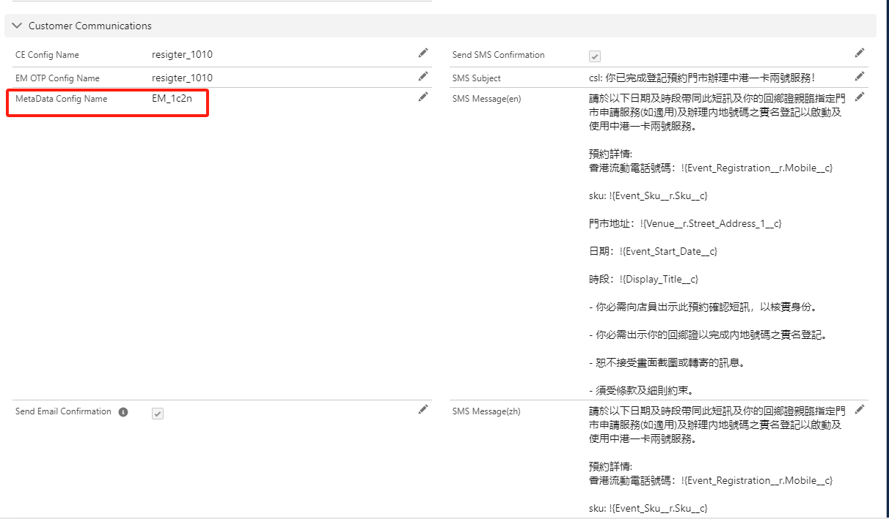

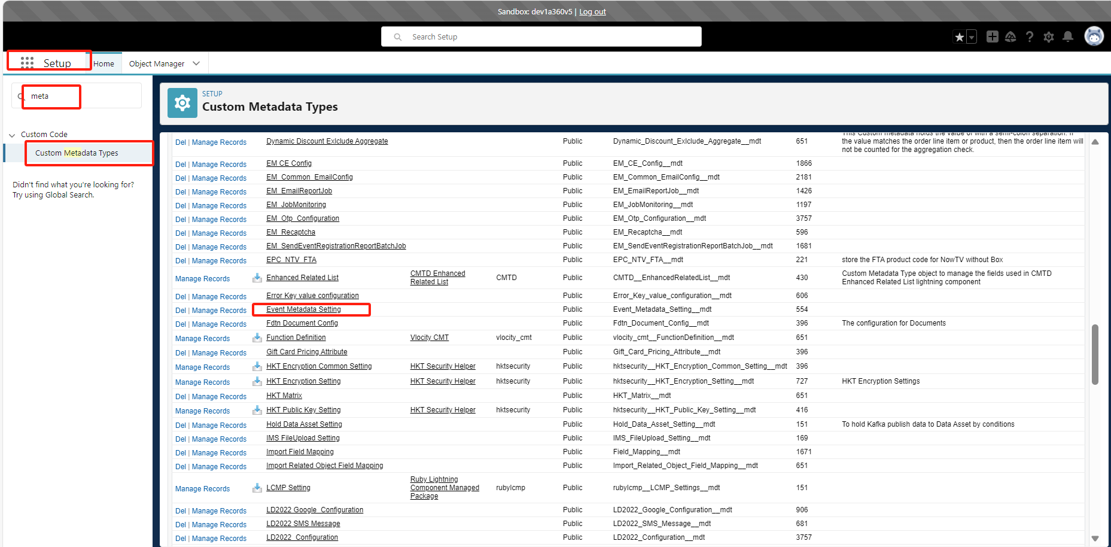

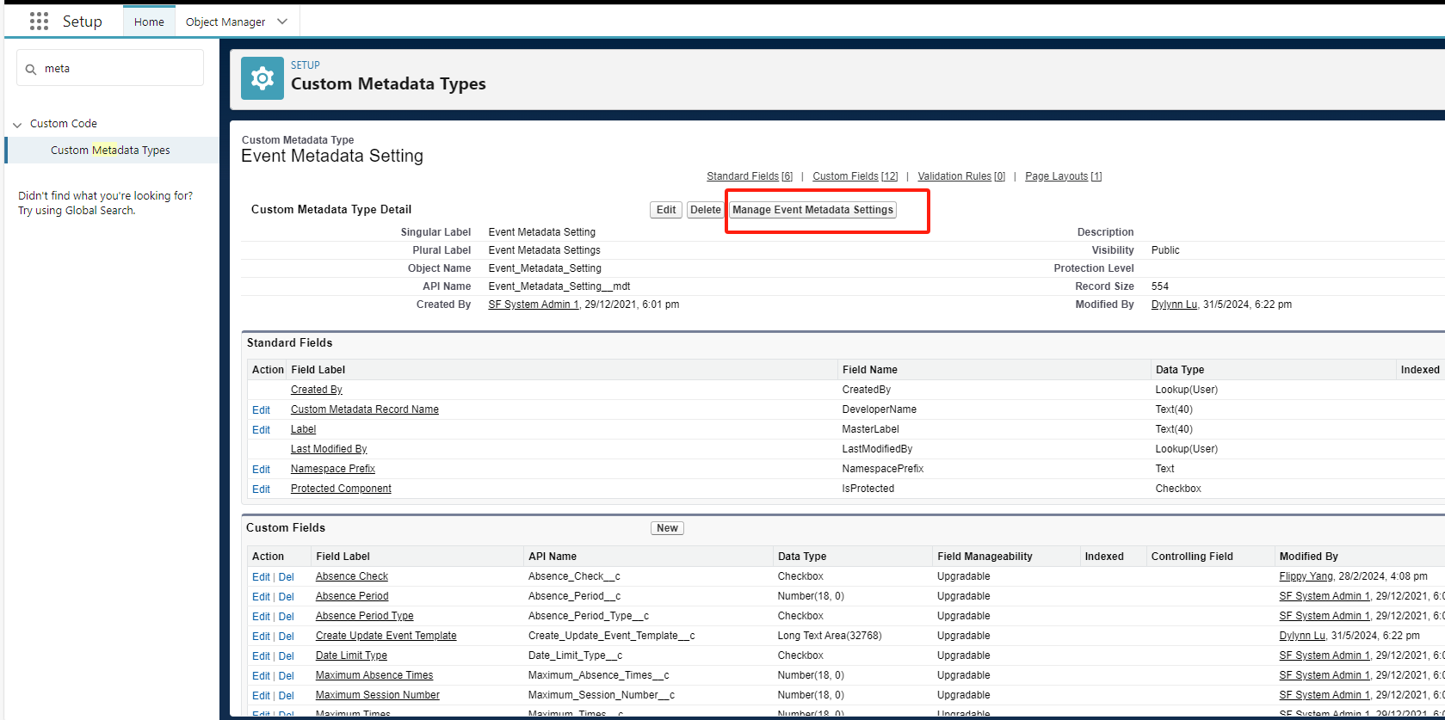

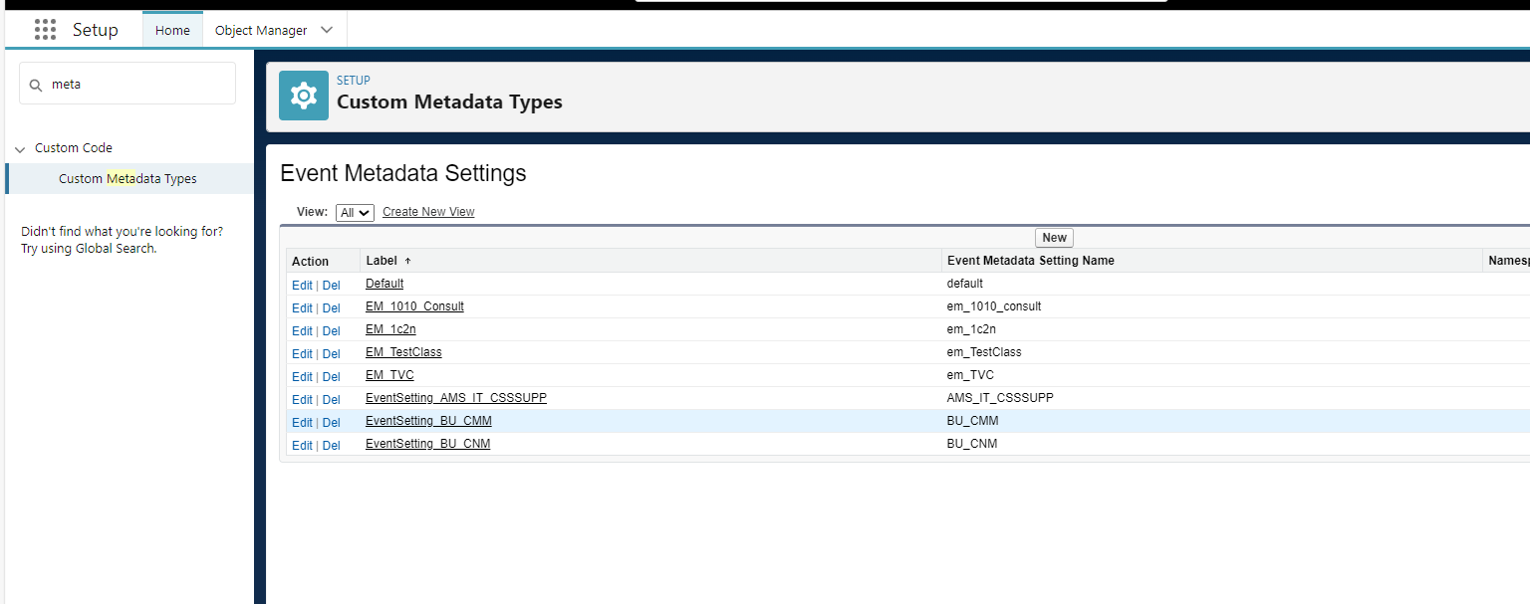

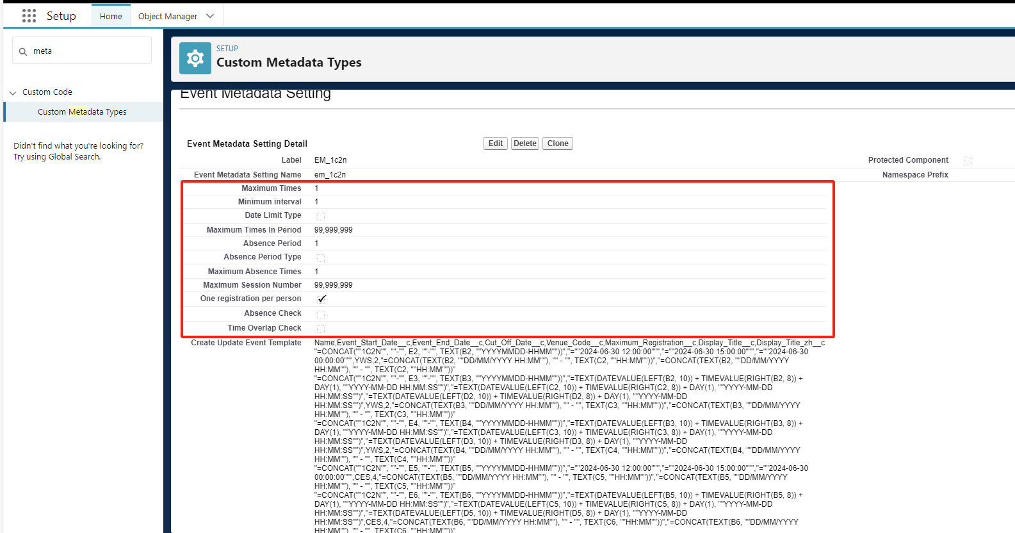

One registration per person: For the same last child event, a mobile phone number can only be registered once

If the maximum limit is triggered, an error will be reported:

[Error report: You have already registered to this event.]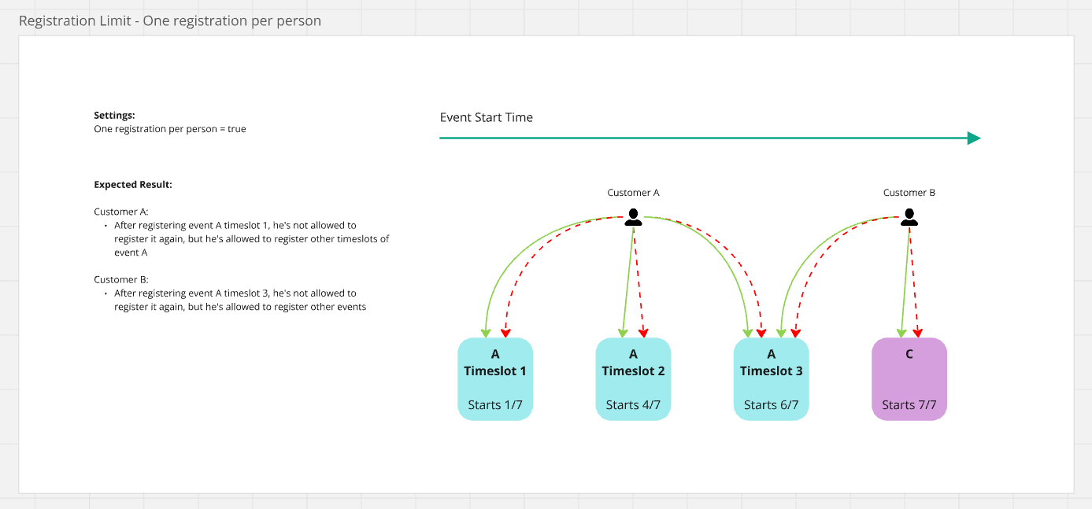

Maximum Session Number: Limit the registered number of people with this mobile phone number of all last child events under the parent event of the currently selected event

If the maximum limit is triggered, an error will be reported:

[Error report: You can not register this event as you have registered 1 sessions in the same workshop!]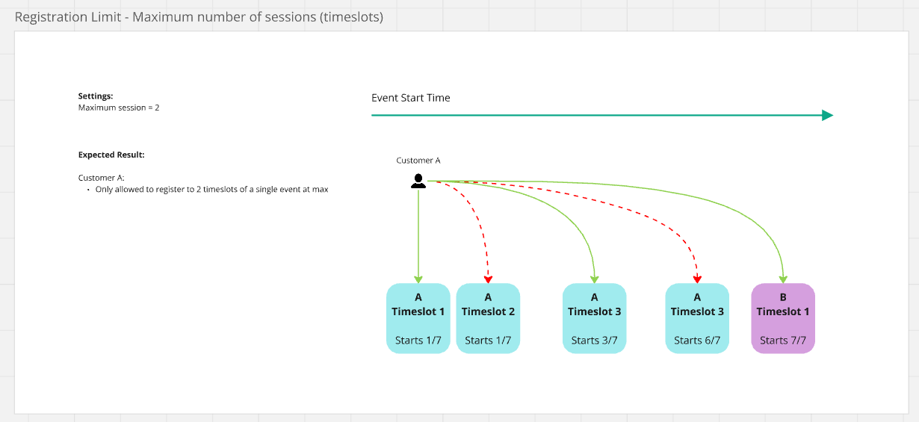

Maximum Times: Limit the number of registrations for a mobile phone number in one day (for the last child event under the same parent event, if there is no parent, for the same last child event)

If the maximum limit is triggered, an error will be reported:

[Error report: More than 1 registrations in a day!]

Minimum interval (hours): Limit the time difference between the currently selected registration event for a mobile phone number and the existing registration event to be less than the minimum interval (for the last child event under the same parent event, if there is no parent, for the same last child event)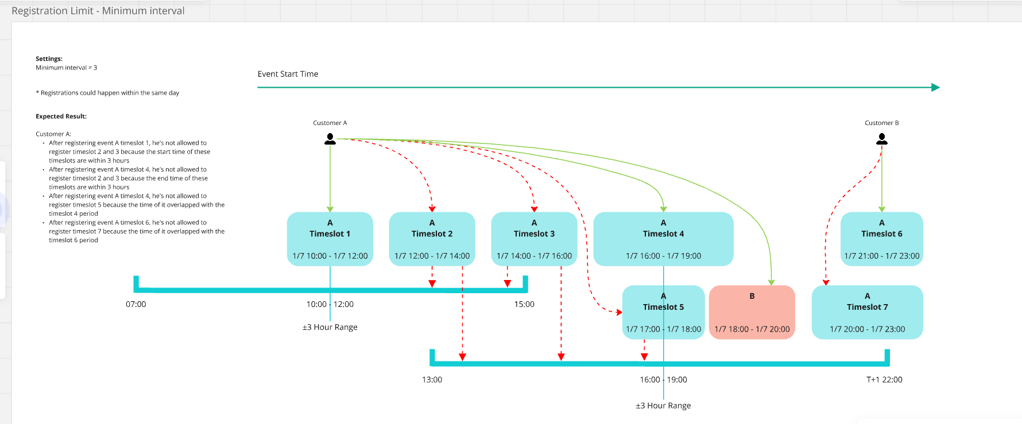

Date Limit Type (week [false]/month [true]): Limit the currently selected registration event of a mobile phone number to not overlap with the start and end time of other existing registration events (for the last child event under the same parent event, if If there is no parent, it is for the same last child event)

Maximum Times In Period: Limits the number of registrations for the currently selected registration event of a mobile phone number to no more than N times for other existing registration events in the same month or the same week (for the last child event under the same parent event, if If there is no parent, it is for the same last child event)

If the maximum limit is triggered, an error will be reported:

[Error report: The current event overlaps with the registered event or the interval is less than 1 hour]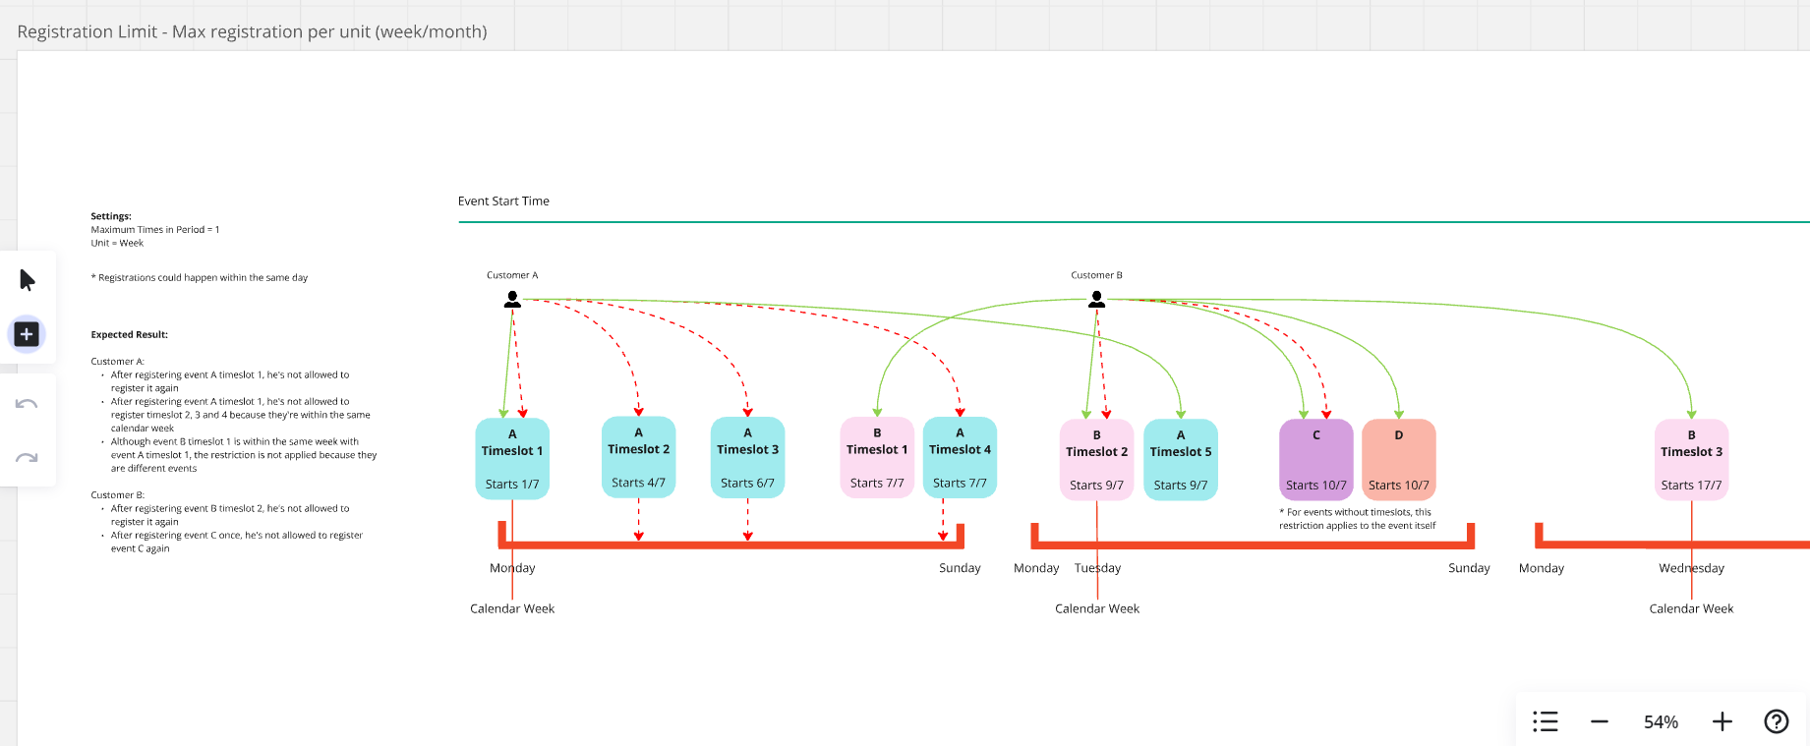

Maximum Absence Times: Limit the number of attendances for the same mobile phone number (for the last child event under the same parent event, if there is no parent, for the same last child event)

If the maximum limit is triggered, an error will be reported:

[Error report: The number of absences has exceeded 1]

Judgment order:

One registration per person-----》Maximum Session Number-------》SelectedEvent.Maximum_Registration__c-------》Maximum Times、Maximum Times In Period、Maximum Absence Times

Maximum_Times-----》Maximum Times In Period-------》Maximum_Absence_Times__c

Note: The above configuration has not been uploaded to the official environment. The current configuration of the official environment still follows the child event, as follows:

One registration per person: For the same event eventid (if there is a sub-event, it is the sub-eventid), a mobile phone number can only be registered once

[Error report: You have already registered to this event.]

Maximum Session Number: Limit the number of registered users of this mobile phone number for all child events under the parent event of the currently selected event.

[Error report: You can not register this event as you have registered 1 sessions in the same workshop!]

Maximum Times: For all events, limit the number of registrations for a mobile phone number in one day

[Error report: More than 1 registrations in a day!]

Minimum interval (hours): For all events, the time difference between the currently selected registration event for a mobile phone number and the existing registration event cannot be less than the minimum interval.

Date Limit Type (week [false]/month [true]): For all events, restrict the currently selected registration event for a mobile phone number to not overlap with the start and end time of other existing registration events.

Maximum Times In Period: For all events, limit the number of registrations for the currently selected registration event for a mobile phone number to no more than N times for other existing registration events in the same month or the same week.

[Error report: The current event overlaps with the registered event or the interval is less than 1 hour]

SelectedEvent.Maximum_Registration__c: (Configuration in sub-event) Limit the maximum number of registrations under this event

[Error: There are only 0 positions left! You and your friends exceed the remaining positions!]

Maximum Absence Times: For all events, limit the number of attendances for the same mobile number

[Error report: The number of absences has exceeded 1]

**Parent Event and child Event Configuration of Send OTP restrictions:**

**1. All Send OTP configurations are only related to the parent event, that is, the configuration of the parent event determines the configuration of all last child events under the parent event.**

**2. Send OTP has two parts of the business. One is to send a mobile phone number verification SMS before registration; the other is to send a success SMS to register a mobile phone number after successful registration.**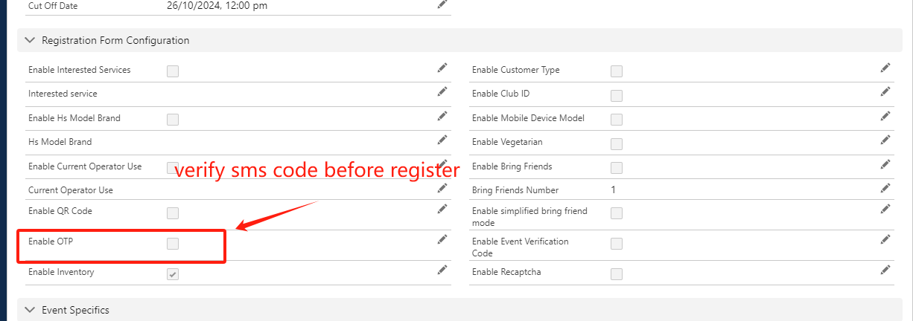

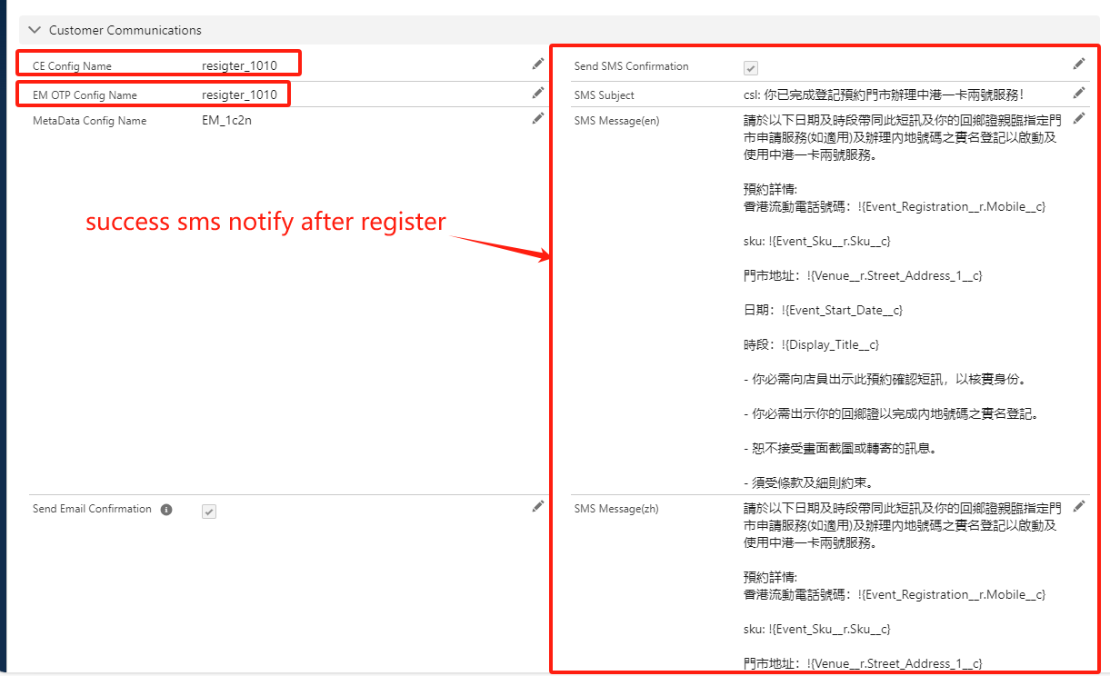

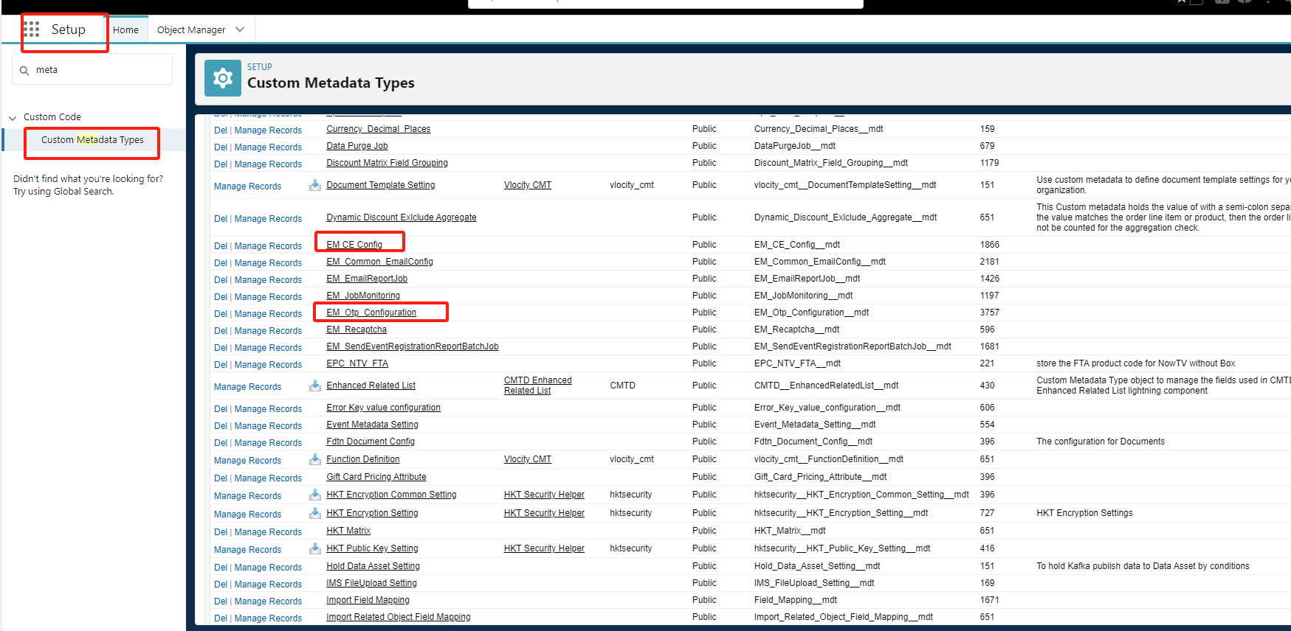

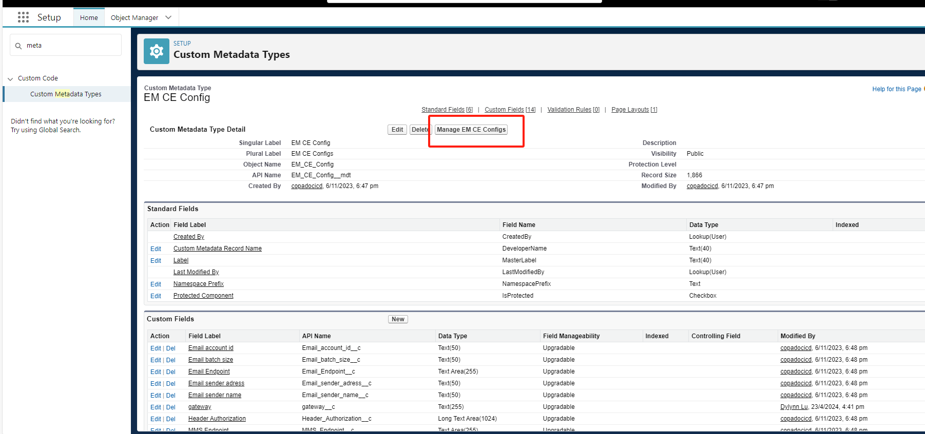

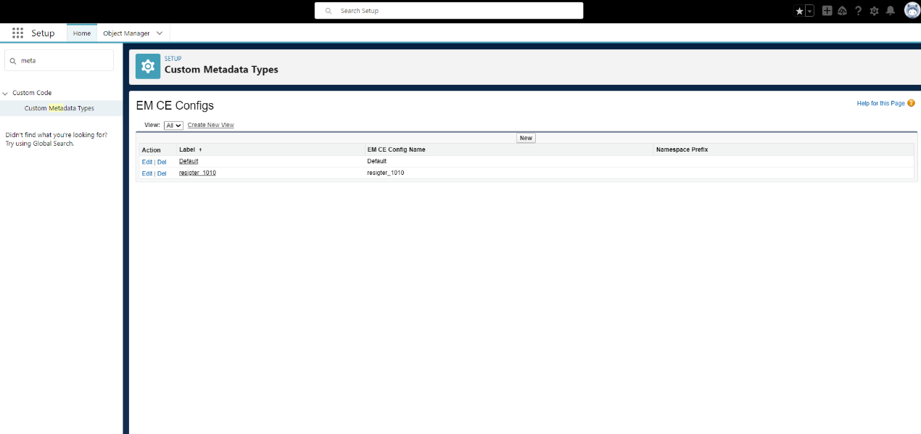

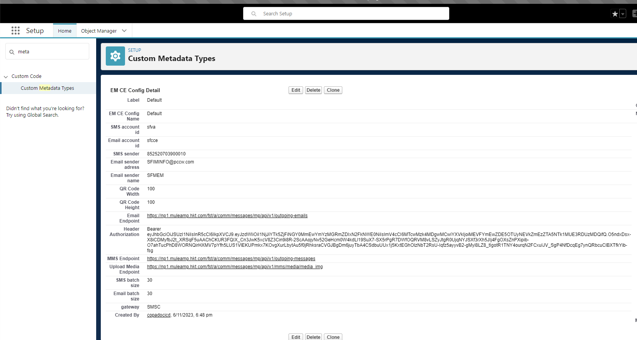

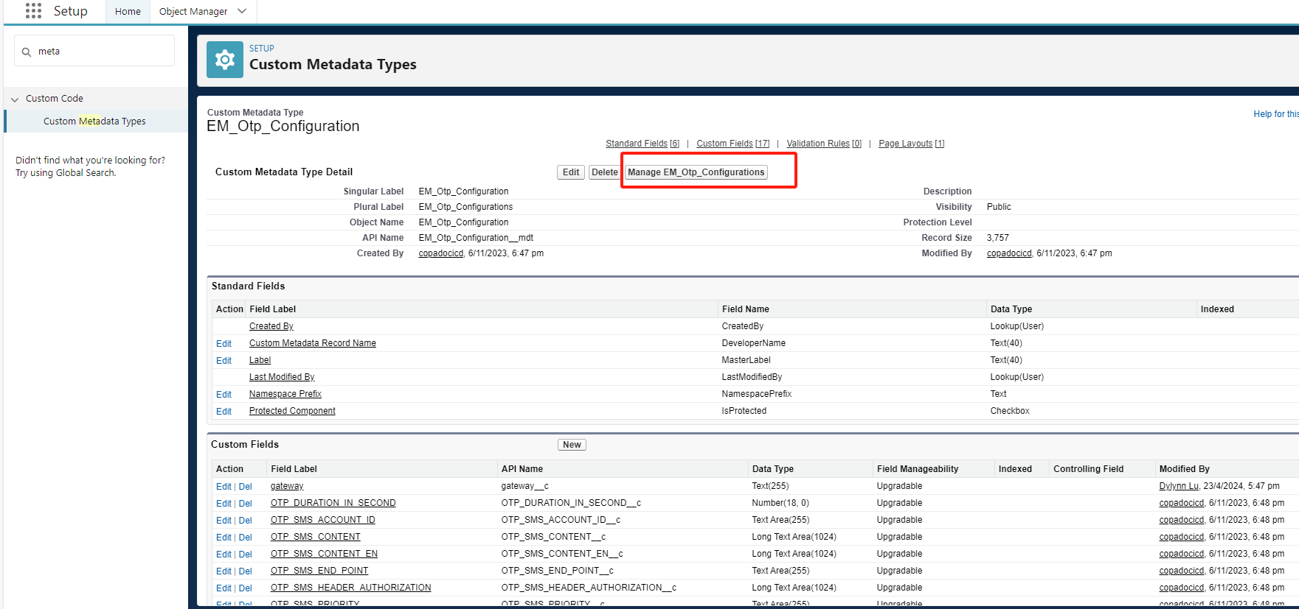

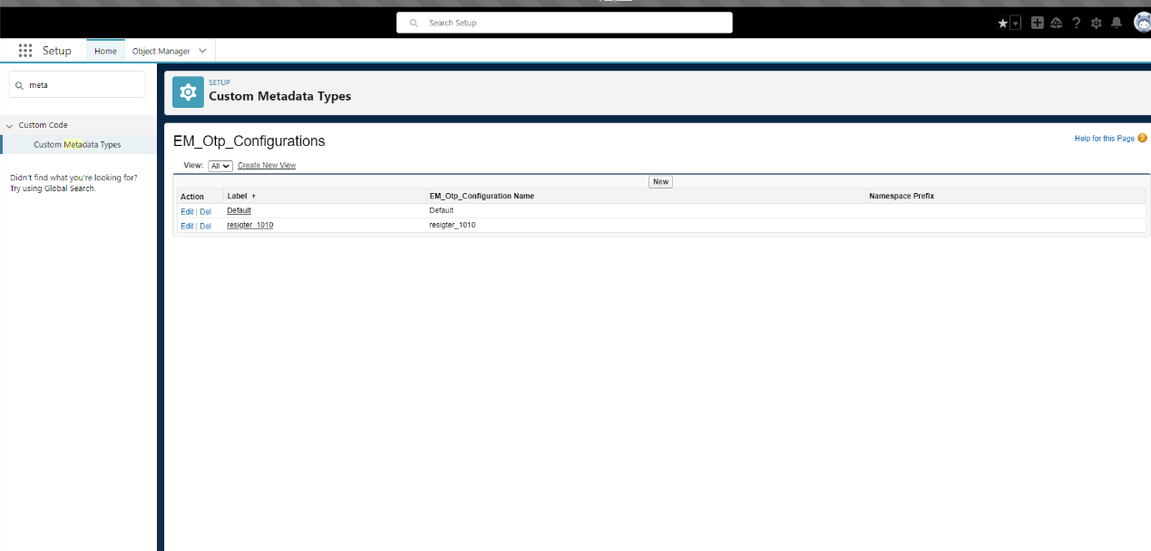

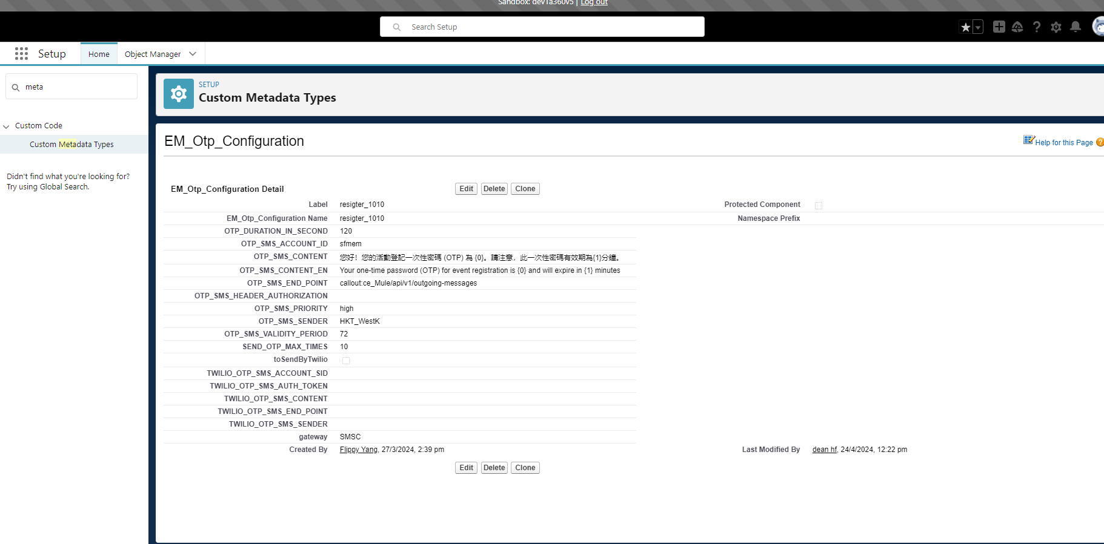

**Parent Event and child Event Configuration of Send Email restrictions:**

**1. All configurations of Send Email are only related to the parent event, that is, the configuration of the parent event determines the configuration of all last child events under the parent event.**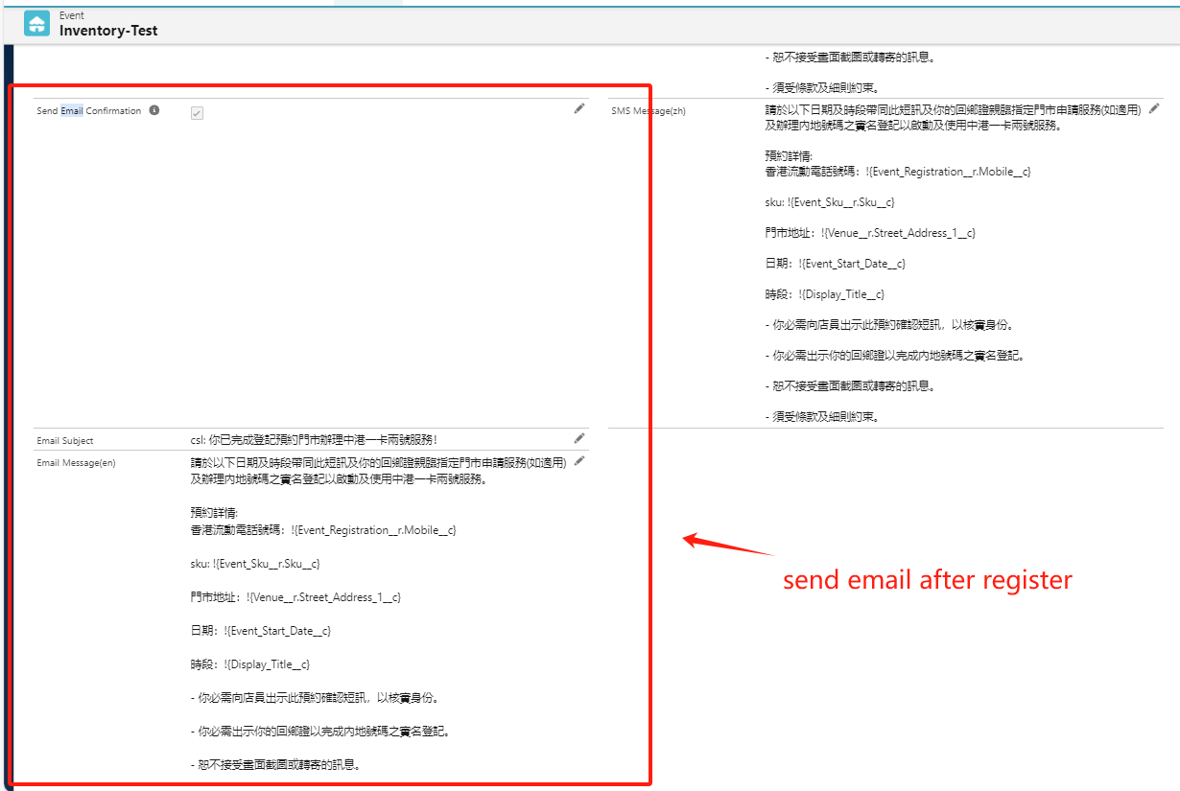





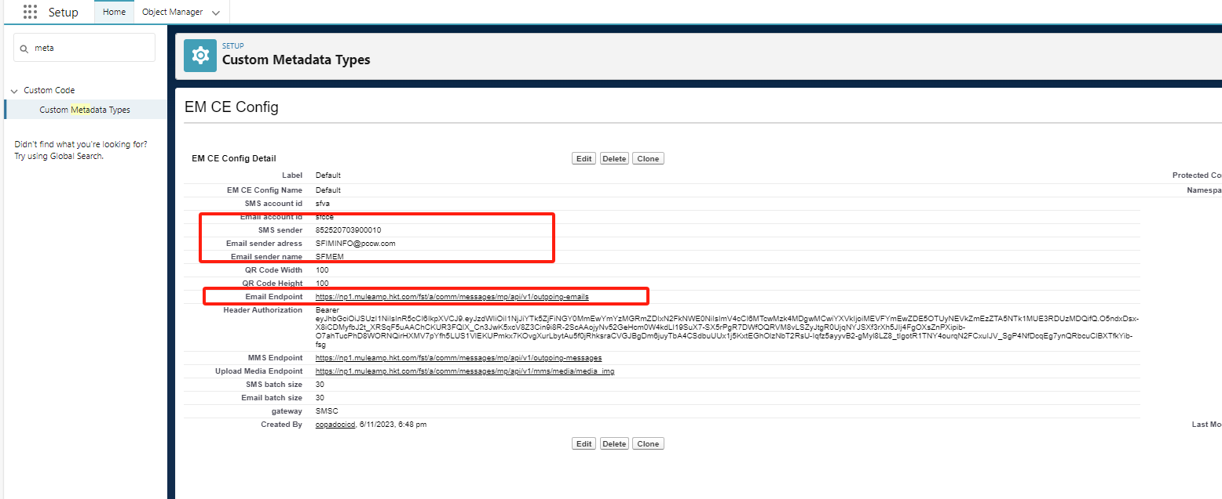

Adjust product inventory: For activities that require the purchase/reservation/gift of merchandise, etc., it is used to adjust the inventory quantity of each store.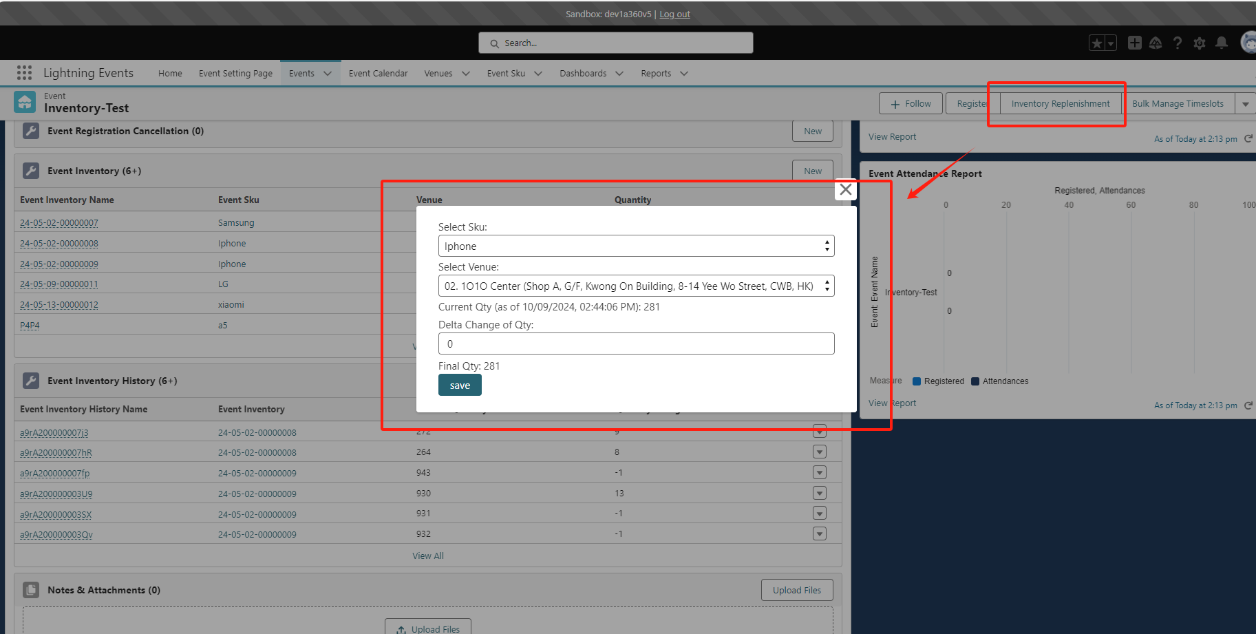

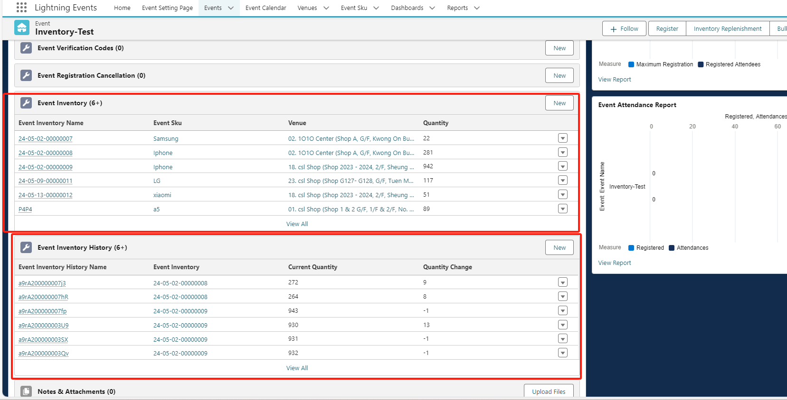

Corresponding processing logic：

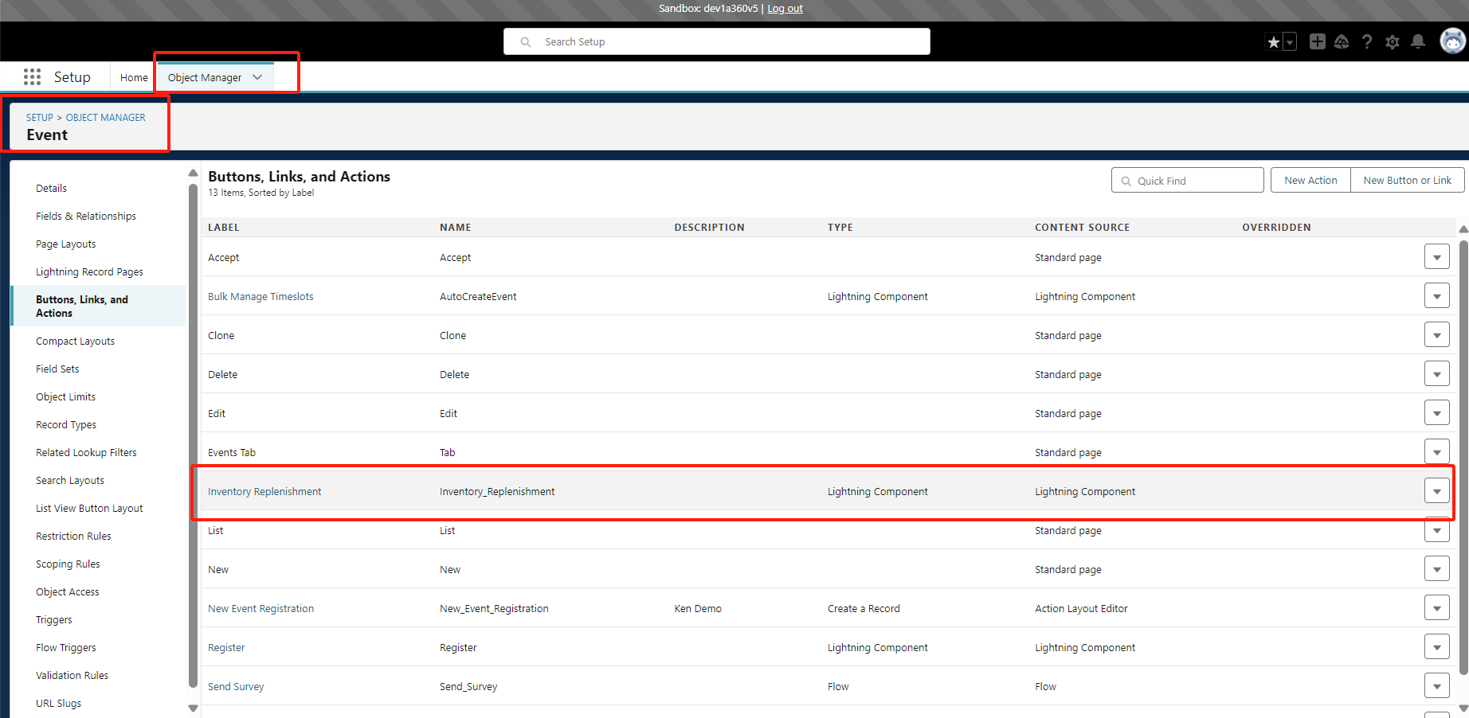

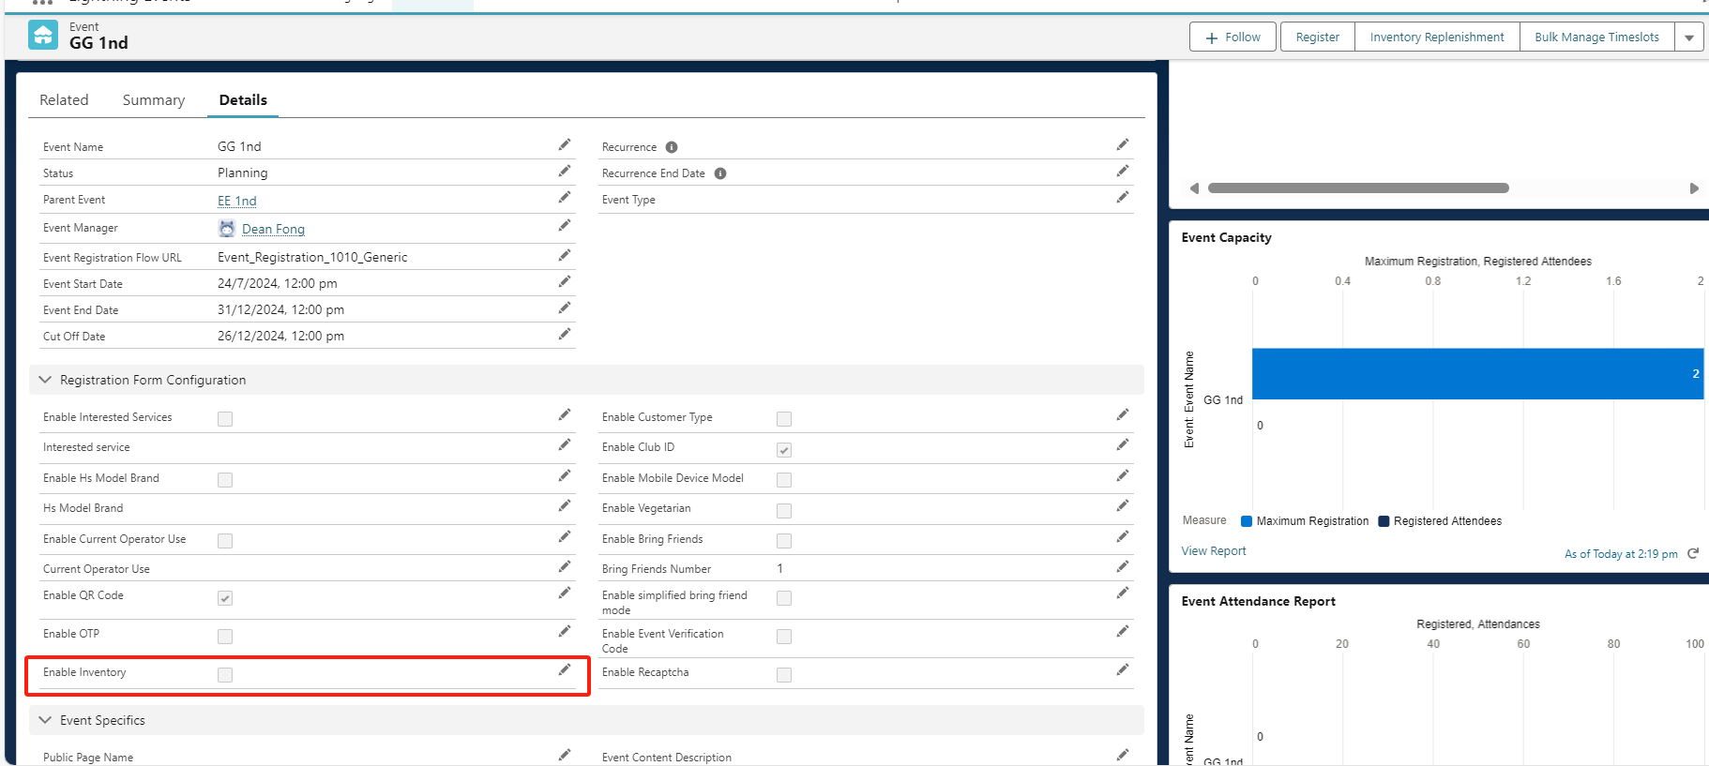

Batch creation of events: Used to quickly create or edit or delete LAST CHILD EVENTS under each PARENT EVENT in batches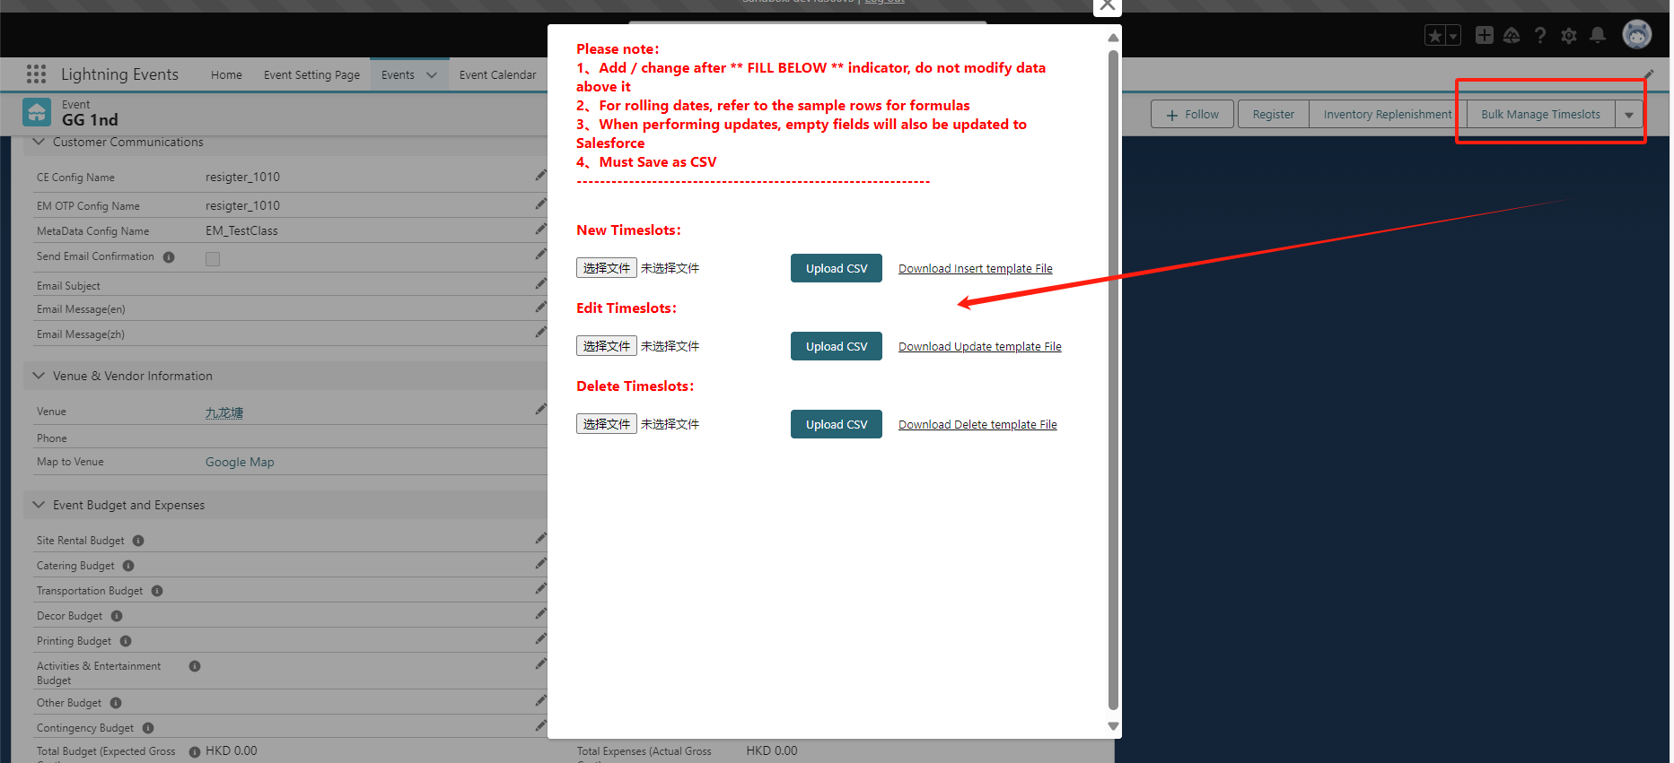

Corresponding processing logic：

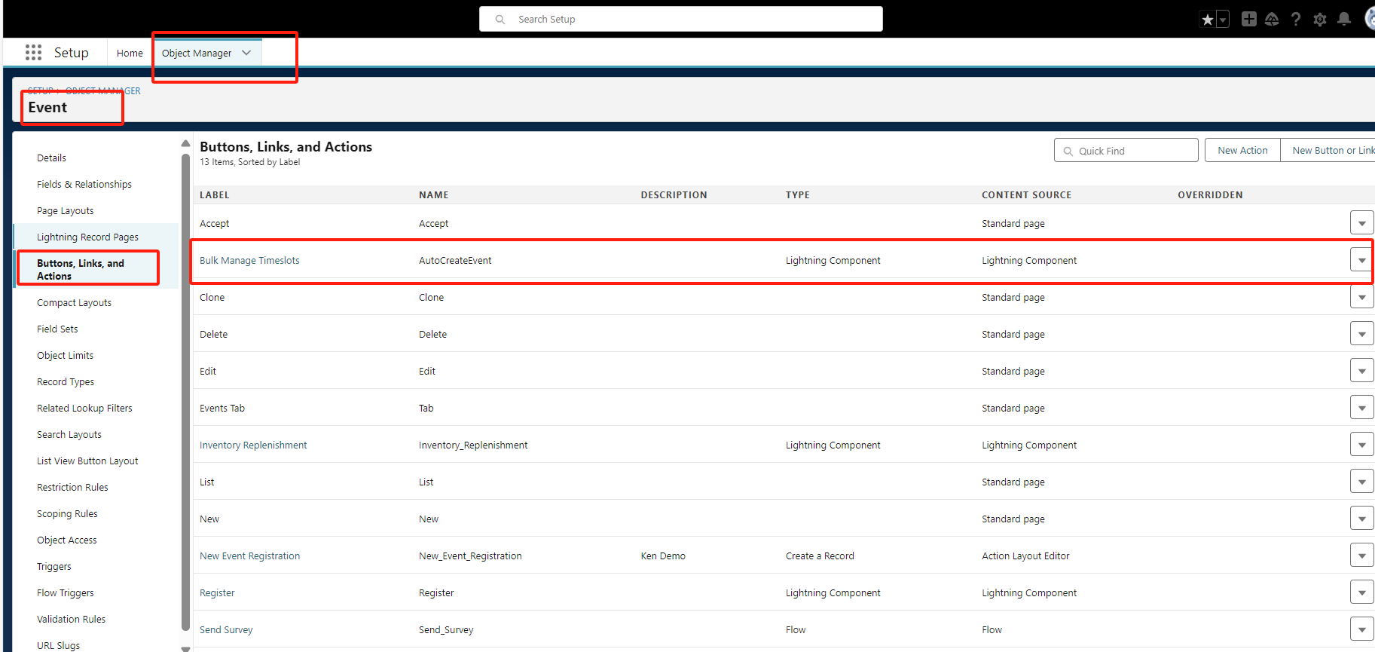

Note: This function is not yet available in the PROD environment

Function of bringing friends when users register or make reservations: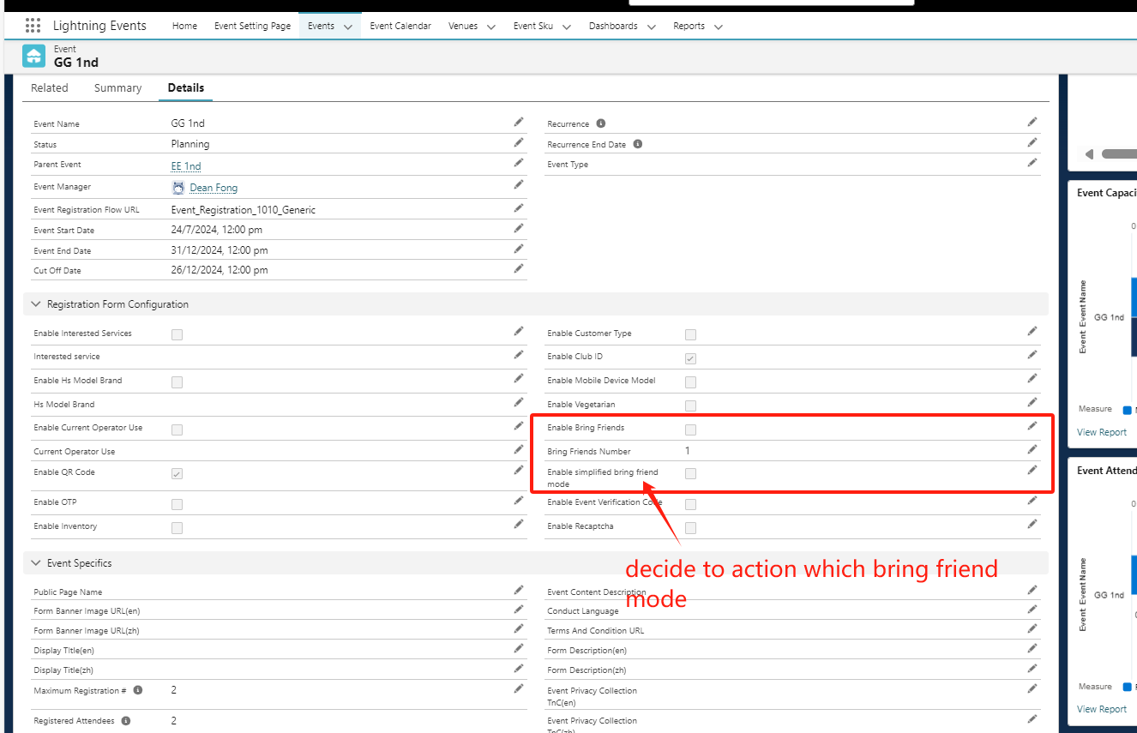

There are two ways to bring friends:

1、

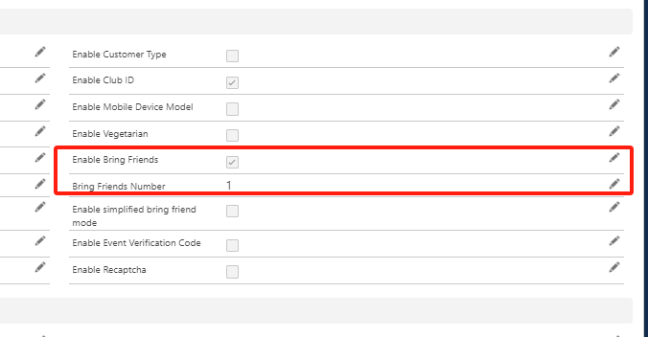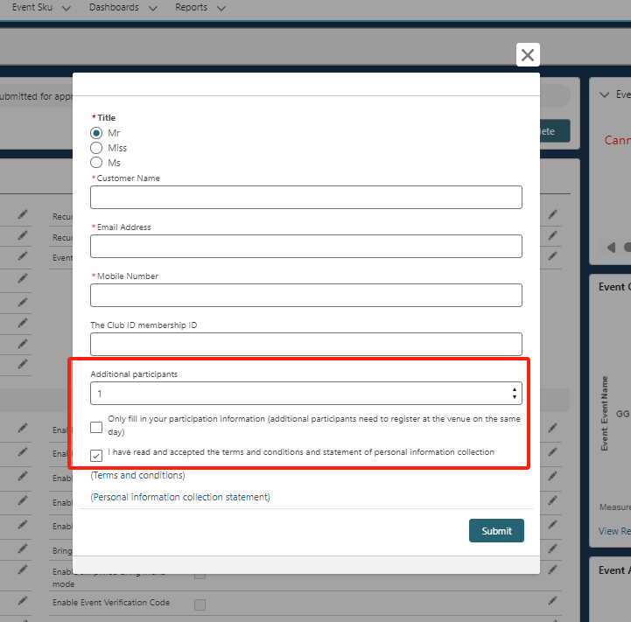

PS: If √only fill in XXXX, two null resigter records will be automatically created for the client, and then when the client arrives at the scene, the staff will fill in the corresponding infos for them.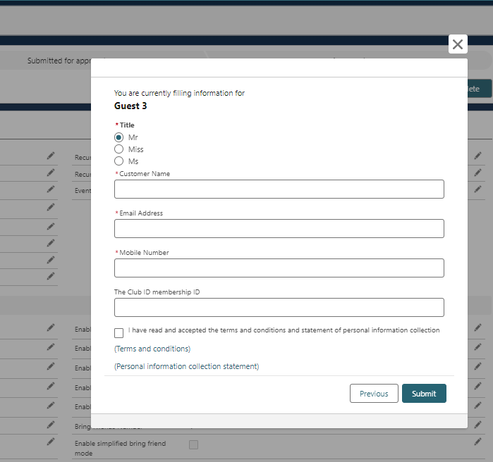

2、

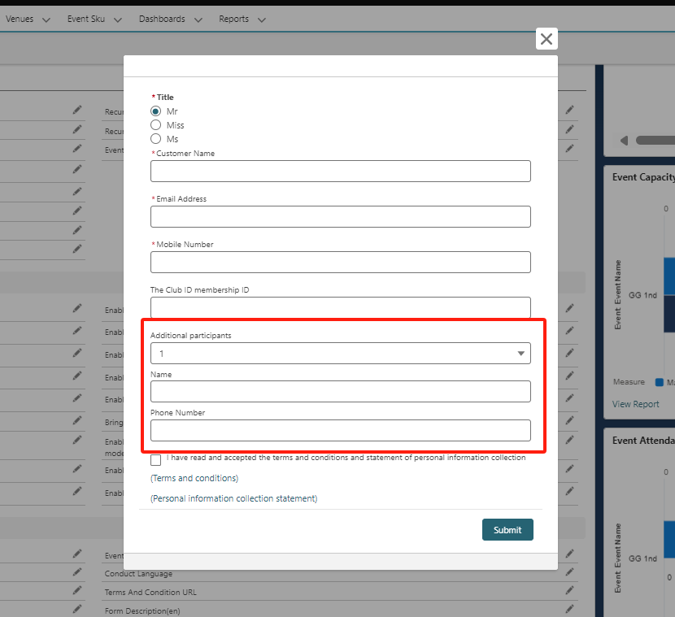

PS: If √only fill in XXXX, two null resigter records will be automatically created for the client (only refer leader info, the rest of the info is null), and then wait until the client arrives at the site, and the staff will fill in the corresponding infos for them.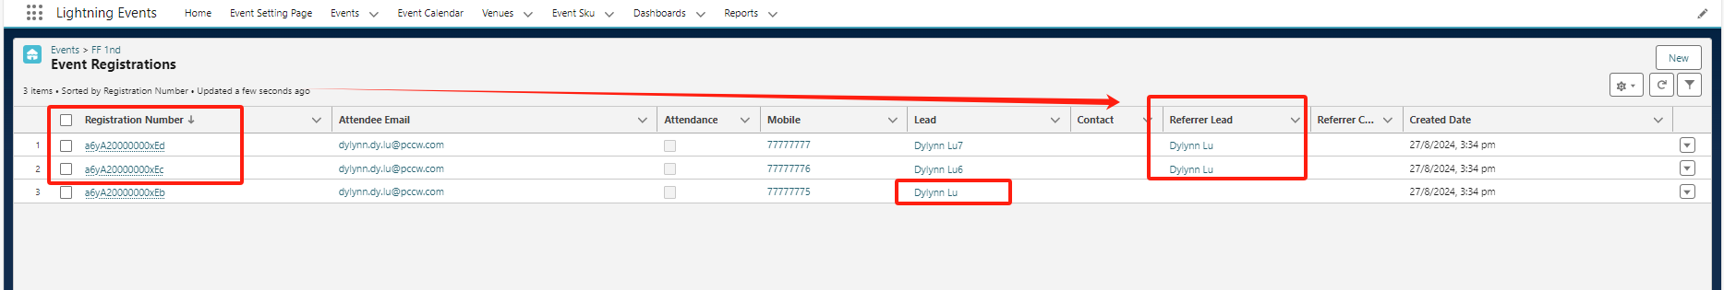

Click to enter a certain record, and then click resigter to edit the user's information, or you can directly click edit pen on the page or edit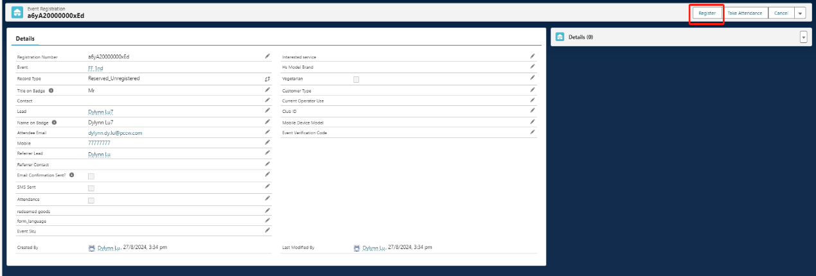

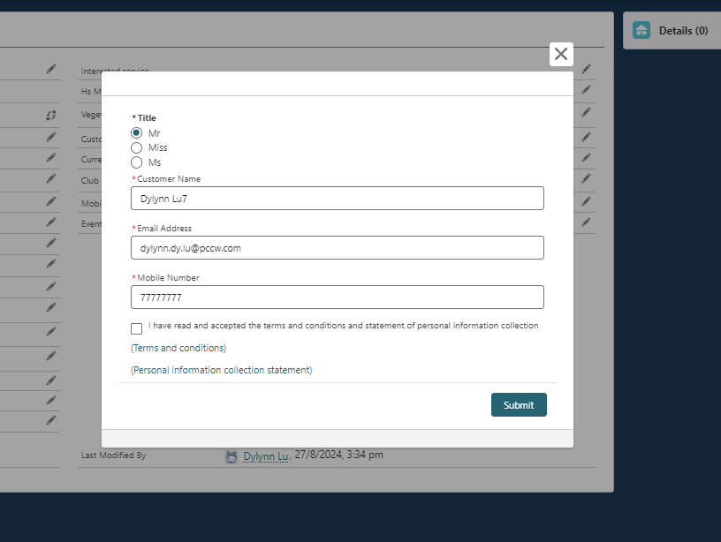

## Note: The second way to bring friends above is not yet available in the PROD environment.

# **Code explanation**

**1.flow interface code**：

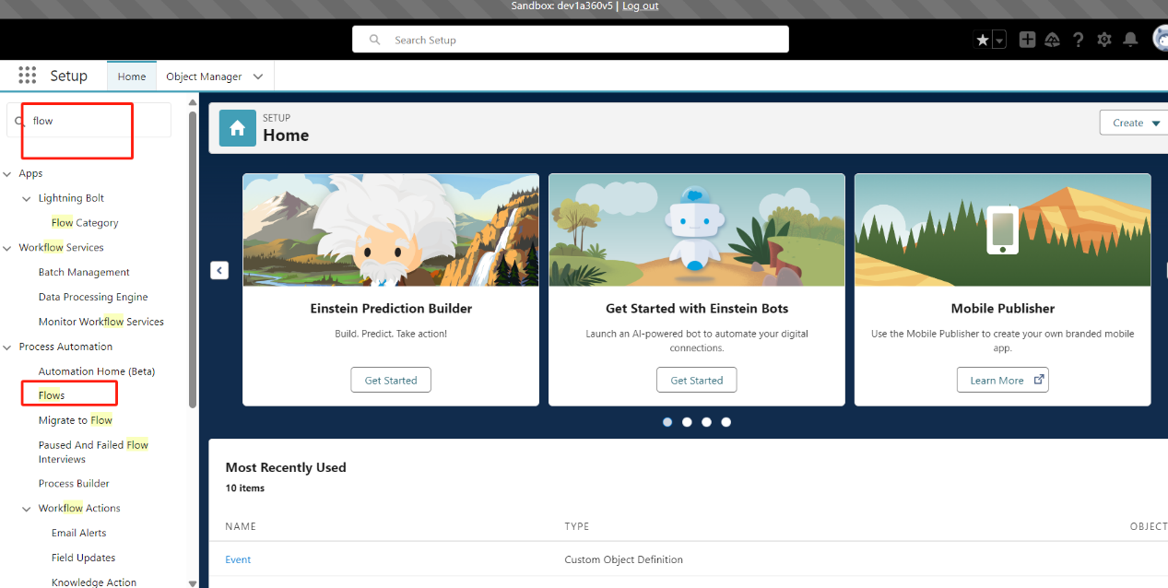

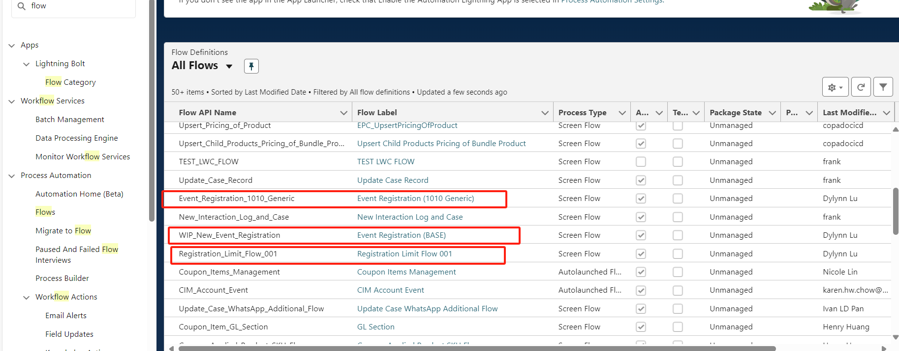

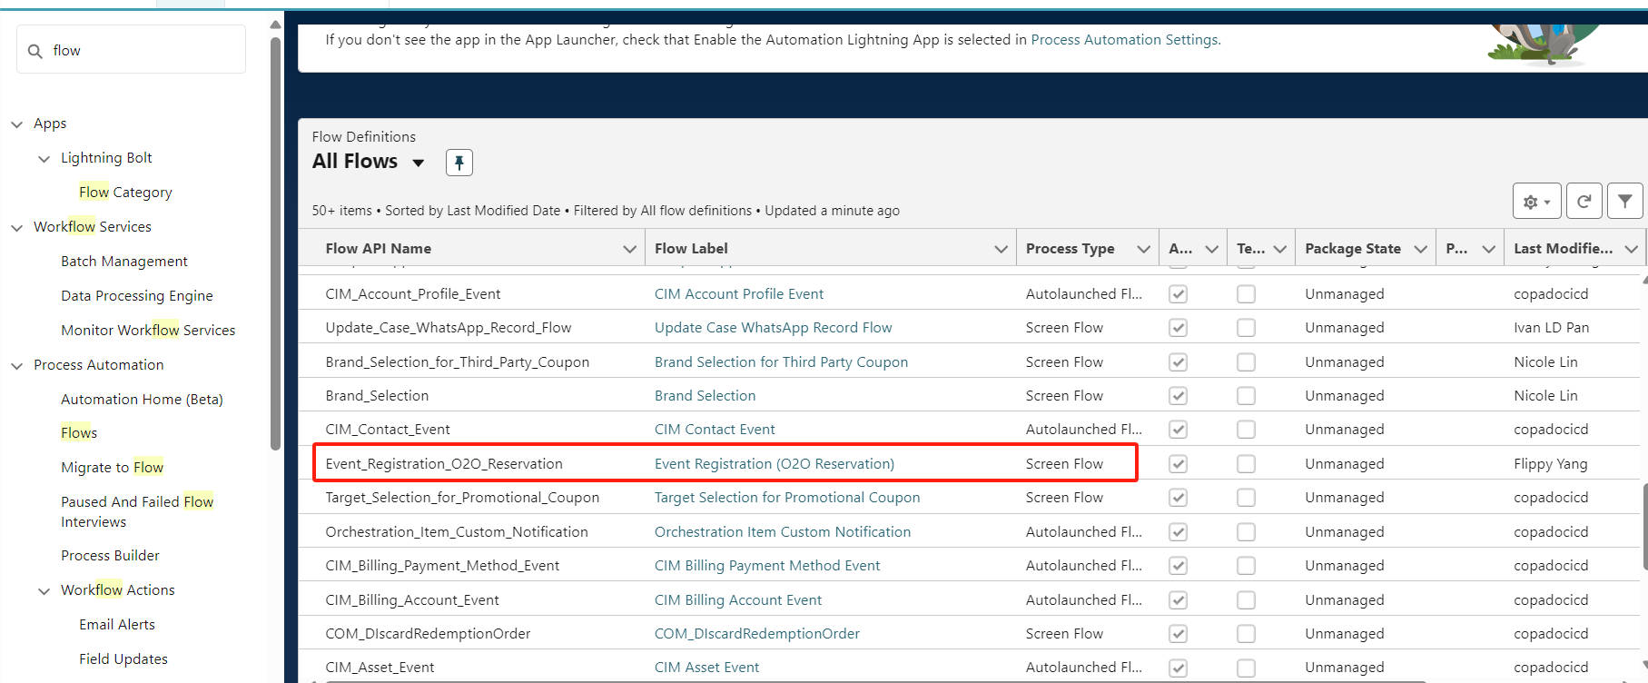

The first layer flow: Event_Registration_1010_Generic, Event Registration (O2O Reservation), the basic logic of the two flows is the same, the difference is that the upper layer business is different

The second layer: Registration Limit Flow 001, mainly used to judge and limit One registration per person-----》Maximum Session Number-------》SelectedEvent.Maximum_Registration__c-------》Maximum Times , Maximum Times In Period, Maximum Absence Times

Maximum_Times-----》Maximum Times In Period-------》Maximum_Absence_Times__c settings of these parameters (see page 6 Parent Event and child Event for details on registration restrictions)

The third layer: Event Registration (BASE), which is mainly used to determine whether there are duplicates in the database based on the user's mobile phone, and to perform data storage and other operations.

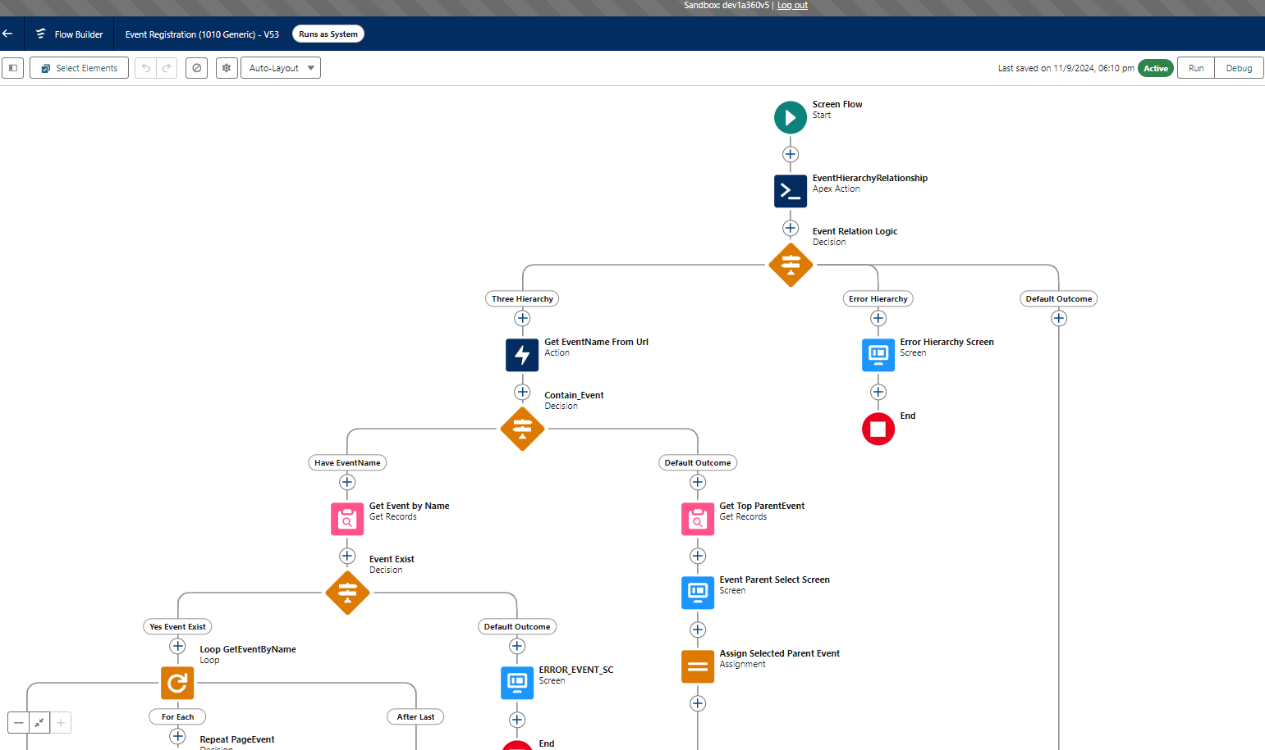

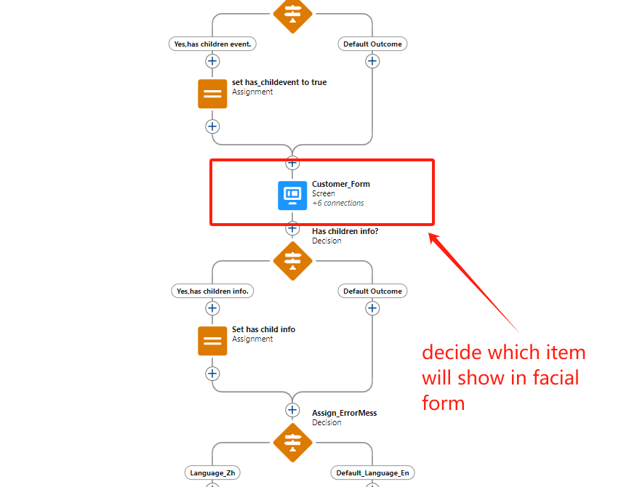

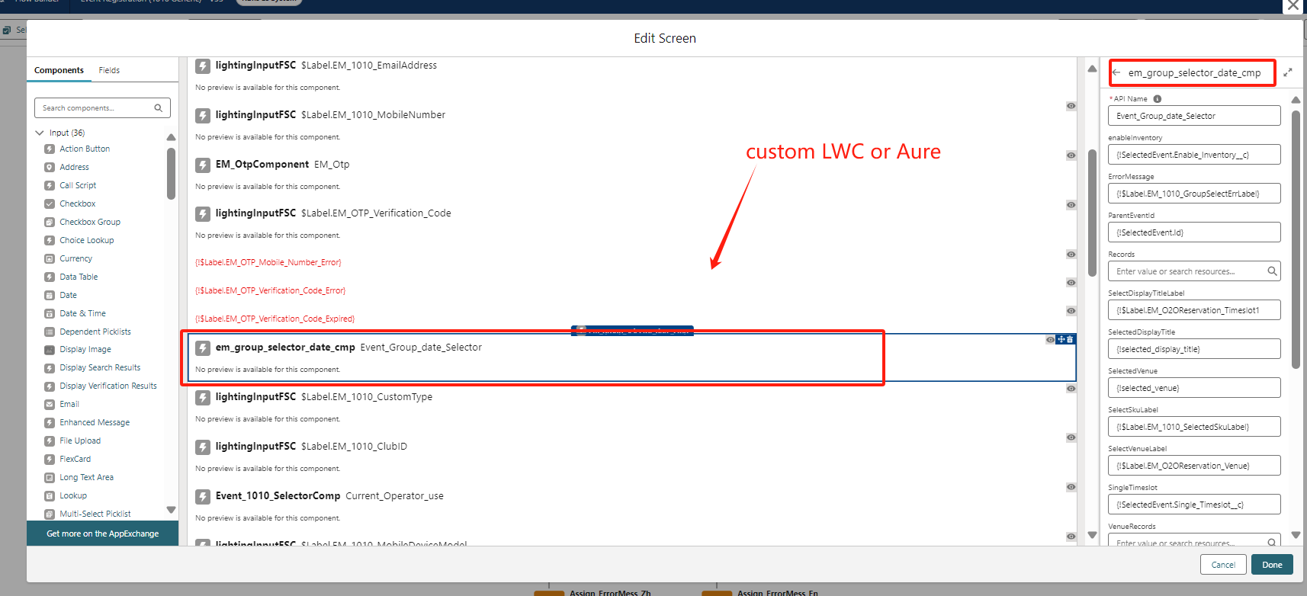

**2.flow component (LWC or Aure code)**

Project address:[**ruby / CSS / Marketing Events Management · GitLab (pccw.com)**](https://egit.btu.pccw.com/ruby/css/marketing-events-management)

Vscode installation plug-in: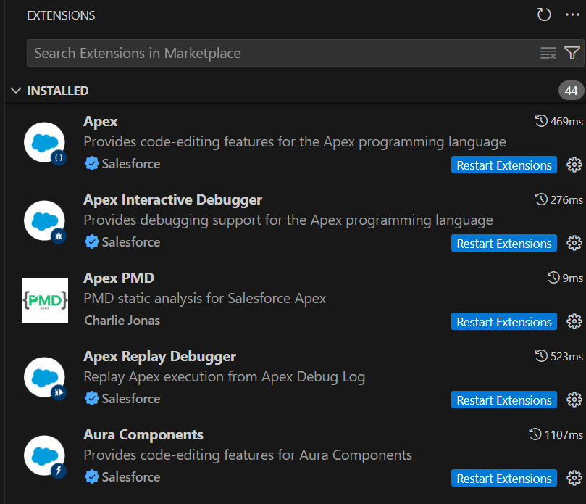

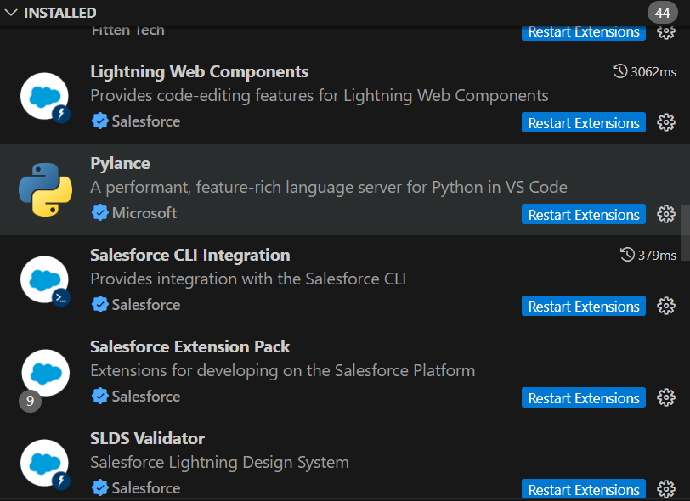

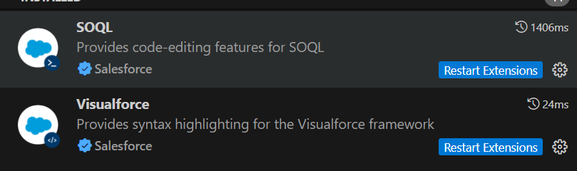

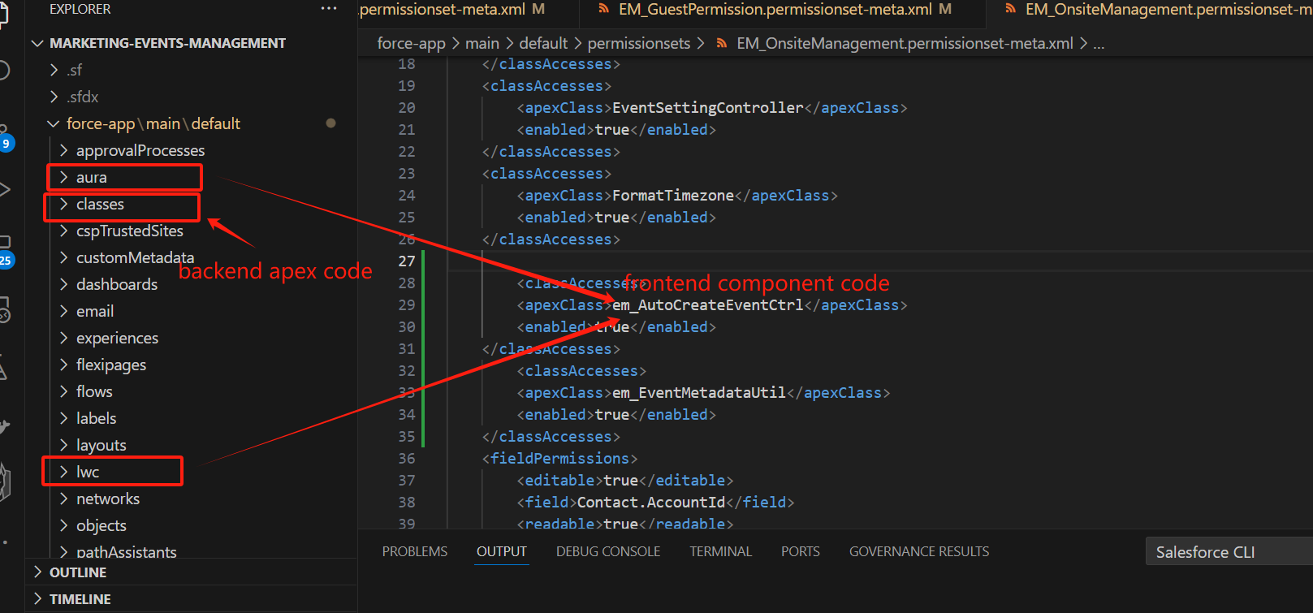

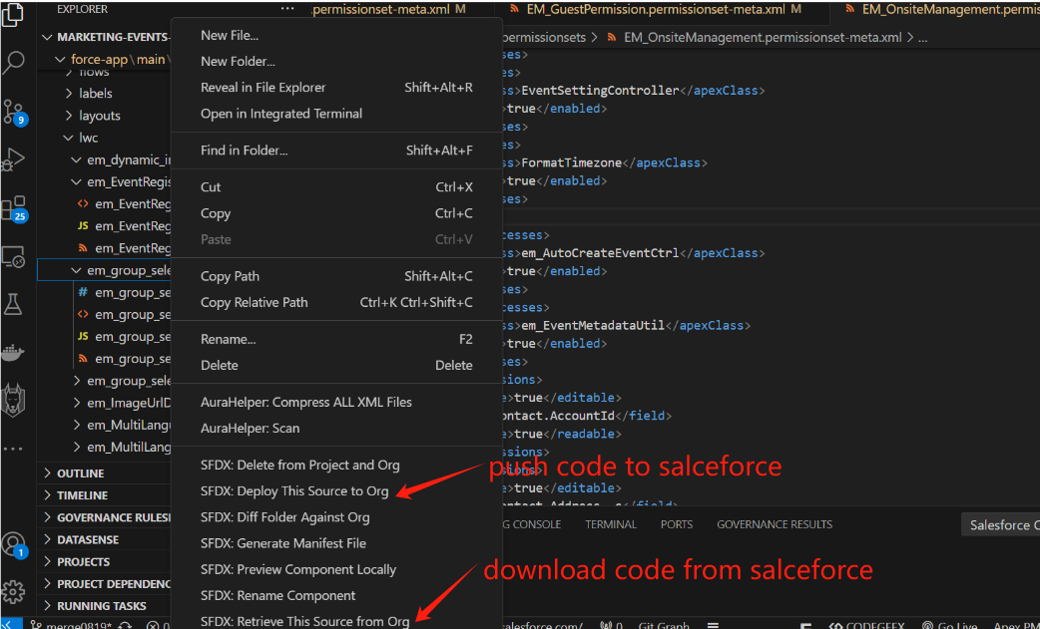

**3.Apex class**

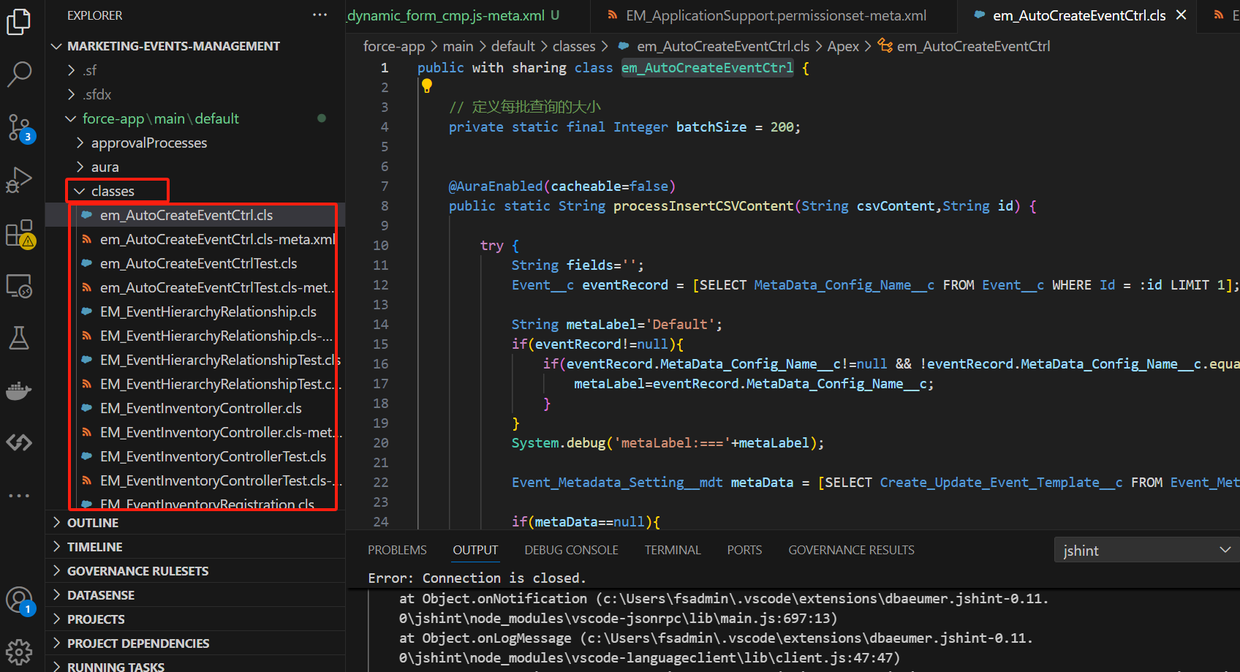

Note that each new class must create a corresponding new test, and ensure that each class must pass the test, and the coverage rate must reach 80% before it can be pushed to the uat environment. You can run test in the devconsole of dev360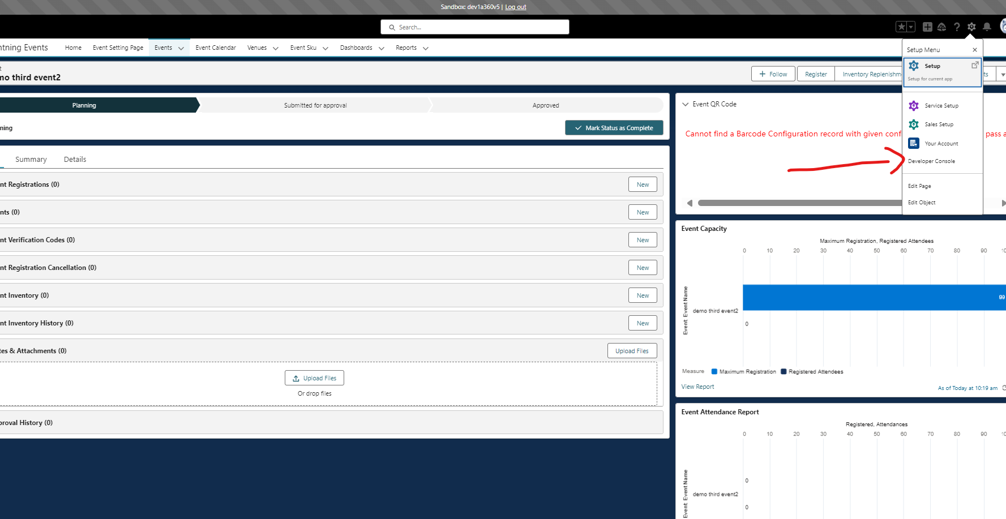

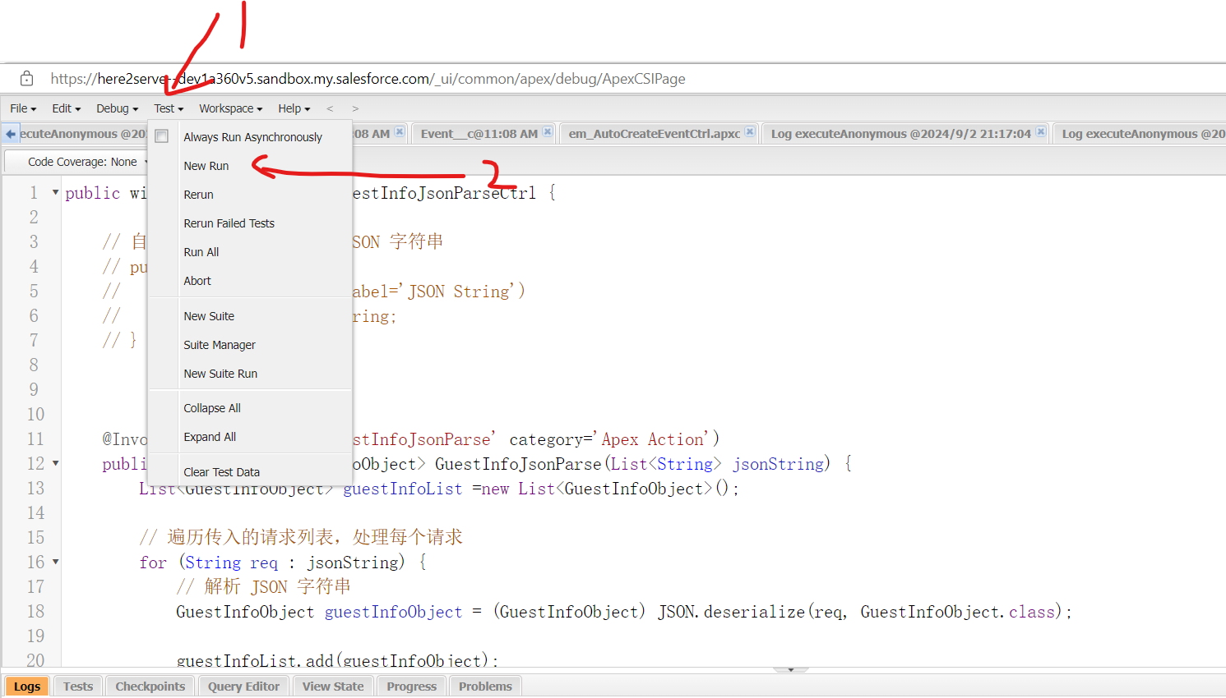

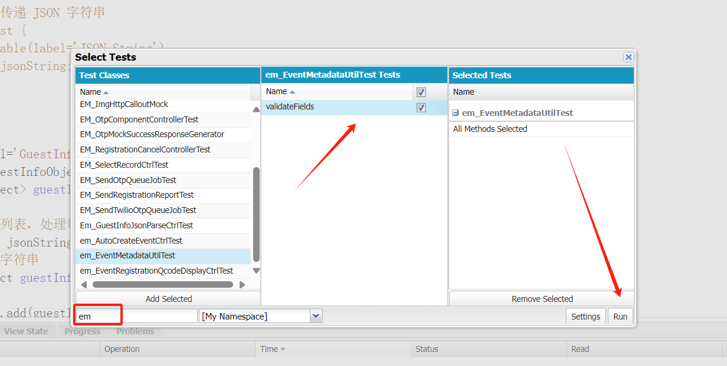

Wait for it to run. If it finishes, next: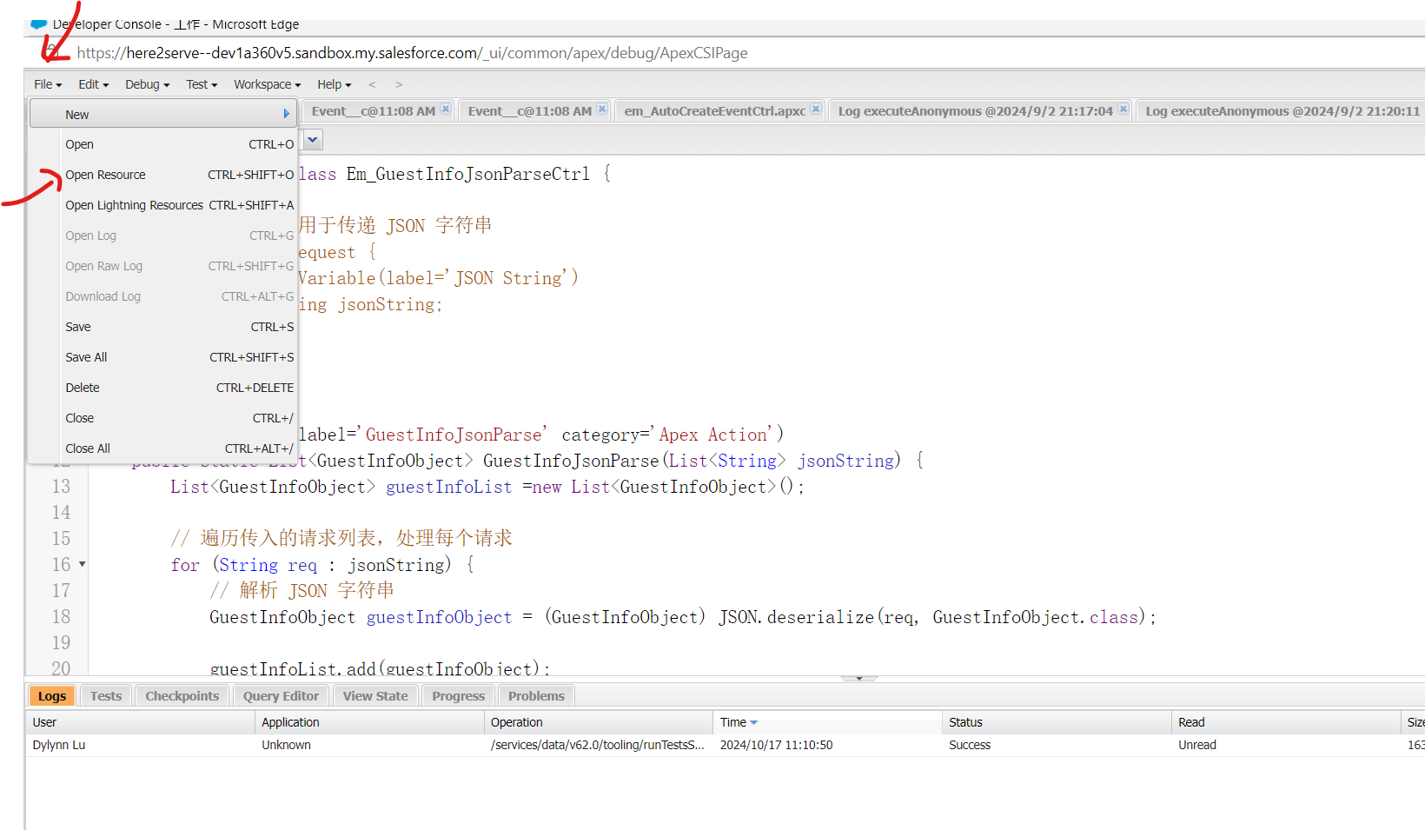

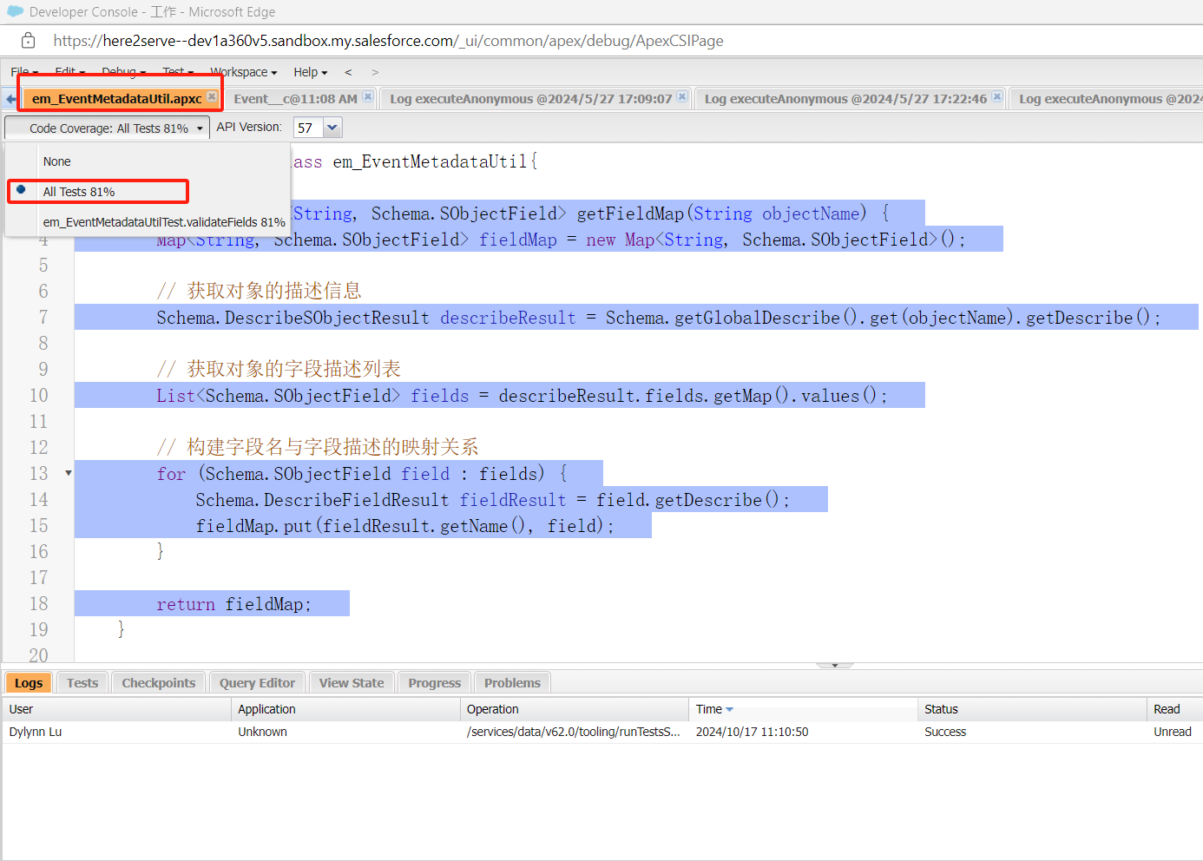

**4.table object**

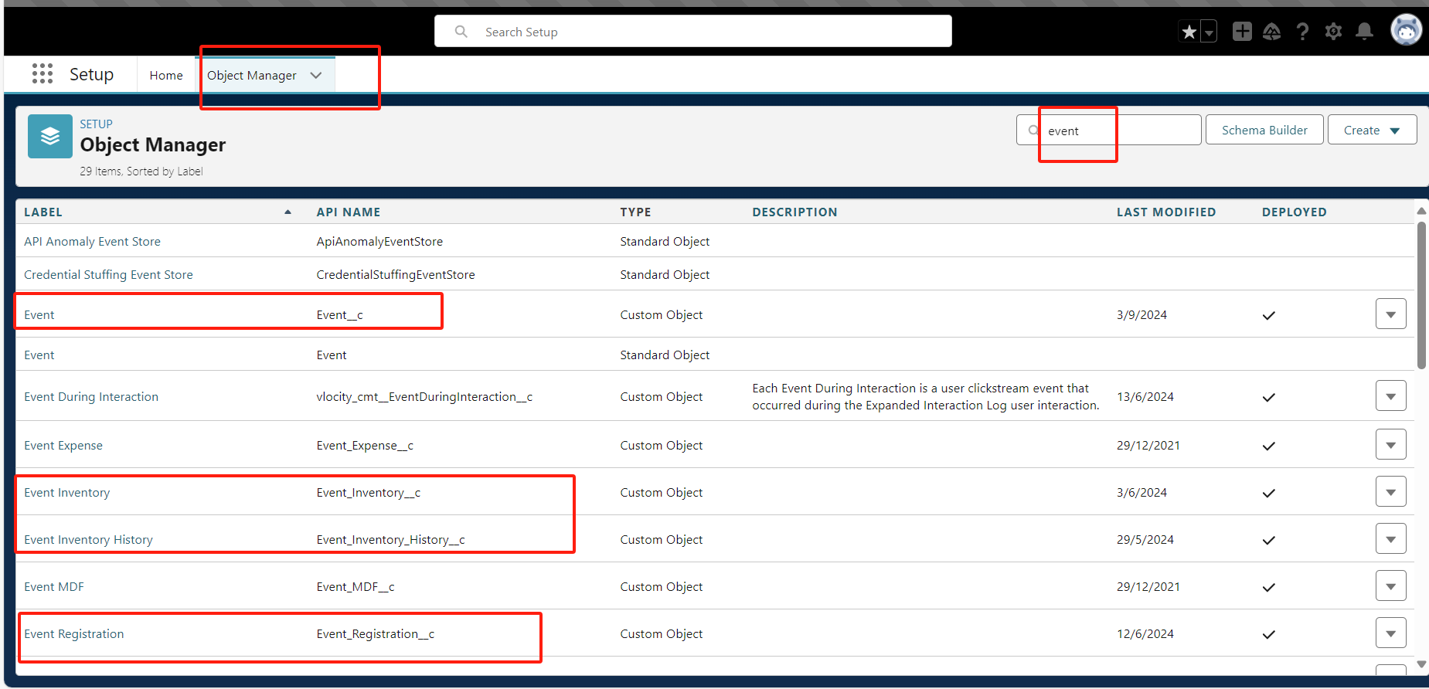

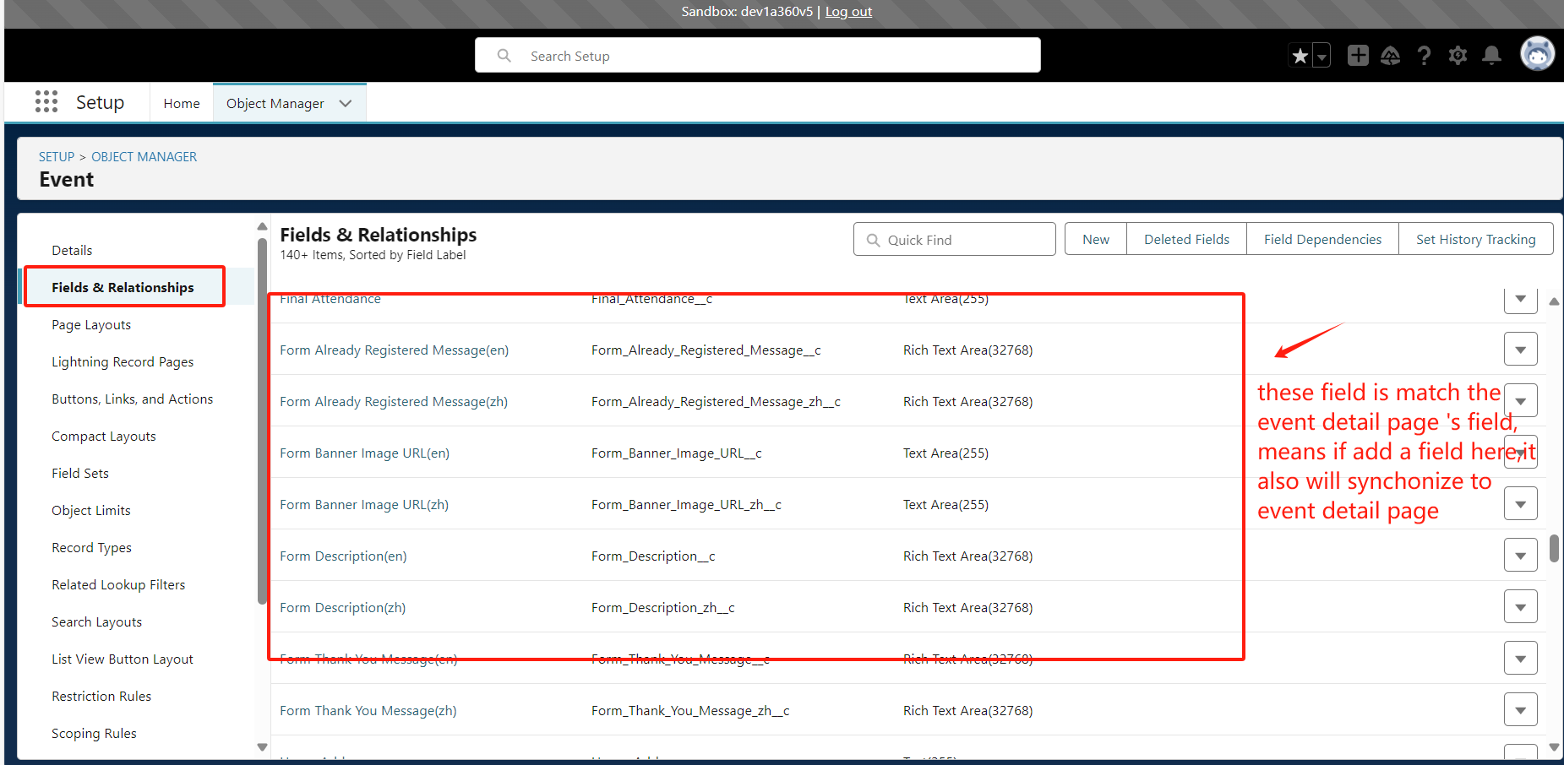

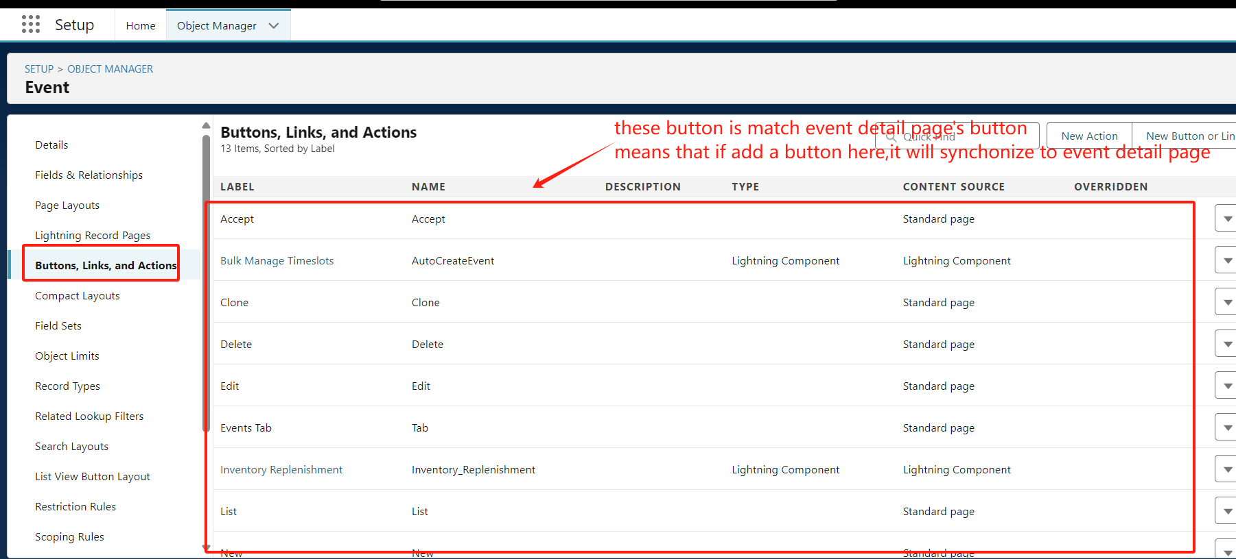

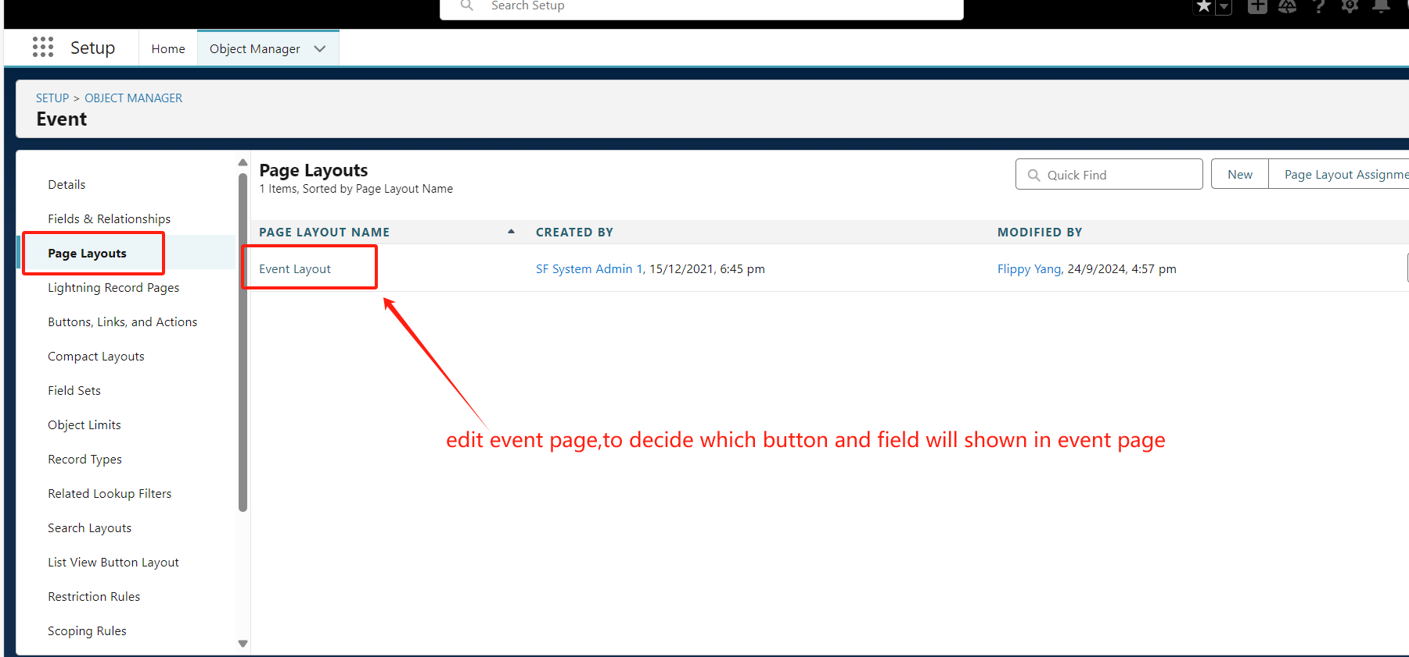

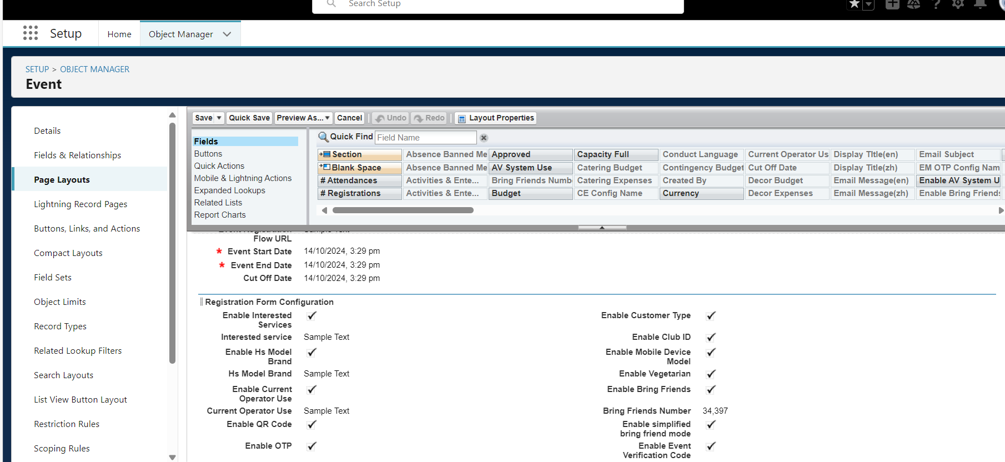

Venue：

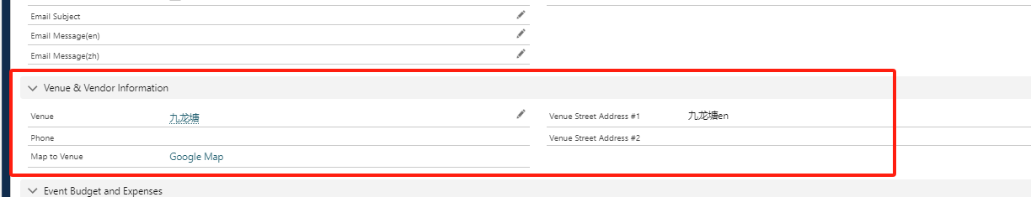

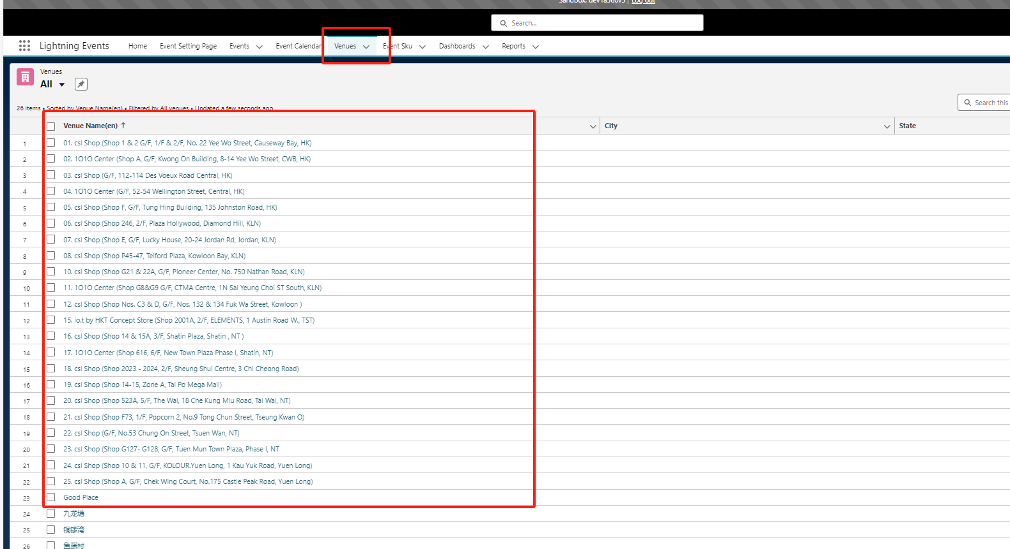

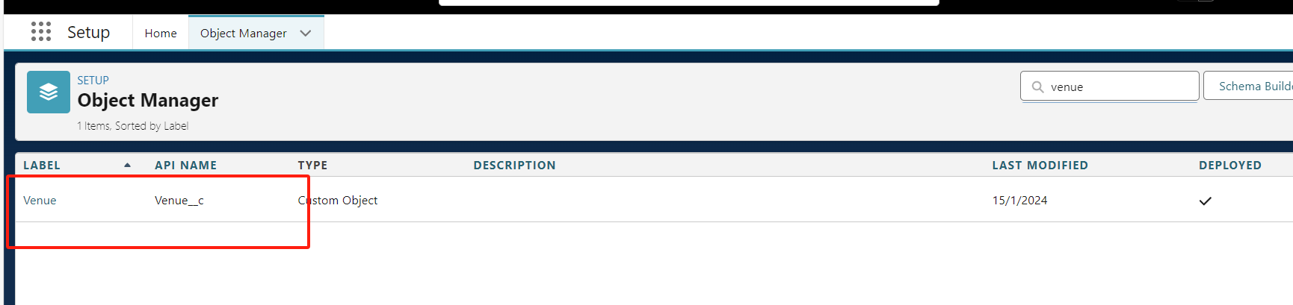

**5.SMS and email**

在form注册后的短信和邮件都是通过调用apex代码发出去的，具体代码如下：

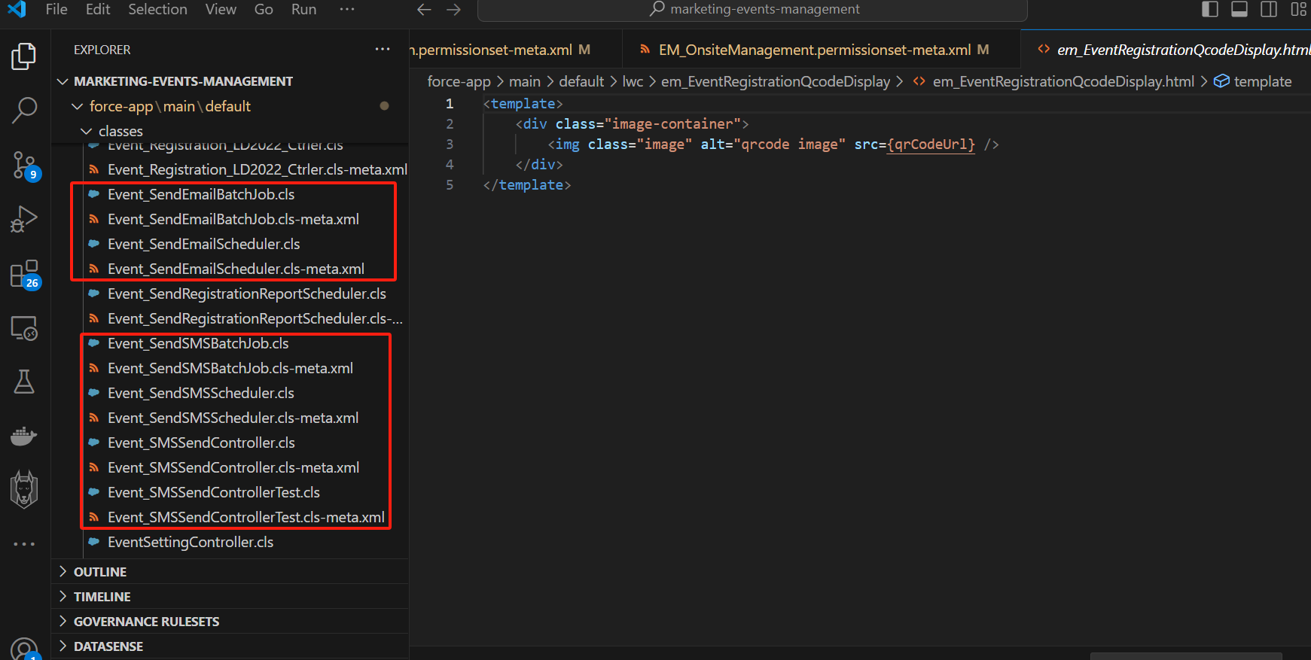

You can use the following code to manually control the start and stop of sending text messages and emails in the devconsole:

//停止email

String SCHEDULED_JOB_NAME = 'Event_SendEmailBatchJob_Recurring';

List<CronTrigger> cts = [SELECT Id FROM CronTrigger WHERE CronJobDetail.Name =: SCHEDULED_JOB_NAME];

if (cts.size() > 0) {

// Aborts the existing job (which was already completed)

system.abortJob(cts[0].Id);

}

//启动email

EM_CE_Config__mdt[] emConf = [SELECT Email_batch_size__c FROM EM_CE_Config__mdt];

Database.executeBatch(new Event_SendEmailBatchJob(),integer.valueOf(emConf[0].Email_batch_size__c));

//停止sms

String SCHEDULED_JOB_NAME = 'Event_SendSMSBatchJob_Recurring';

List<CronTrigger> cts = [SELECT Id FROM CronTrigger WHERE CronJobDetail.Name =: SCHEDULED_JOB_NAME];

if (cts.size() > 0) {

// Aborts the existing job (which was already completed)

system.abortJob(cts[0].Id);

}

//启动sms

EM_CE_Config__mdt[] emConf = [SELECT SMS_batch_size__c FROM EM_CE_Config__mdt];

Database.executeBatch(new Event_SendSMSBatchJob(),integer.valueOf(emConf[0].SMS_batch_size__c));

**6.report**

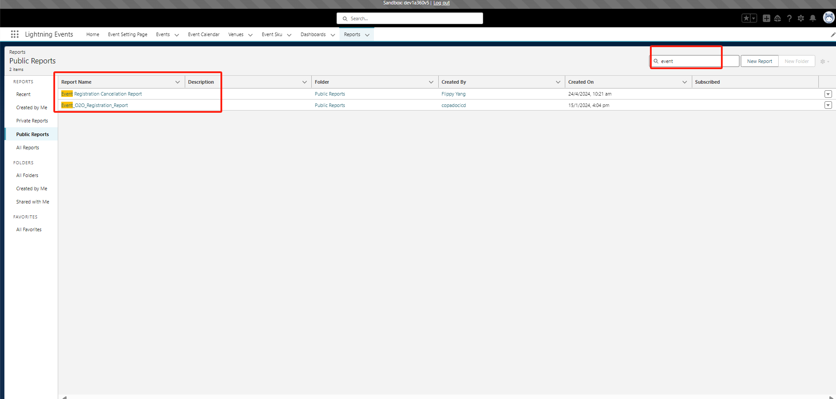

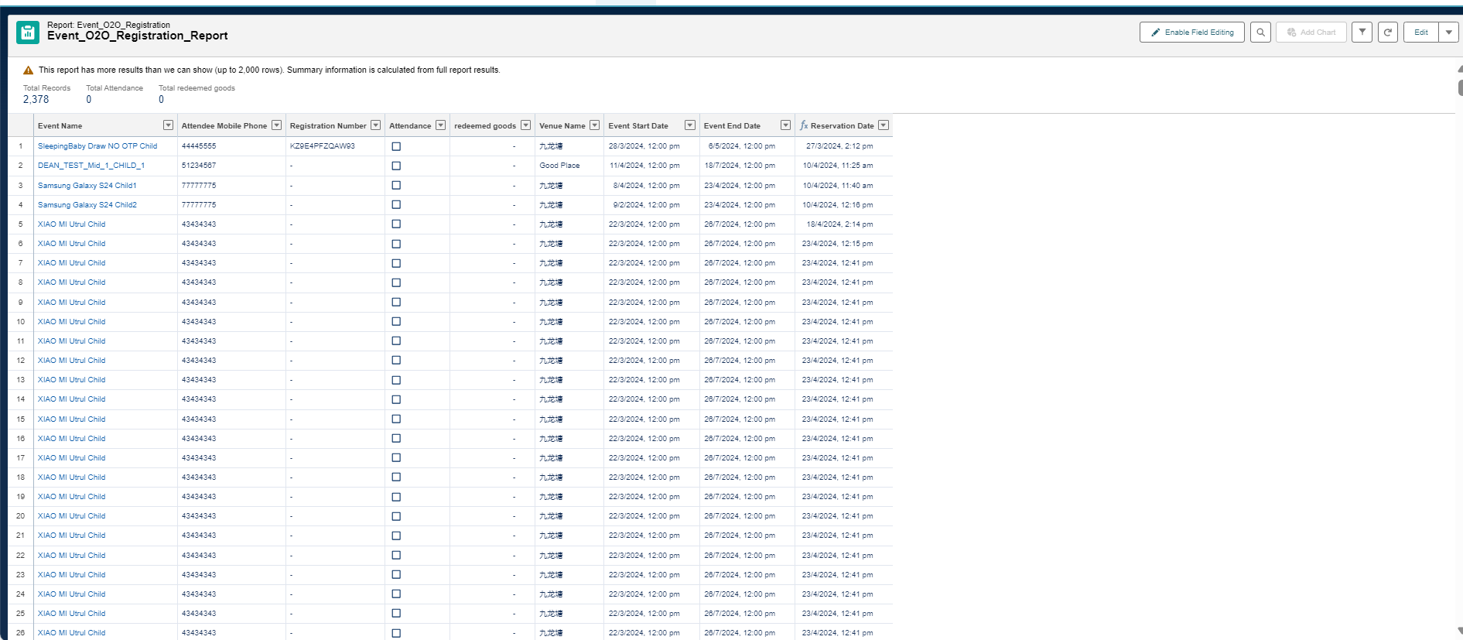

**How to configure report:**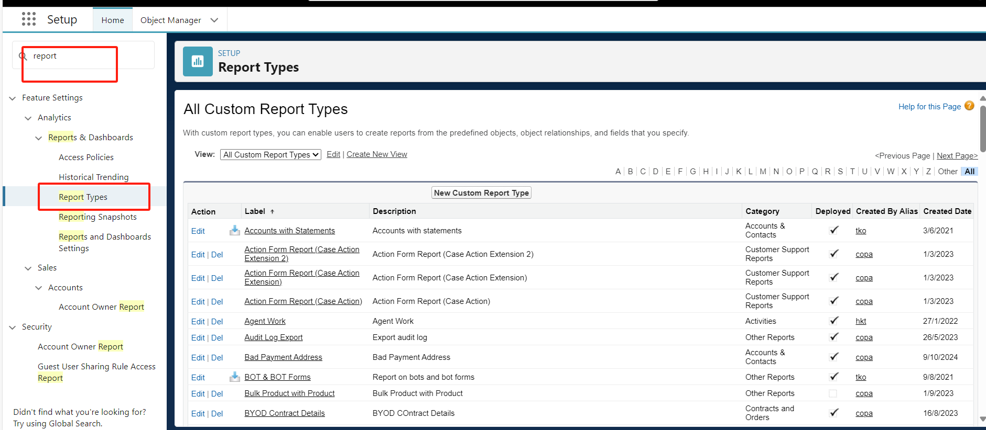

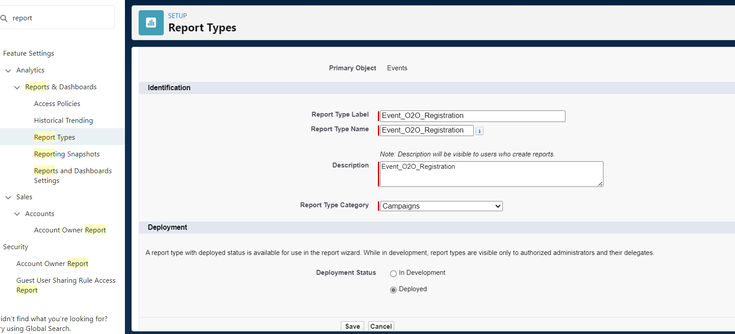

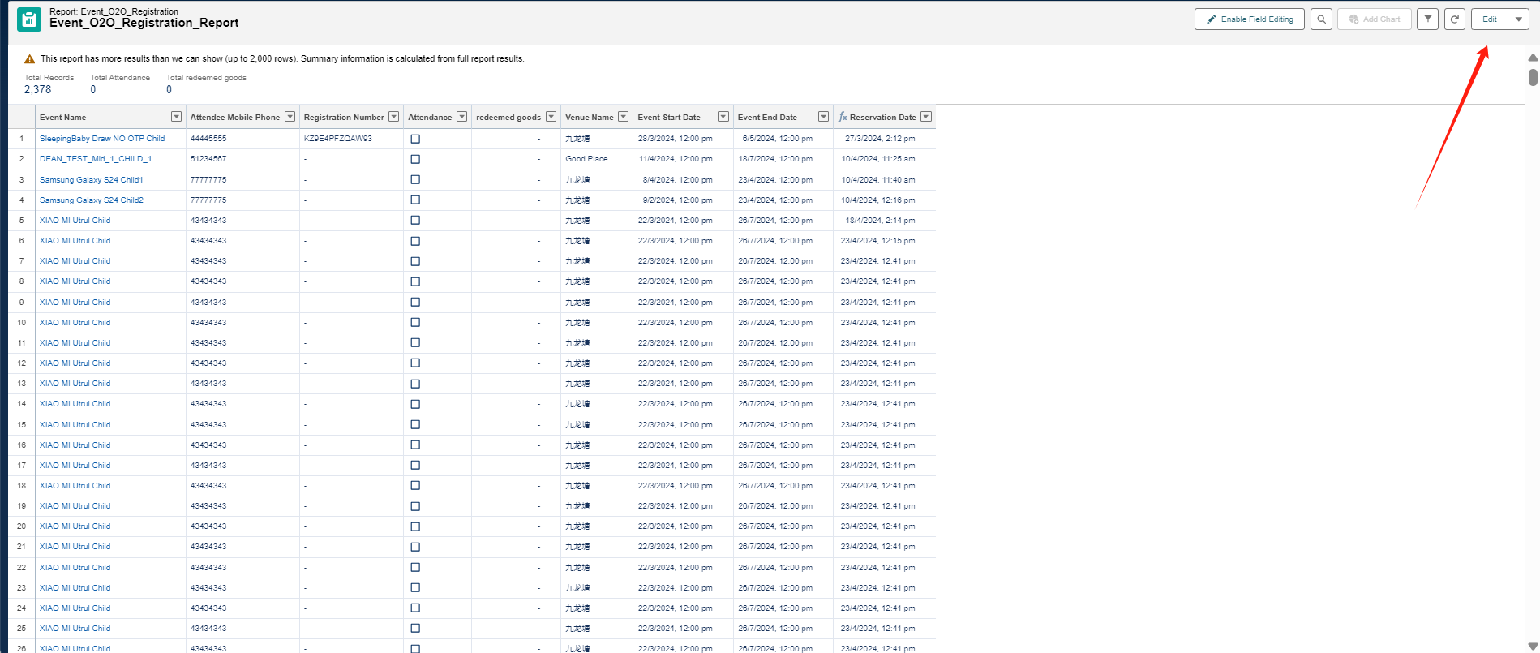

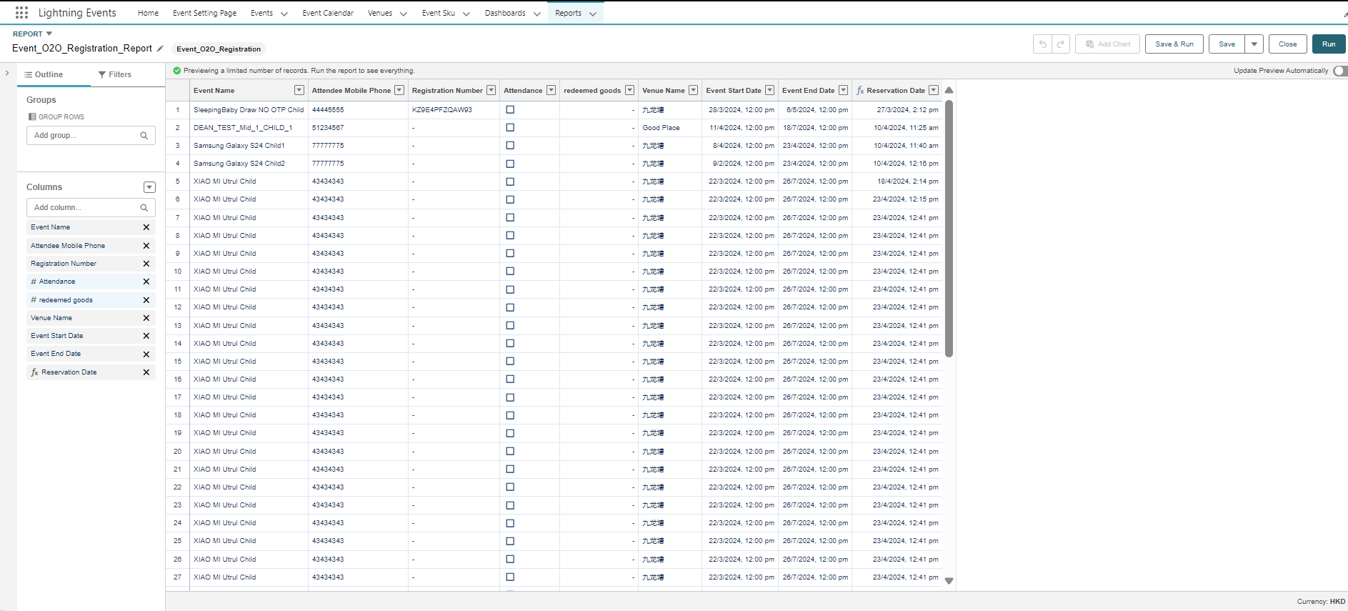

**7.Permissions**

7.1. Add these permission sets to your profile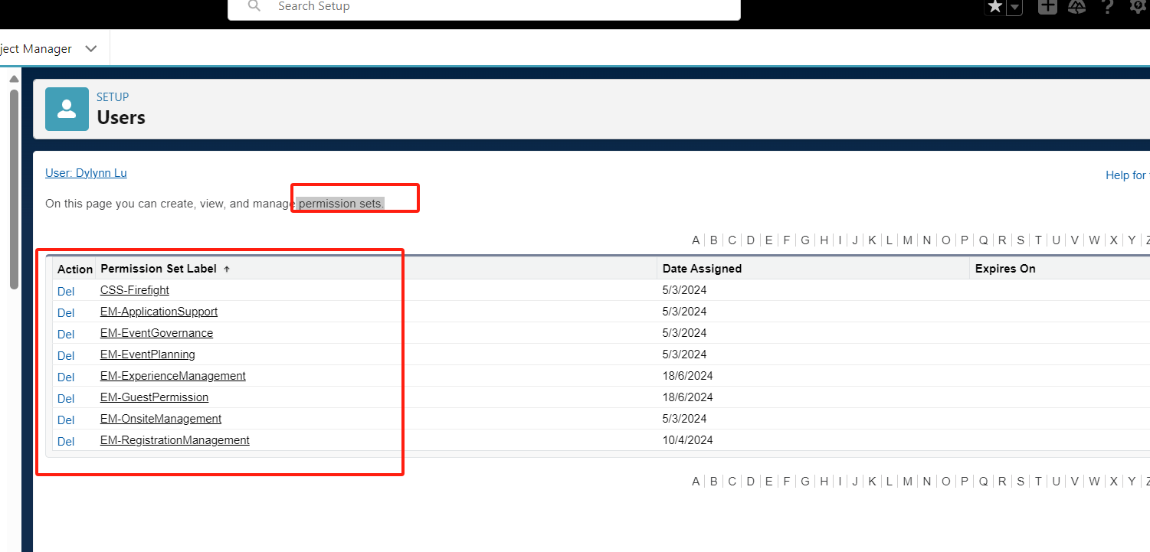

7.2. Every time you wait for Object new in event Object or add a new apex class, you need to apply edit and read permissions in the above permissions.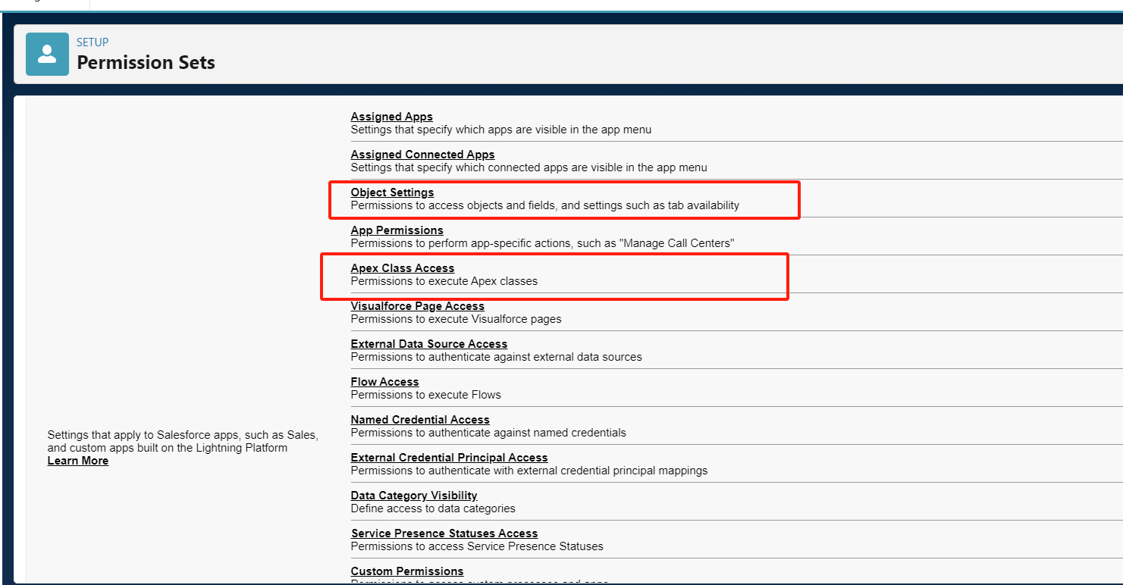

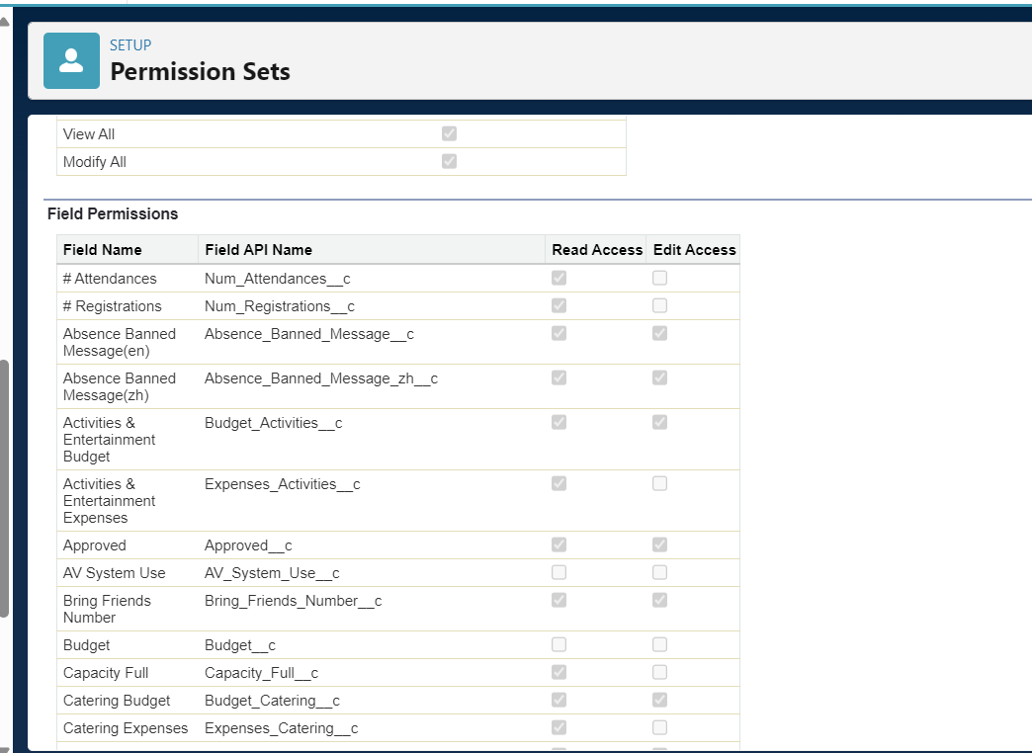

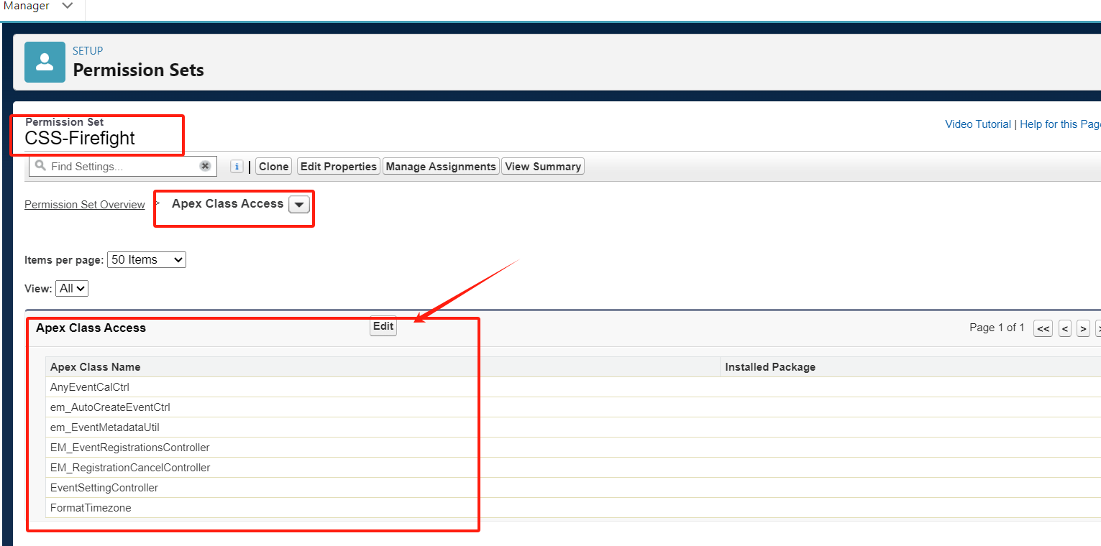

Note: In the Dev360 field, permission conflicts or errors often occur. You can choose to configure it in the code and then deploy it.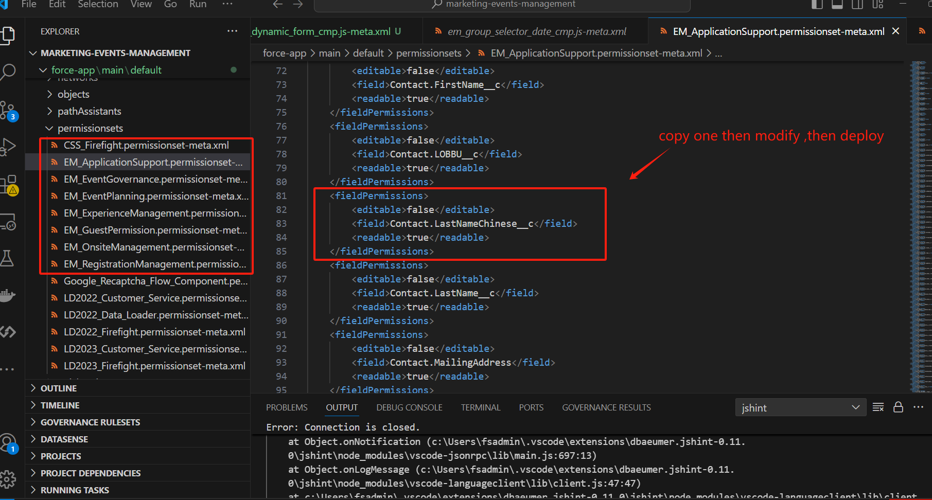

# **Release process**

1. Publish on copado first, link as follows:

[Copado guide.docx (sharepoint.com)](https://pccw0.sharepoint.com/:w:/r/sites/CustomerSelfService/_layouts/15/Doc2.aspx?action=edit&sourcedoc=%7B9454381d-6251-4493-b735-61138902aaef%7D&wdOrigin=TEAMS-MAGLEV.teamsSdk_ns.rwc&wdExp=TEAMS-TREATMENT&wdhostclicktime=1728879429719&web=1)

2. If you need to operate db data, such as adding, modifying, or deleting, the following steps are required: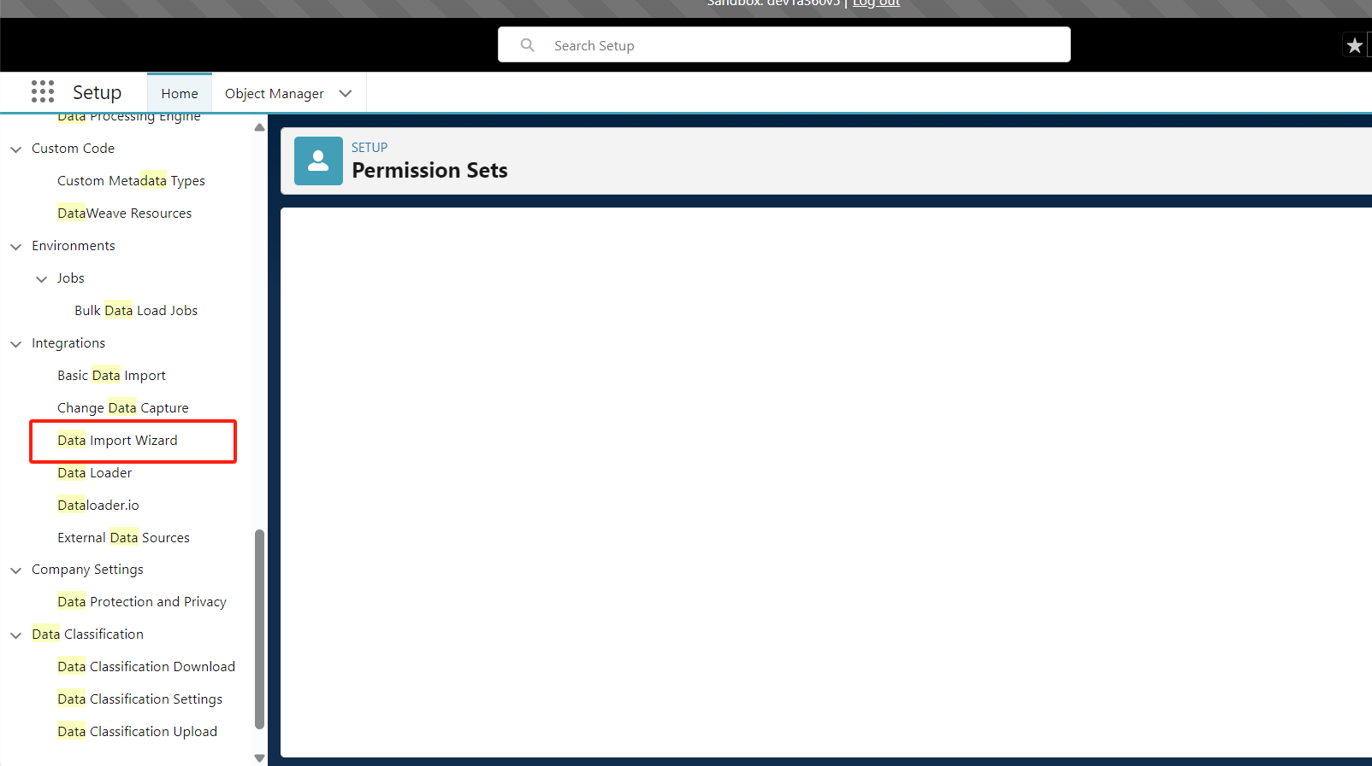

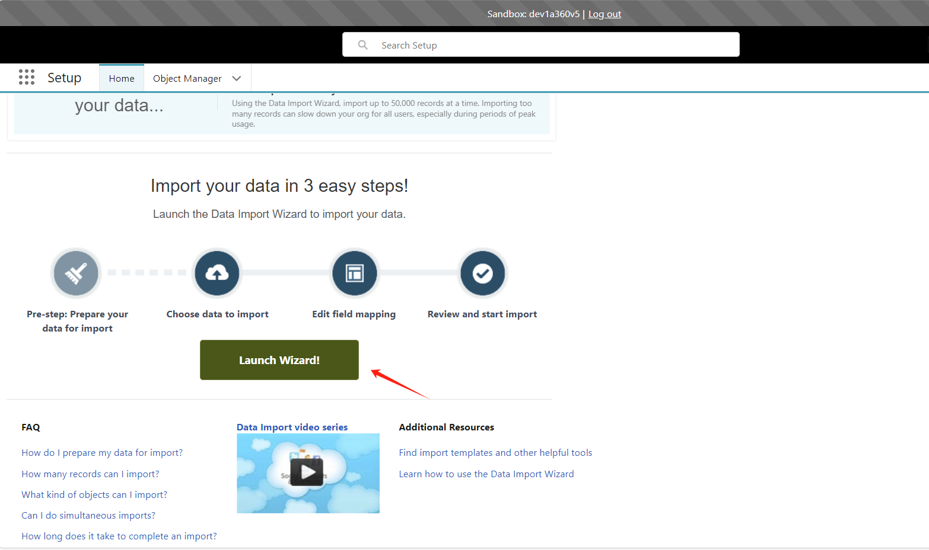

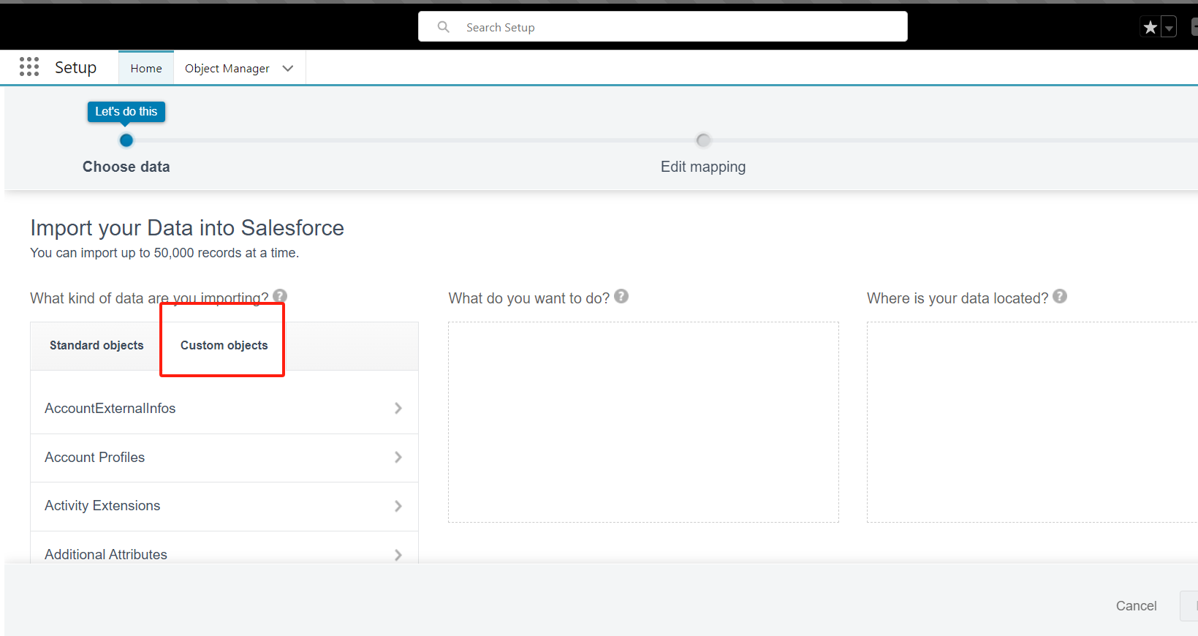

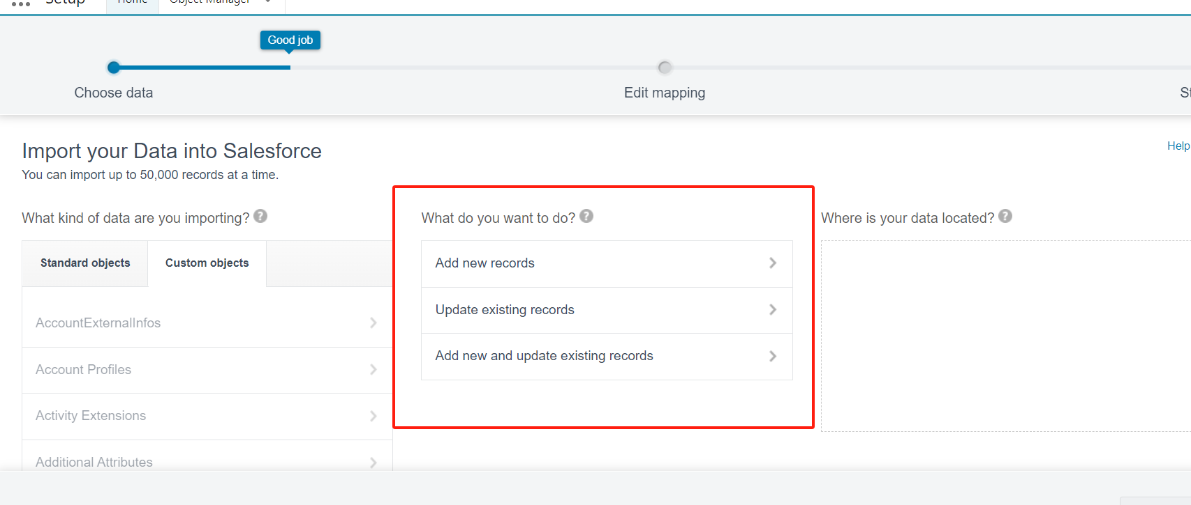

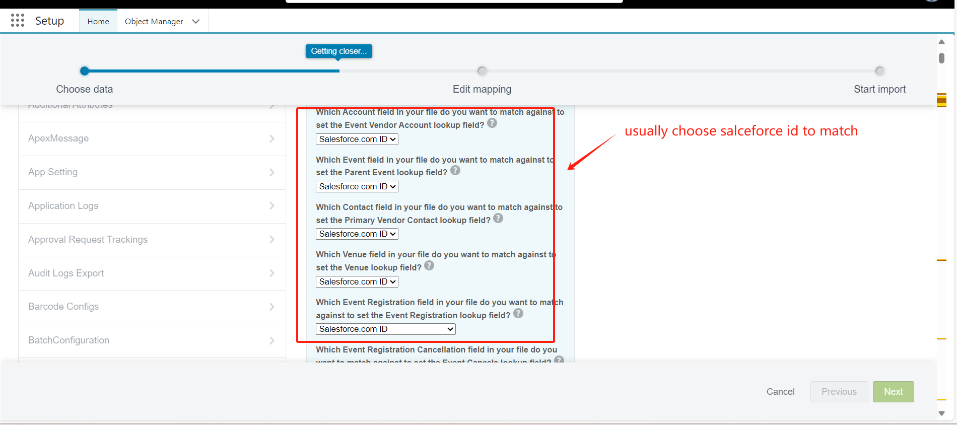

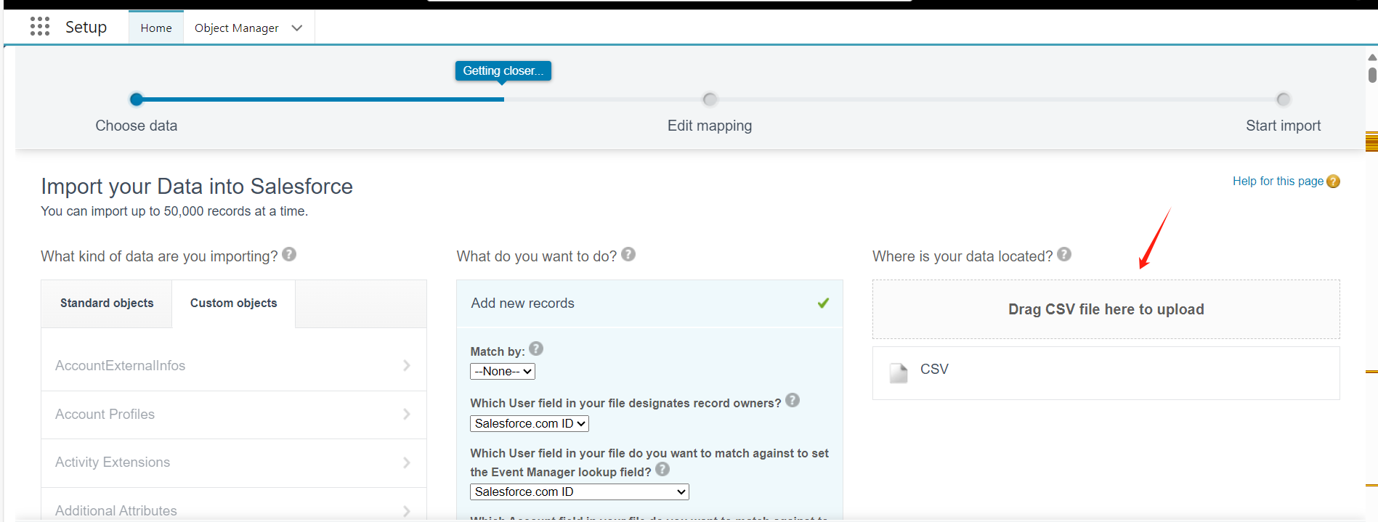

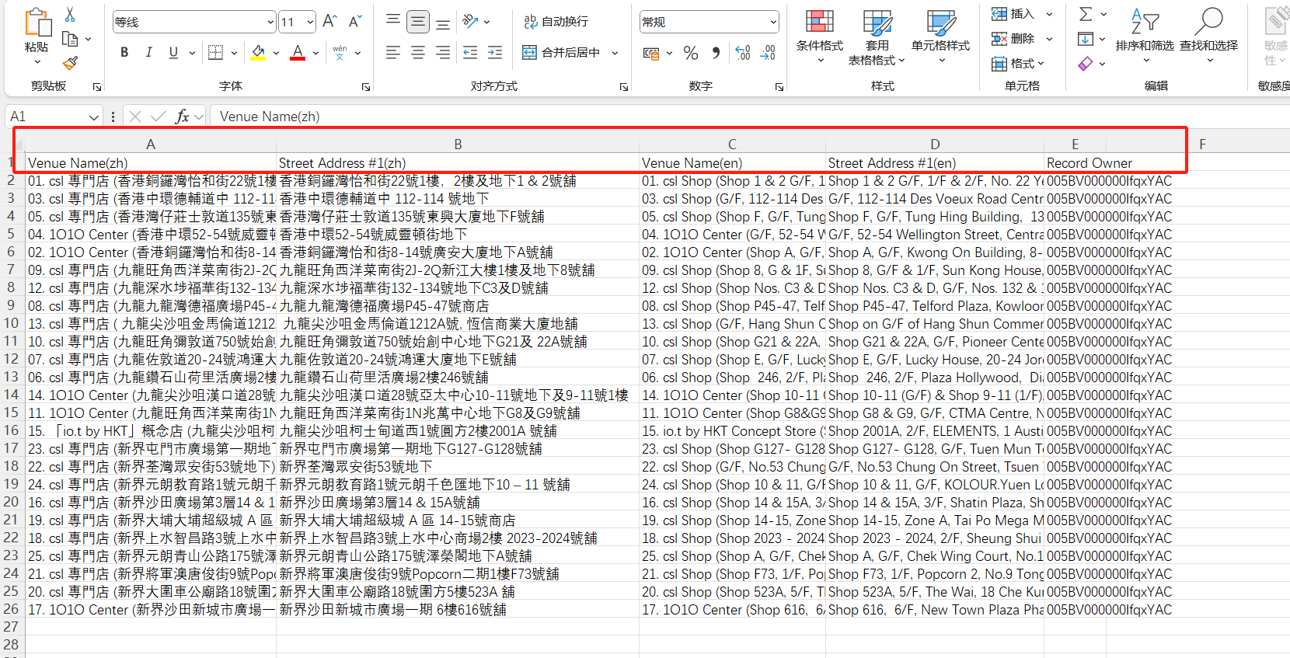

Note: Title must match the label of object, otherwise an error will be reported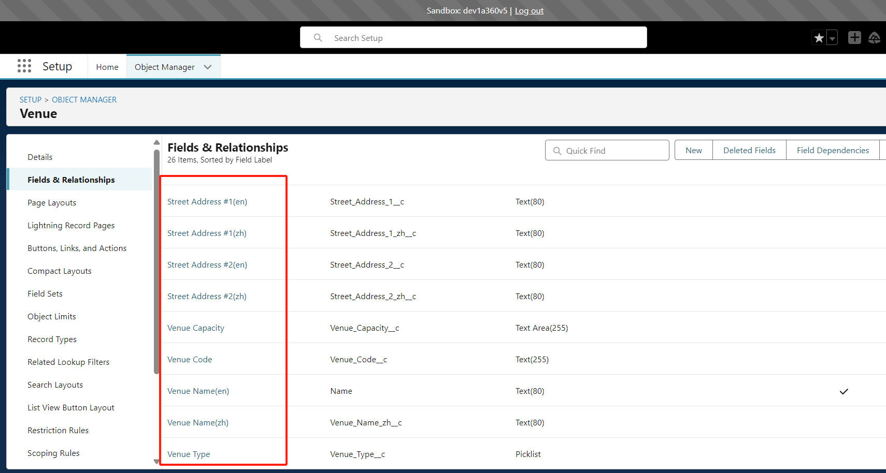

1. If you want to configure a new page or change the page, follow these steps:

**Edit：**

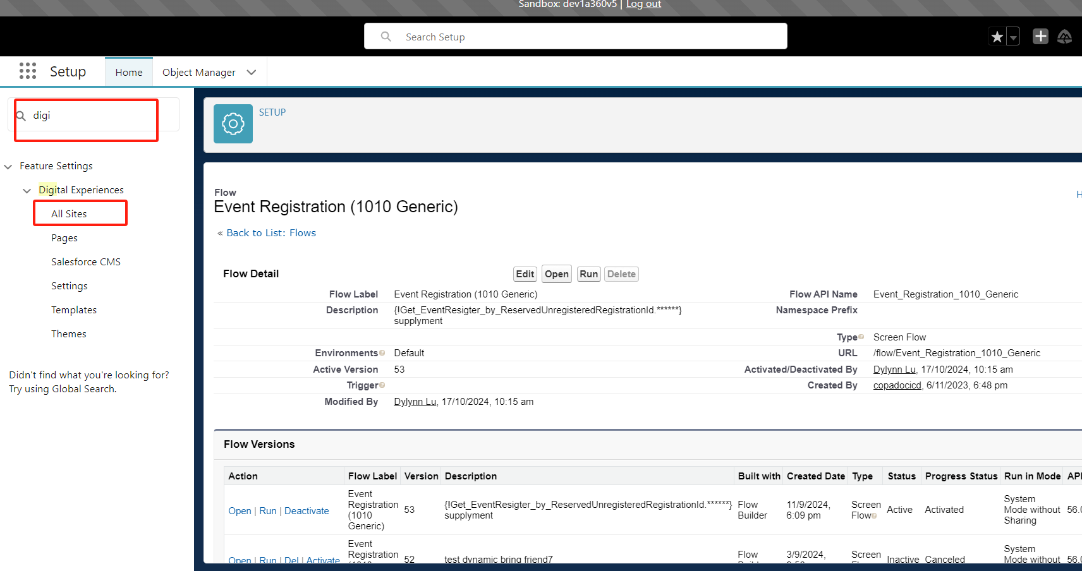

**

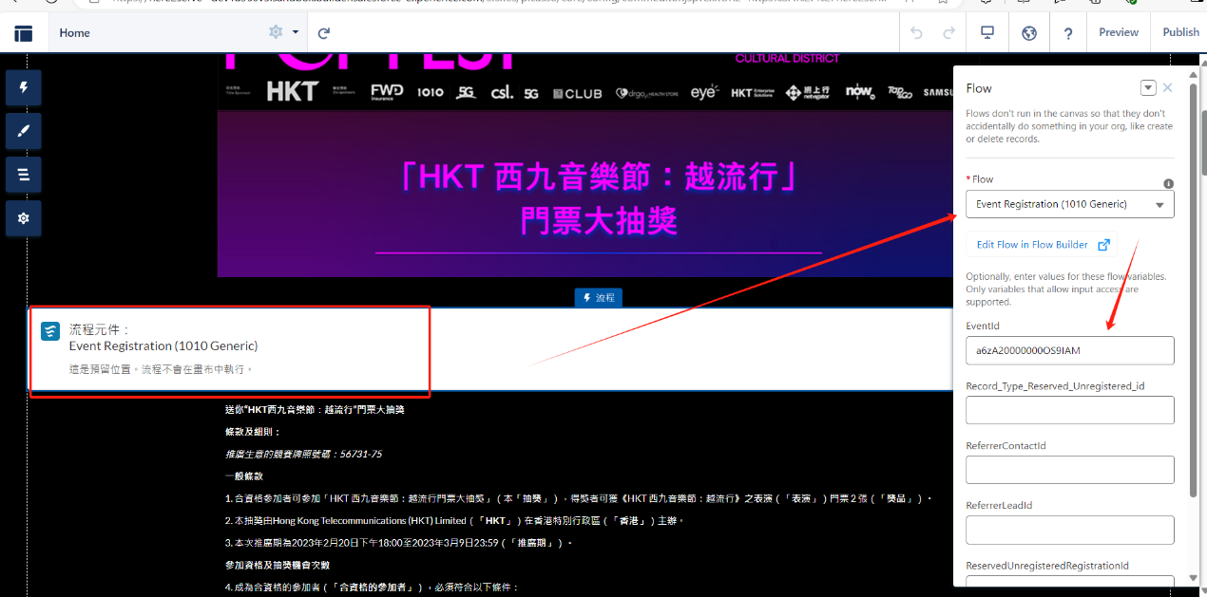

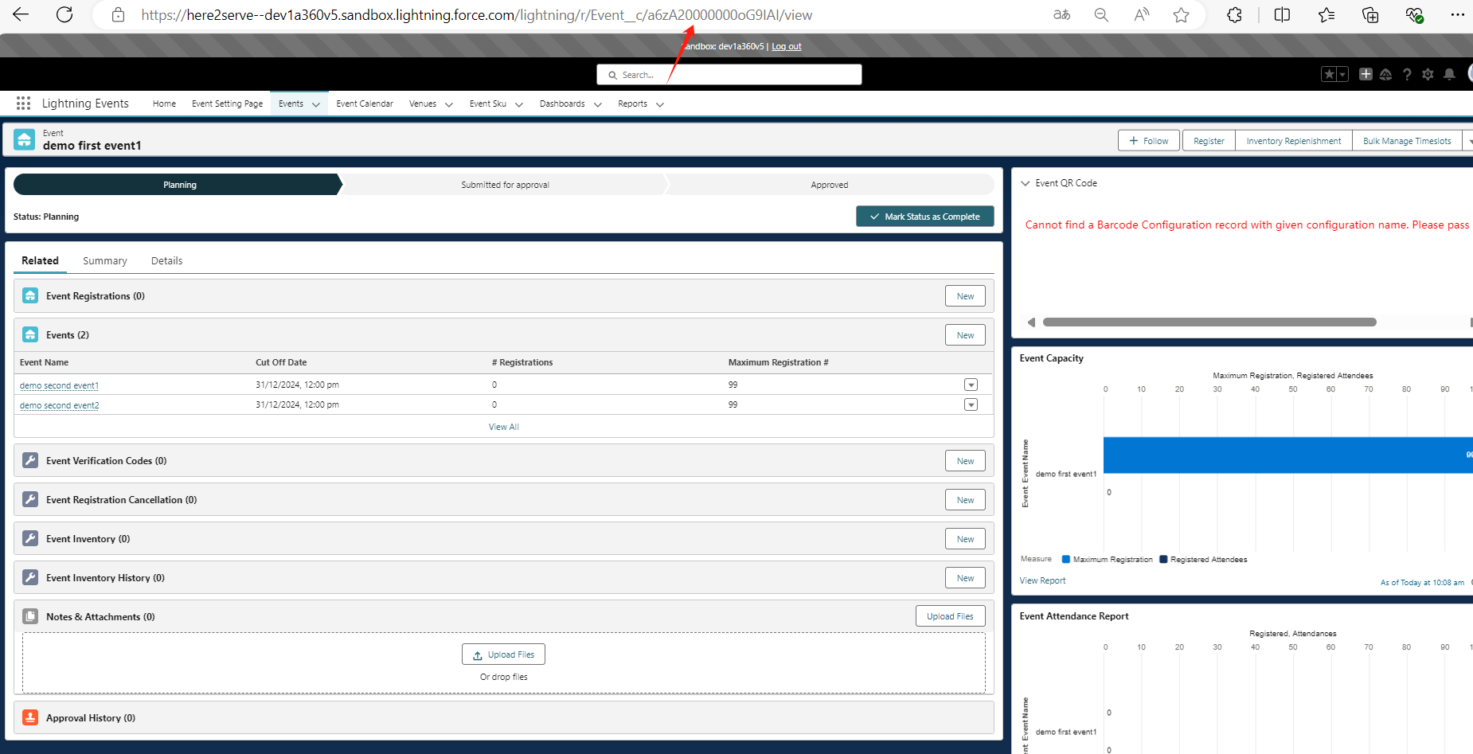

The EventId is as follows: To display that event, go to the corresponding environment (dev, uat, prod) to find the corresponding eventId, and then fill it in.

**New page：**

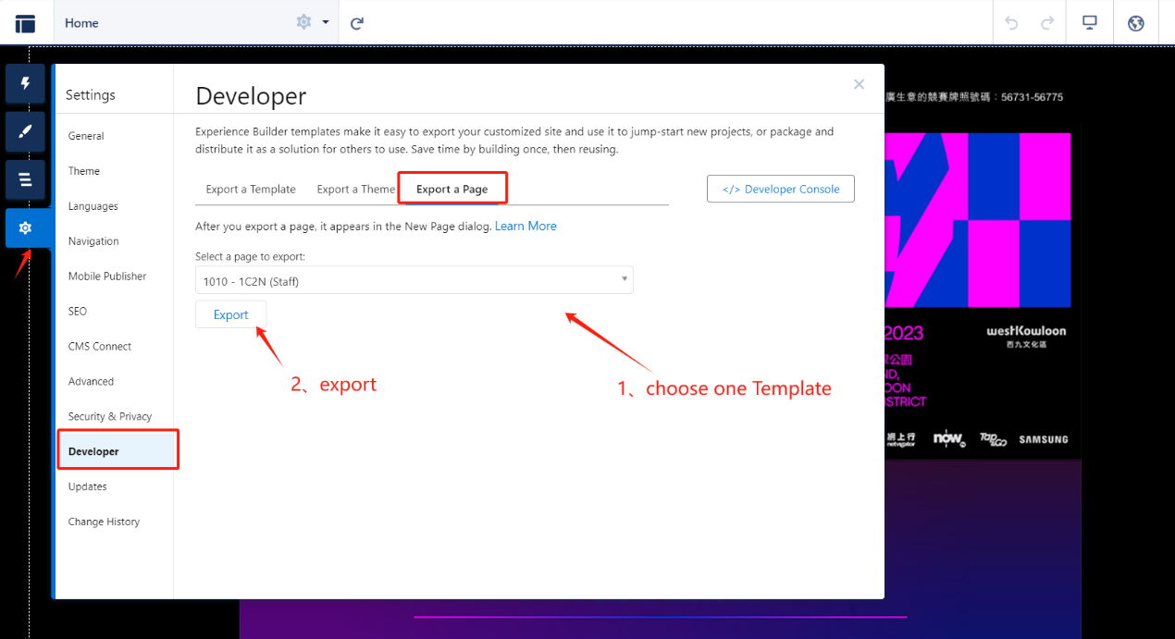

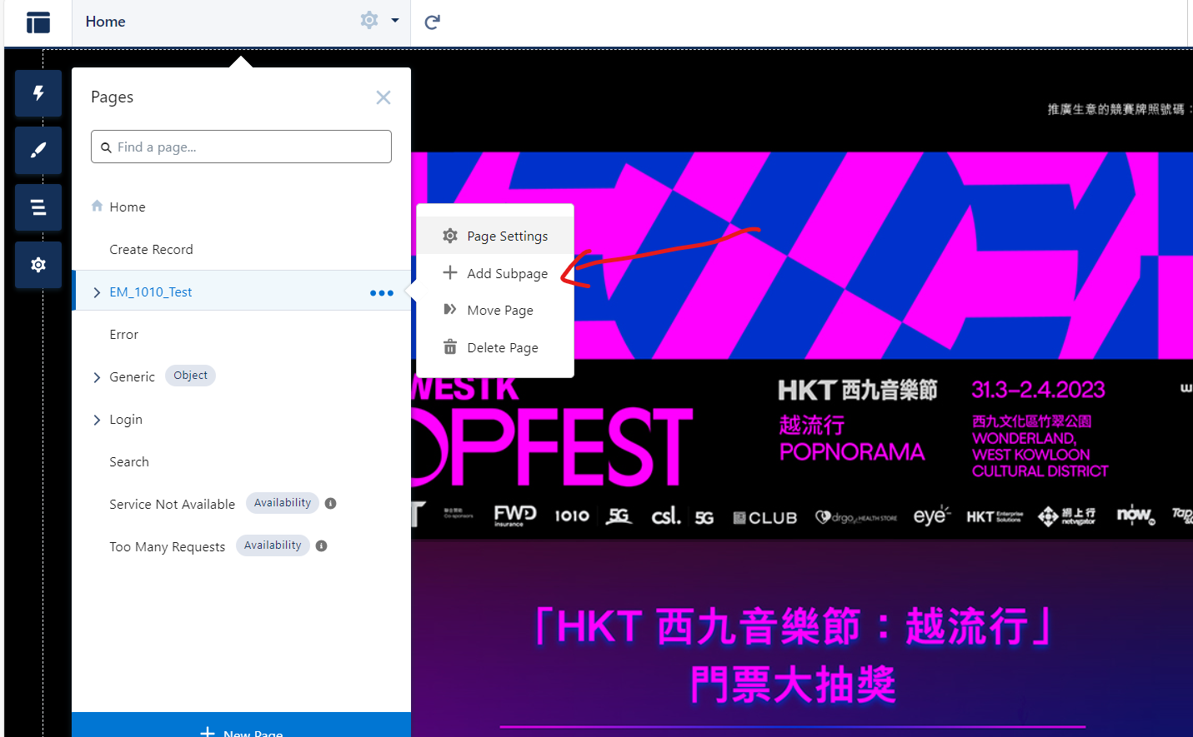

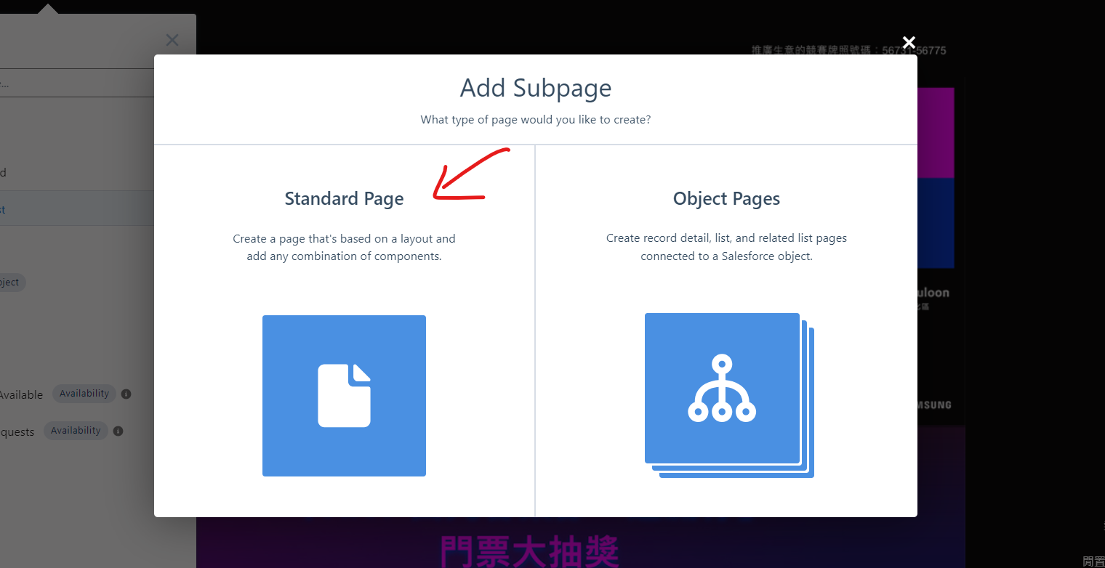

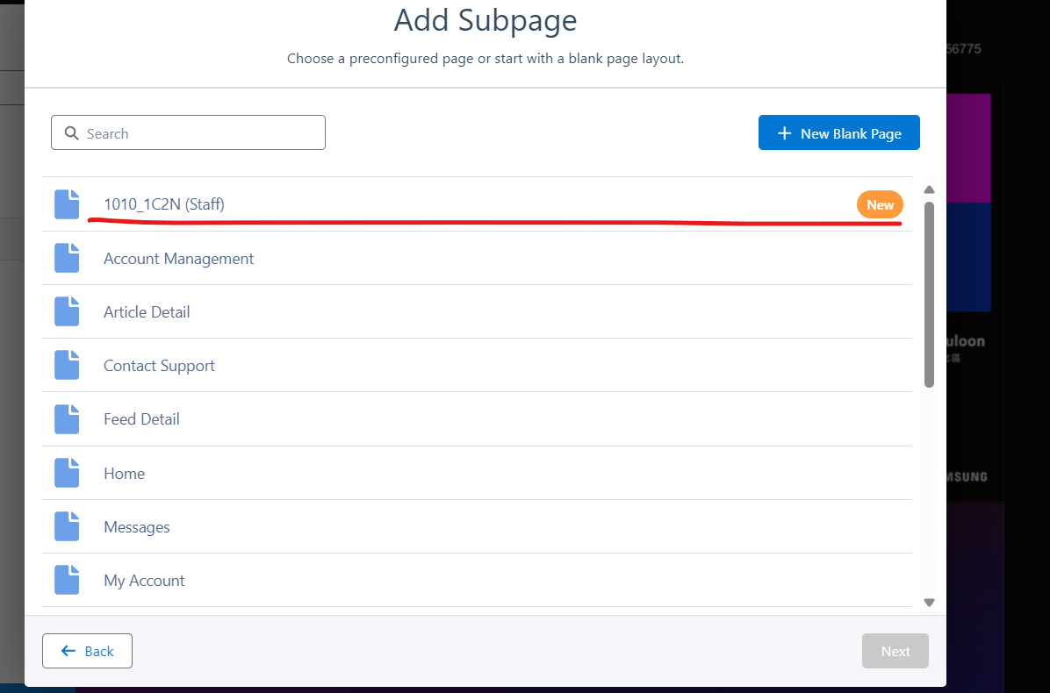

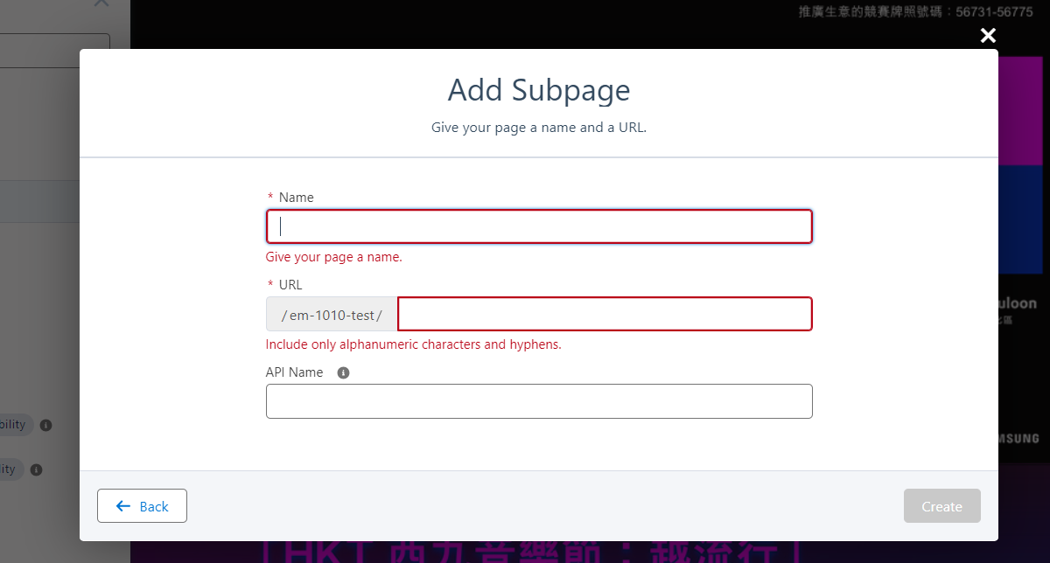

The corresponding relationship between Link and forder:

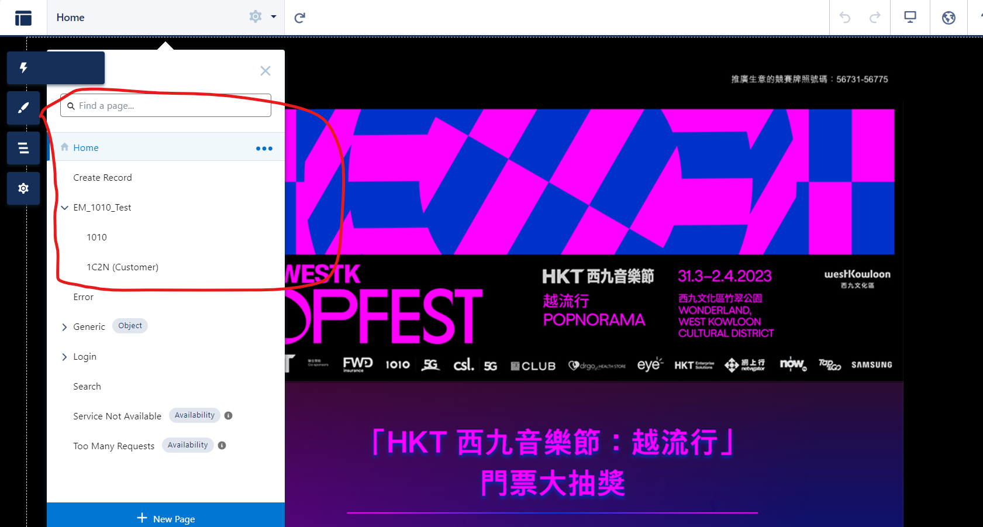

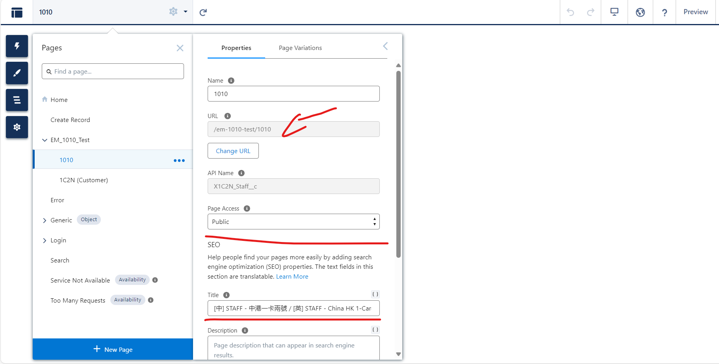

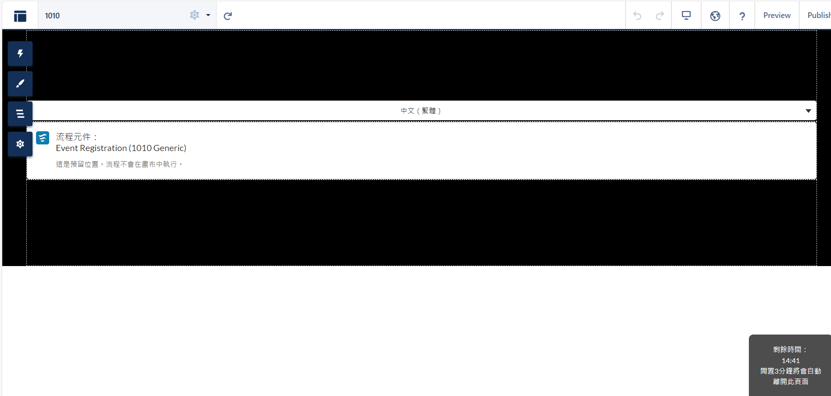

The link corresponding to the Home directory: [https://here2serve--dev1a360v5.sandbox.my.site.com/ld2023registration](https://here2serve--dev1a360v5.sandbox.my.salesforce-setup.com/servlet/networks/switch?networkId=0DBBV00000000MF)

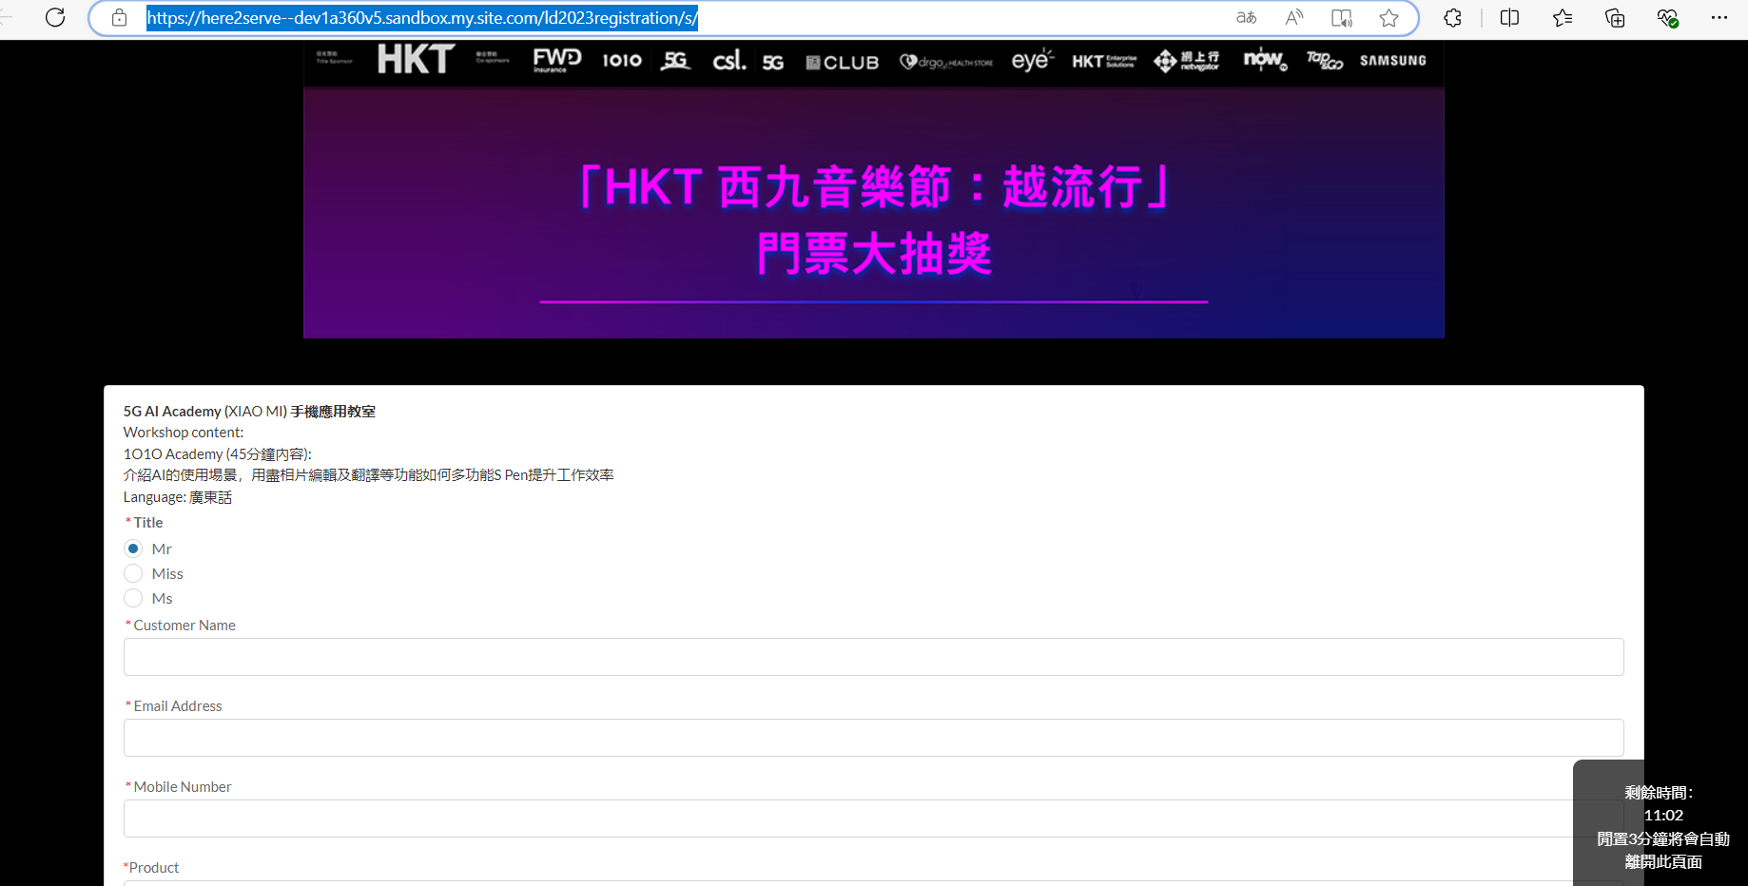

Em_1010_Test directory:

https://here2serve--dev1a360v5.sandbox.my.site.com/ld2023registration/s/em-1010-test/1010

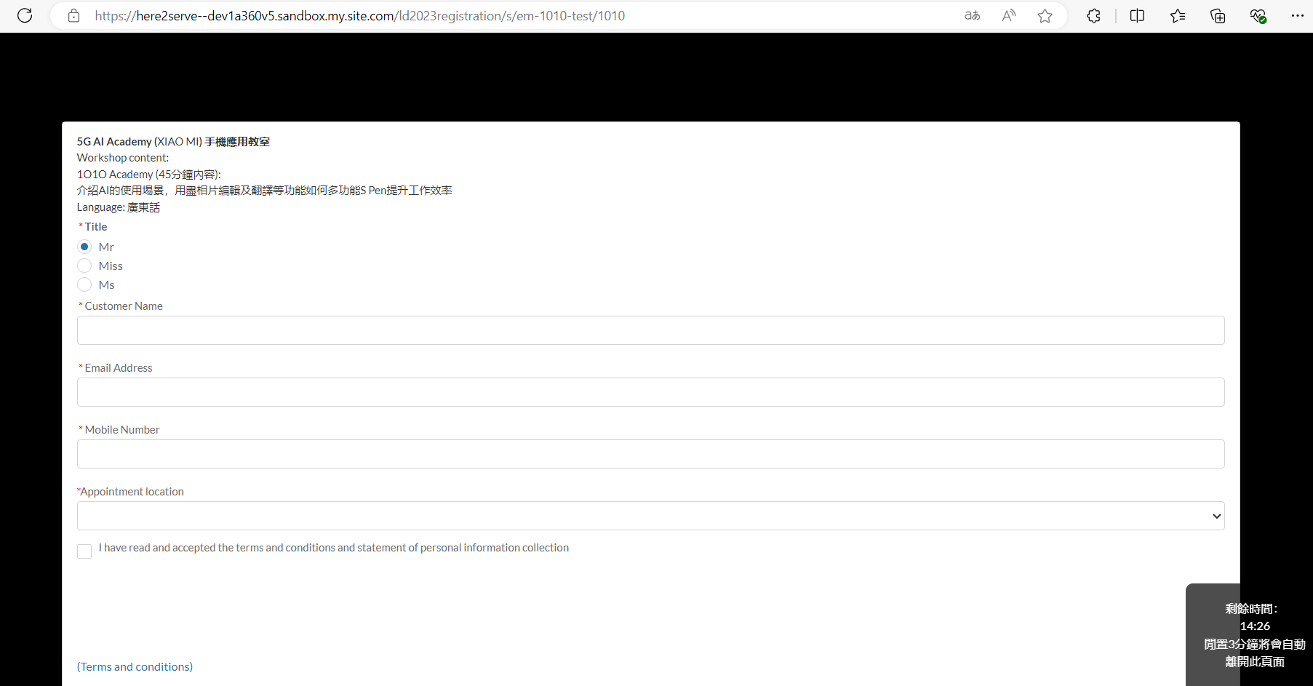

## Note: Before configuring the website page in the prod environment, you must first try to configure a website page in the sfmem environment that is the same as prod.

# **To deploy list**

## 1. 3 layered events (three-layer Event function) ————uat

## 2. event inventory (complete set of product event functions) ————uat

## 3. auto create timeslot (create third-level Event [Timeslot] function in batches) ————uat

## 4. event reg restriction fixes (registration restriction configuration is changed to read parent event function) ————uat

## 5. sms email job restart monitor (SMS email task failure monitoring function) ————dev

## 6. B&O requirement (new form function of building) ————dev

## 7. Simply bring friend requirement & bugfix (add a new UI display for bringing friends) ——————dev

## 8. Report job——dynamic sql (dynamically pass in sql to create a report function that needs to be sent by email) ————dev